Standard operating procedures (SOPs) child protection
Judiciary and no judiciary measures

Ecole Libanaise de Formation Sociale

INDEX

Introduction
Participatory Working Methodology
Chapter 1: Protection of juveniles exposed to danger in Lebanon
- Objective of the protection
- The concept of protection
- The system of the protection of juveniles exposed to danger in Lebanon
- Specific diagram of the protection system in Lebanon
Chapter 2: Juvenile protection track according to Law 422/2002 & the proposed measures
for case management
1. Foreseeing and monitoring danger
2. Graphic track of protection
2.1- judicial measures track
2.2- non judicial measures track
3. Assessment
4. Preparation of protection measures
5. Enforcement of protection measures
6. Review of protection measures
Chapter 3: Case management methodology
First Stage: Detection of the case & preliminary assessment
Second Stage: Assessment
Third & Fourth Stages: The Preparation and implementation of protection measures
Fifth Stage: The Review
Chapter 4: Operational Tools of every stage:
Appendix 1: Indicators of the Degree of danger or mistreatment
Appendix 2: Filing of the case of the juvenile upon receipt of reporting / notification
Appendix 3: Guide to receive notification or reporting of alarming information and additional
investigation

Appendix 4 : The Assessment Guide of facts/data related to the danger
Appendix 5 : Assessment of the vulnerability of the juvenile
Appendix 6 : Parents capacity and competencies assessment guide
Appendix 7 : A guide to assess available resources in the social environment
Appendix 8 : Assessment Report Drafting Sample
Appendix 9 : Criteria for referring the juvenile
to an alternative care institution
Appendix 10: Protection plan –the Court’s decision according to the case: NOT AVAILABLE)
Appendix 11: Measures required by the judge from the parents
Appendix 12: Intervention Plan/judicial and non-judicial measures
Appendix 13: Report addressed to an alternative care institution
Appendix 14: Criteria of Protection Measures Review
Appendix 15: Sample of the Protection Measures Review Report
Appendix 16: Required documents depending on nature of file
(judicial or non-judicial)
Chapter 5: Skills specific to the protection of juveniles
- Required behaviors/attitudes for the protection of juveniles:
- Main values underlying the practice in the protection of juveniles
- Common knowledge for all the interveners
4- Common skills related to:
- Intervention in the field of protection
- Evolution of the professional practices in the field of protection
- Multi-disciplinary work and partnership

5- Skills of the specialists
5.1 Social worker
5.2 Specialized educator
5.3 Nurse
5.4 Judicial police
5.5 Psychologist
5.6 Regional committees advisor
5.7 The Person accredited

List of Tables & Flowcharts:
Flowchart A: Participatory working methodology step by step
Flowchart B: Case management methodology
Flowchart 1: Protection concept
Flowchart 2: Protection system in Lebanon
Flowchart 3: Partners in the protection of juveniles
Flowchart 4: Official Procedures for Juveniles Protection in Lebanon:
Headed by the Ministry of Justice & the Ministry of Social Affairs
Flowchart 5: Graphic track of protection
Flowchart 6: Mandatory reporting
Flowchart 7: Track of reporting in case of offence
Flowchart 8: Reception, processing & assessment of the reporting
Flowchart 9: Evaluation process of alarming facts
List of participating institutions:
Institutions and entities which participated in the tools field test in December 2013-February 2014
Names of institutions which participated in the training with the UNICEF.

INTRODUCTION

With the support and funding of the UNICEF and in collaboration with the Higher Council for Childhood - Ministry of Social Affairs, the Lebanese School for Social Work at Saint Joseph University (Université Saint-Joseph) conducted in 2011 a study entitled "Strengthening Child Protection System in Lebanon: Challenges and Opportunities” which led to several findings and recommendations that formed an entry for a new project aimed at a complete enhancement of the protection system in Lebanon on the basis of Law 422/2002 on the Protection of Juveniles.
Results and recommendations shed the light on strengths and gaps in the design of the existing system and its effectiveness as well as the adopted mechanisms and their comprehensiveness and accuracy. The study also revealed the need for strategies that aim to develop standards and practices in the field of child care and protection because the absence of standard operating procedures (SOPs) for the application of the provisions of the law, guidance and protocols constitutes a major obstacle to interveners, who, due to this absence, resort to their personal intuition and experience rather than to scientific criteria for a professional and rigorous performance.
In other words, whether Law 422 is amended or a new child protection law is enacted, a series of standard operating procedures are required to implement legal provisions. These SOPs include:
- Standardized protocols for foreseeing, monitoring and assessment of danger & review of the measures taken.
- A standardized methodology for case management with operational and practical tools that ensure accuracy in decision making.
- Provide training to make sure that professionals working with children and families are aware of the scope of Law 422, ensure the sustainability and quality of child protection mechanism at the local level and are able to adhere to the basic procedures to determine the nature of the detected risk and the possibility of its treatment under the Law 422/2002.
Based on the foregoing, UNICEF and the Ministry of Social Affairs completed their partnership and support for the second project intended to issue SOPs in the field of protection of juveniles in Lebanon.
These standard procedures are established for all interveners in the field of protection in order to strengthen their work at both the administrative and clinical levels. These procedures also seek to change social centers (public and private) into centers ready to assess the needs of juveniles at risk (high or low) and their families and provide them with appropriate protection / support services.
Standard operating procedures (SOPs) constitute a set of instructions that describe the steps to be followed by all interveners in the protection of juveniles in Lebanon, as well as activities to be carried out. The implementation of these SOPs is an integral part of the system of the protection of juveniles in compliance with Law 422/2002. The methodology of work that is in line with legal, administrative, technical and ethical requirements of the Lebanese system should be detailed. These procedures also help Ministries involved in the protection of juveniles to maintain their monitoring of compliance with rules, accuracy in the analysis, guidance, decision-making and quality steps / services.
Case management –the therapeutic track in the protection of juveniles- is purely systematic and practical, based on an organized approach of planned intervention in order to find a solution so as to face the danger that threatens the development and safety of juveniles. Case management follows a track composed of five stages that must be followed by interveners of all specializations and positions whether the case follows a judicial or non-judicial track.
The main advantage of the project is in:
Being an “intellectual – technical – field – schematic and political work to make of the protection of juveniles a national collective and participatory cause,
And being a project that involved stakeholders step by step in building protection bonds and producing operating procedures and related mechanisms, which raised the level of commitment they have and encouraged them to adopt and approve them as a standardized work system that enhances their performance and contributes to ward danger away from concerned juveniles.
This booklet contains the following chapters:
- System of protection of juveniles in Lebanon
- Description of the methodology used for the preparation and adoption of standard operating procedures (SOPs)
- Proposed procedures for case management
- Protection of juveniles track in accordance with Law 422/2002: judicial and non- judicial tracks; case management methodology.

Standard Operating Procedures (SOPs)

in the Field of Protection of Juveniles in Lebanon

Judicial & Non-Judicial Procedures

CHAPTER 1: Protection of juveniles exposed to danger in Lebanon

- Objective of the protection
- The concept of protection
- The system of the protection of juveniles exposed to danger in Lebanon

- Specific diagram of the protection system in Lebanon

The concept of protection is established by The Charter of Human Rights and Freedom and this right emanates automatically from the fundamental rights of every individual such as the right to life, security, assistance/relief and protection that is the responsibility of the parents in the first place as long as they are capable of fully providing it. It is also the responsibility of the community surrounding the juvenile such as neighbours, extended family, educational and recreational environment, etc.

It is worth mentioning that the protection of juveniles exposed to danger is the responsibility of the State that is considered as “the father and largest protector for all children (..) That’s why the State commissioned institutions with diversified and specialized services to protect juveniles at risk (...) The protection must seek to identify and address the causing factors and consolidating the capacities of parents (.....) When these institutions fail in the protection of juveniles, the government seeks through courts and in accordance with the laws and cultural norms adopted in each community to develop a protection scheme in a preventive, rehabilitative and not punitive context” (Kadushin 1988).

- The objective of protection is to rectify conditions that impede or threaten the safety and development of the juvenile, taking his best interest into consideration, whether these conditions arise from a potential danger or real danger,( i.e. any actual abuse in its comprehensive meaning).

Protection measures are based on ensuring the child’s best interest and thus protecting him/her from all imminent dangers, as well as activating the role of parents, enhancing their capacities and involving them and the juvenile in implementing the protection measures taken which shall:
- Protect appropriately the juvenile and take into account his/her best interest.
- Enhance the responsibility of parents as they are primarily responsible for the protection of the child and for eliminating the danger surrounding him/her
- Encourage the juvenile and his/her parents to participate and commit to protection measures and change the circumstances detrimental to his/her safety and development.
- Activate the social environment to provide support to the juvenile and his/her family.

Concept of danger according to Law 422/2002 (protection of juveniles in conflict with law and exposed to danger)

In its general sense, the concept incorporates all forms of abuse, threat and suspicious circumstances that may endanger the safety and development of a juvenile. The concept of danger includes two levels according to the following:

Likelihood of danger: This level of danger includes all the nuisance, unjustified anger and alarming threats that do not directly affect the physical, emotional, mental, intellectual, and social development of the juvenile. This level can also include the absence of significant risk: where conditions appear to be convenient and do not pose any significant threat or abuse that would impede the physical, emotional, mental and social development of the juvenile.

Danger: Includes all injuries resulting from ill-treatment such as:
- Use of physical violence against a juvenile causing him harm or damage (bruises, scars, tangible immediate injuries)
- All types of neglect
- Actual threats (risk of death, physical harm), and anything that would impede the physical, emotional, mental and social development of the juvenile in a rude manner such as insulting, shaming or bullying into doing arbitrary acts
- Frequent incidents that impede the development and the well-being of the juvenile such as undernutrition, lack of clothing, shelter, hygiene, medical care and safety.
- Sexual touching, caresses, sexual relations, rape or committing indecent acts, or engaging a juvenile in prostitution and pornographic activities (Appendix 1: The indicators of danger or mistreatment levels)
As in other countries, the Lebanese Law on the Protection of Juveniles does not protect every juvenile who needs assistance and special services. Therefore the intervention of the judiciary in the privacy of families should be limited only to dangerous and exceptional situations as stipulated in Law 422/2002 (Protection of Juveniles in Conflict with the Law or Exposed to Danger). Pursuant to Chapter III-Article 25 of this law, the security and safety of the juveniles are threatened in the following cases:
- If he/she was found in an environment exposing him to exploitation, threatening his/her health, safety, ethics or conditions of education.
- If he/she was exposed to sexual abuse or physical violence exceeding the limits of what is allowed by custom as a manner of harmless discipline.
- If he/she was found begging or homeless.
  - The juvenile is considered a beggar, by this law, if he/she practices professional begging for almsgiving by any means.
  - He/she is considered homeless if he/she left his/her house to live on the streets and public places or if he/she did not have a house and was found in the aforementioned case.
The provisions of this Article shall apply to every juvenile who did not reach the age of eighteen.

Protection of juveniles is a collective responsibility that rests primarily with each of the following:
- Parents / family as being responsible in the first place
- The community that provides help, assistance and support for the parents to carry out their responsibilities
- The State that provides services for all the families and that resort to exceptional and limited measures to fill the absence or inability of the parents / family to ensure the safety and development of the juvenile.
The protection decision shall take into account four main factors²:
* Nature, seriousness and frequency of the reported facts.
* Age, personal traits and degree of vulnerability of the juvenile.
* Ability and willingness of parents to put an end to all what threatens the safety or development of the juvenile.
* Resources available in the social environment that can provide assistance to the juvenile and his/her family (Diagram 1: Protection concept).

____________________
Gouvernement du Québec Ministère de la Santé et des Services Sociaux ”La Protection sur mesure :un projet collectif »,Harvey 1990
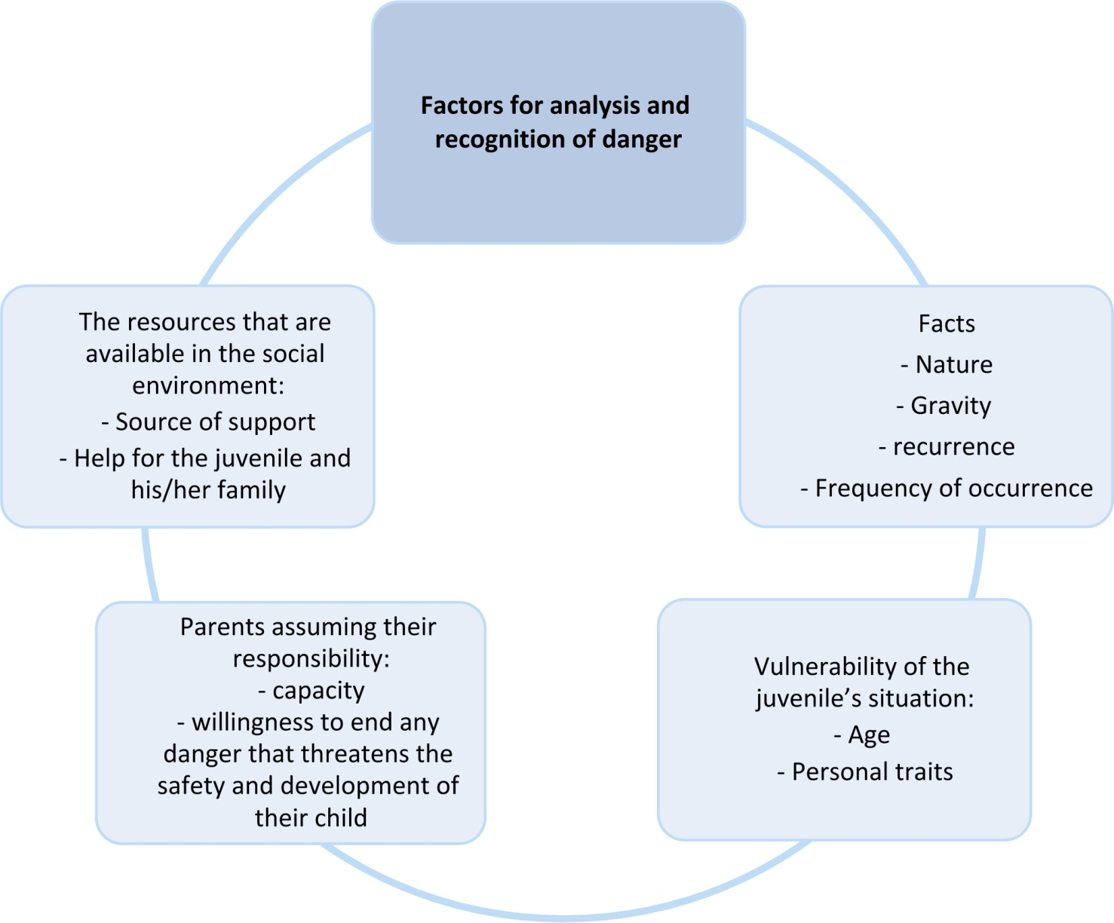
Diagram 1: Protection Concept

System of protection of juveniles in Lebanon

The system of protection of juveniles in Lebanon is officially linked to the Ministry of Justice, and is in force by virtue of Law 422/2002 (protection of juveniles in conflict with law and/or exposed to danger) to protect juveniles from danger and address the ensuing damage. It also relies on several articles of the Lebanese Penal Code to prosecute and punish the aggressor if he/she is a juvenile (Figure 2*: protection system in Lebanon)

Accordingly, the juvenile judicial system (courts) deals with individual cases by a decision of the juvenile judge. It is the responsibility of the judiciary and the Ministry of Justice which, in turn, commissions NGOs to follow up with the juveniles and their parents. Judicial protection measures are based on the concept of “the real and the potential danger” and could result in stripping some powers from parents.

Several entities play a key role in preventing and eliminating danger surrounding the juvenile. The role of each of the following entities is clarified as follows:

- Juvenile court: When the parents and social resources are not able to protect the juvenile, the juvenile court then carries out its mandated role in accordance with the following: A juvenile judge, according to the current Lebanese legal system in force, shall establish a special court to consider measures to protect at-risk juveniles.

- Juvenile Department: The Juvenile Department is an administrative body at the Ministry of Justice that organizes work, supervises and coordinates with all line public and private bodies on all matters related to juveniles in conflict with law or exposed to danger.

- “The Union for the Protection of Juveniles in Lebanon” is a non-governmental organization mentioned in Law 422/2002 as the organization responsible to help in the implementation of this law.

- “APEG (Association pour la Protection de l’Enfant de la Guerre)” is a NGO contracting with the Ministry of Justice and assigned by the Juvenile court to provide medical/psychological follow-up to the juveniles exposed to danger.

- Law No. 422/2002 is a therapeutic and preventive reference aimed at preventing the real, potential or existing danger. Therefore, choosing appropriate protection measures shall be done on the basis of the decision that determines the existence and level of the danger which threatens the safety and development of the juvenile. The judiciary shall be the only authority responsible for the selection of measures. As for everything else, participation in the assessment and expressing opinions shall be done at the request of the juvenile judge.

- In some cases, the protection of a juvenile threatened in his security and integrity is conducted through a range of non-judicial measures inspired by the spirit of Law 422/2002 which urges parents to perform committed to their responsibilities. However these non-judicial measures are not clearly marked in Lebanese law texts. The judge can refer to them when he/she deems appropriate to keep it in the range of parents who pledge to take on their responsibility to protect their child or resort to “reconciliation” within a specific time period. The judge may retract these measures return in order to take an appropriate action in accordance with the result that refers to the continuation of the risk.

• Except that, non-judicial measures to protect the juvenile are the responsibility of the Ministry of Social Affairs through several units, most notably: the Directorate of Social Services - Department of Juvenile Protection - regional departments: six in addition to SDCs affiliated to the ministry and deployed on Lebanese territory, in collaboration with the associations and organizations, including the UNHCR and partners.
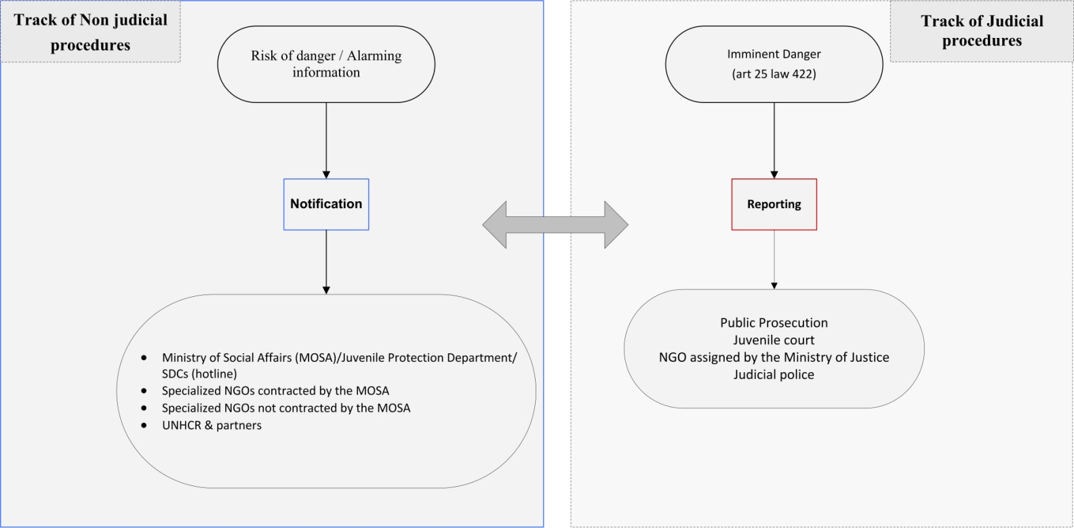
Diagram 2: Protection system in Lebanon
CHAPTER 2: Juvenile Protection track according to Law 422/2002
& the proposed measures for case management

- Foreseeing and monitoring danger
- Graphic track of protection
2.1- judicial measures track
2.2- non judicial measures track
3. Assessment
4. Preparation of protection measures
5. Enforcement of protection measures
6. Review of protection measures

The Case management in the protection of juveniles is based on a structured approach of intervention aimed at finding a solution to address the danger that hinders the development and safety of the juvenile. Thus, case management contributes directly to prevention through early detection which foresees potential dangers and monitors them, and hence addresses the damage and prevents risks. These procedures follow a track of six stages. Hereafter clarifications on every stage included in the following points: Nature of the stage, required behaviors, role and duties of the responsible persons.

The adopted case management track is summarized as follows:

1. Foreseeing and monitoring danger
2. Graphic track of protection
3. Assessment
4. Preparation of protection measures
5. Enforcement of protection measures
6. Review of protection measures

Foreseeing and monitoring danger

The earlier the danger is monitored, the more the seriousness of the damage on the life of the juvenile is reduced. In fact, early detection and monitoring protect the juvenile from danger. Pursuant to the laws in force, no one shall be allowed to cover up or conceal any data or facts affecting the safety and security of the juvenile. It is the duty of every citizen, whether professional or ordinary, who has suspicions, data or facts that lead him/her to believe that the safety or security of a juvenile is endangered or threatened, to report the case to the judiciary or notify the MOSA and NGOs about alarming information.

Based on the foregoing, foreseeing and monitoring the danger (suspicions) is not confined to a particular category of people but concerns every human being who is present, by virtue of his work or daily life, whether by coincidence or intentionally, in an environment that includes juveniles such as: private and public schools, hospitals, NGOs, SDCs, entertainment and recreation centers, nurseries, clinics and health centers, municipalities, associations, places of worship, residential neighbourhoods... etc.

The following flowchart shows how juvenile protection is a collective and participatory responsibility even if the primary role belongs to the parents (see Flowchart 3: Partners in the protection of juveniles).

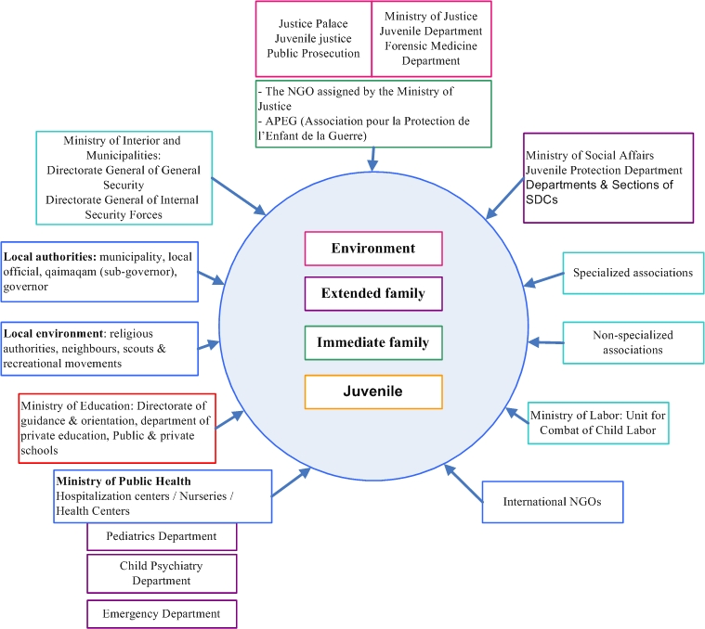

Diagram 3: Partners in the protection of juveniles

Each of the abovementioned entities or others can follow the official procedures of the protection of juveniles: judicial or non judicial (Flowchart 4 below: official procedures for the protection of juveniles in Lebanon: headed by the MOJ & MOSA) that show the Ministries of justice and social affairs as main reference to receive reporting of imminent danger or notification about alarming information concerning a juvenile being threatened in his/her safety and integrity.

Foreseeing a risk requires proceeding directly to the judiciary for reporting in the event the informant saw or upon seeing or observing or suspecting:
- The existence of a danger proceeding from a family member and that still exists
- The existence of an offence with or without specific evidence
- A case of emergency that requires immediate intervention from the judiciary
The informant ought to contact (in the manner he/she deems appropriate) the judicial police, the Office of the Public Prosecutor, the juvenile judge or any of the offices of social representatives mandated by the Ministry of Justice in all governorates or the specialized protection unit within his/her working place, if any. Accordingly, these authorities take notice, proceed with the course of action and take necessary judicial or non-judicial actions.

In the case of alarming facts: the informant must report about because:
- He/she suspects a danger
- He/she considers that the act is not criminal but requires protection, quick assessment of the situation and intervention especially in case the juvenile was of a young age.

The informant who has such information should contact (in the manner he/she deems appropriate) the Directorate of Social Services – Juvenile Protection Department or any of the six centers of the Ministry of Social Affairs authorized to receive complaints related to protection in the governorates, distributed by regions, depending on the domicile of the juvenile. Accordingly, these centers take notice or refer the case to the judiciary in order to take necessary legal actions as follows:

- Beirut & Mount Lebanon Governorates (Juvenile Protection Department) until the adoption of an independent center for Mount Lebanon at the decentralized level that will be added to the five centers listed below:

1. North Governorate – North Department
2. South Governorate – South Department
3. Nabatieh Governorate – Nabatieh Department
4. Mount Lebanon Governorate – Mount Lebanon Department
5. Bekaa Governorate – Bekaa Department

Specialized non-governmental centers contracting with the ministry can also be contacted, for example: Lebanese Child Home Association (AFEL), Himaya (Protection), Sisters of the Good Shepherd, Abaad (Dimensions), Dar-Al-Amal (House of Hope), or accredited organizations like Kafa (Enough), Abaad... etc.
They are requested to inform the Juvenile Protection Department at the MOSA of every case reported and the result that has been achieved as well as the track which was adopted so as the Ministry ensures that procedures are followed as they are established in accordance with this document.

In parallel to the abovementioned, anyone can use the hotline which the MOSA is seeking to activate in order to report alarming information about a certain juvenile.

It is noteworthy that these procedures also belong to the United Nations High Commissioner for Refugees (UNHCR) and its partners working with refugees or displaced juveniles exposed to danger.

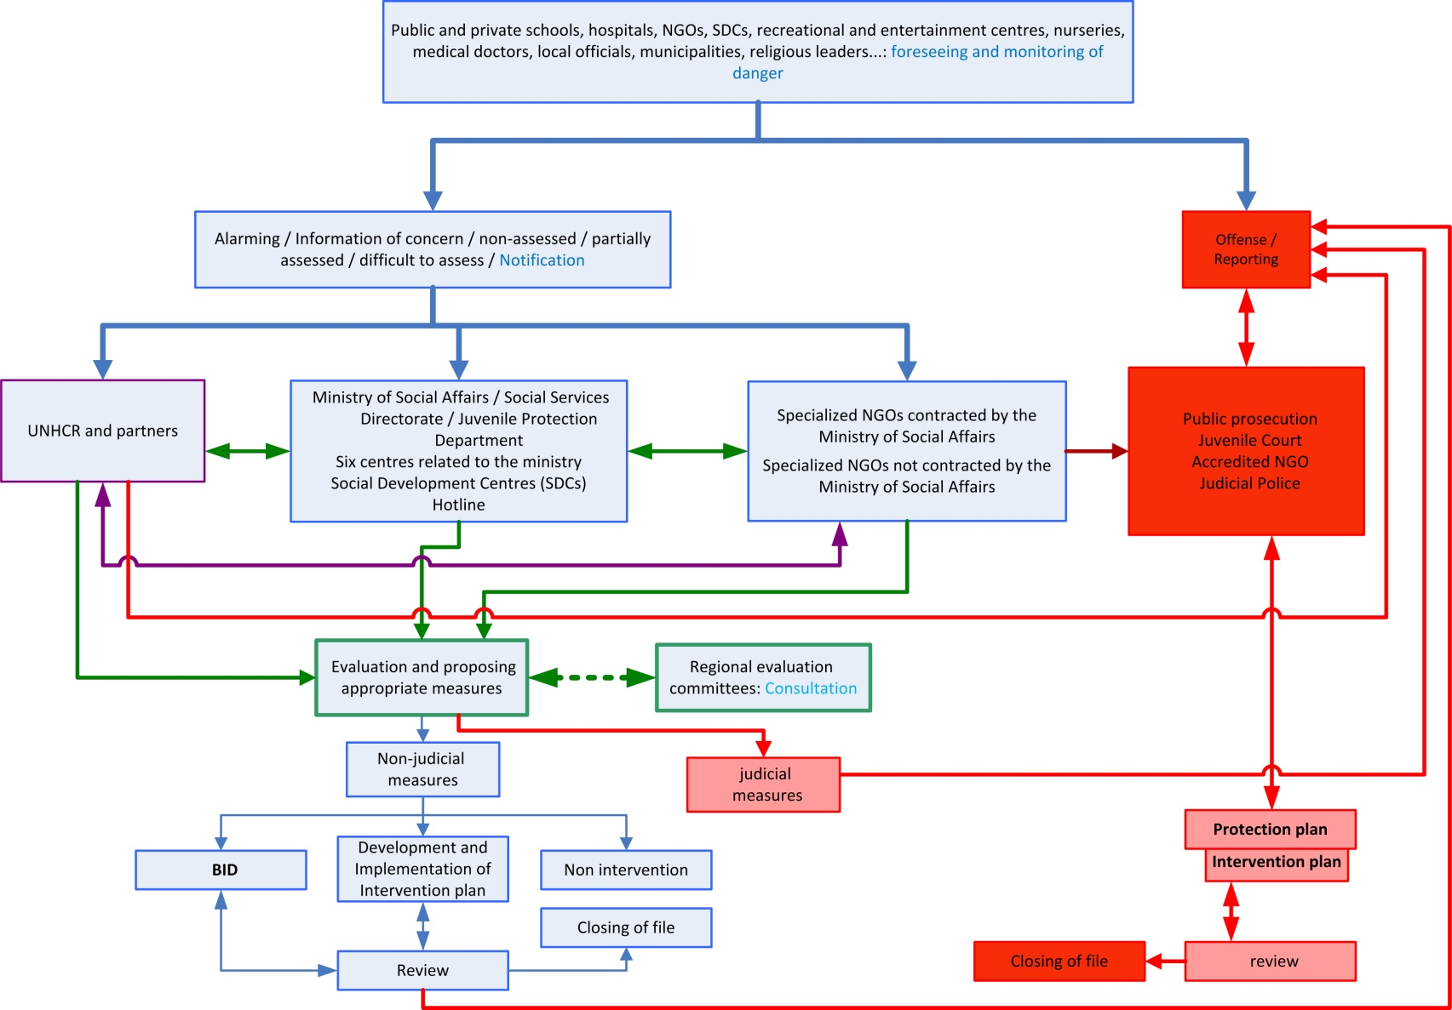
Diagram 4: Official Procedures for Juveniles Protection in Lebanon: Headed by the Ministry of Justice & the Ministry of Social Affairs

- Graphic Track of Protection:

Based on the foreseeing or detection of danger, the system of protection of juveniles exposed to danger in Lebanon proposes two tracks that all interveners of all professions have to follow and explain about to the parents so they are aware of the protection courses and the merits of seeking the court (when, for whatever reason). The judiciary shall be responsible of choosing measures only in cases of sexual abuse and physical violence that exceeds the limits of what is culturally accepted as harmless discipline (Law 422/2002).

The following flowchart (Flowchart 5: Graphic track of protection) indicates how the protection of juveniles follows one of two tracks: judicial or non-judicial with a participatory method.
- The track in red indicates the judicial protection measures and the way that the file of every juvenile will follow when reporting a danger under Law 422/2002 (protection of juveniles in conflict with law and/or exposed to danger). This track is the responsibility of the Ministry of Justice which in turn mandates NGOs which it considers able to follow the file of the juvenile and his/her parents.
- The track in black indicates the non-judicial protection measures and the way that the file of every juvenile will follow when informing about alarming information mentioning the possibility of existence of a danger that must be monitored and resolved and its damage addressed. This track is the responsibility of the Ministry of Social Affairs through several units most notably : Directorate of Social Services - Department of Juvenile Protection - The 6 regional departments in addition to social development centers (SDCs) affiliated to the ministry all over the Lebanese territory and all NGOs that deal with the juveniles and families and the UNHCR and its partners.
Both tracks work in a coordinated and parallel way to put end to danger, protect the juvenile and strengthen the capacities of his/her parents, with taking into consideration that the transition of the case to the judicial track is an obligation in case of aggravation of the situation or if need be. The three red arrows, between the 2 tracks, indicate the necessity of transition to the judicial track through notification in order to take the necessary legal action.

- The first arrow indicates the early line to follow once the additional verification process shows the presence or possible presence of an imminent danger that threatens the development and safety of the juvenile; then the judicial authorities must be notified to let the file complete its path.
- The second arrow indicates another possibility to switch to the judiciary when the assessment process shows the presence or possible presence of an imminent danger that threatens the development and safety of the juvenile; then the judicial authorities must be notified to let the file complete its path.
- The third arrow with a semi-vertical direction indicates that the transition to the judicial track is an obligation at the review stage which may show a decline in the status of the juvenile in terms of development and safety or failure of parents to put end to the detected danger.

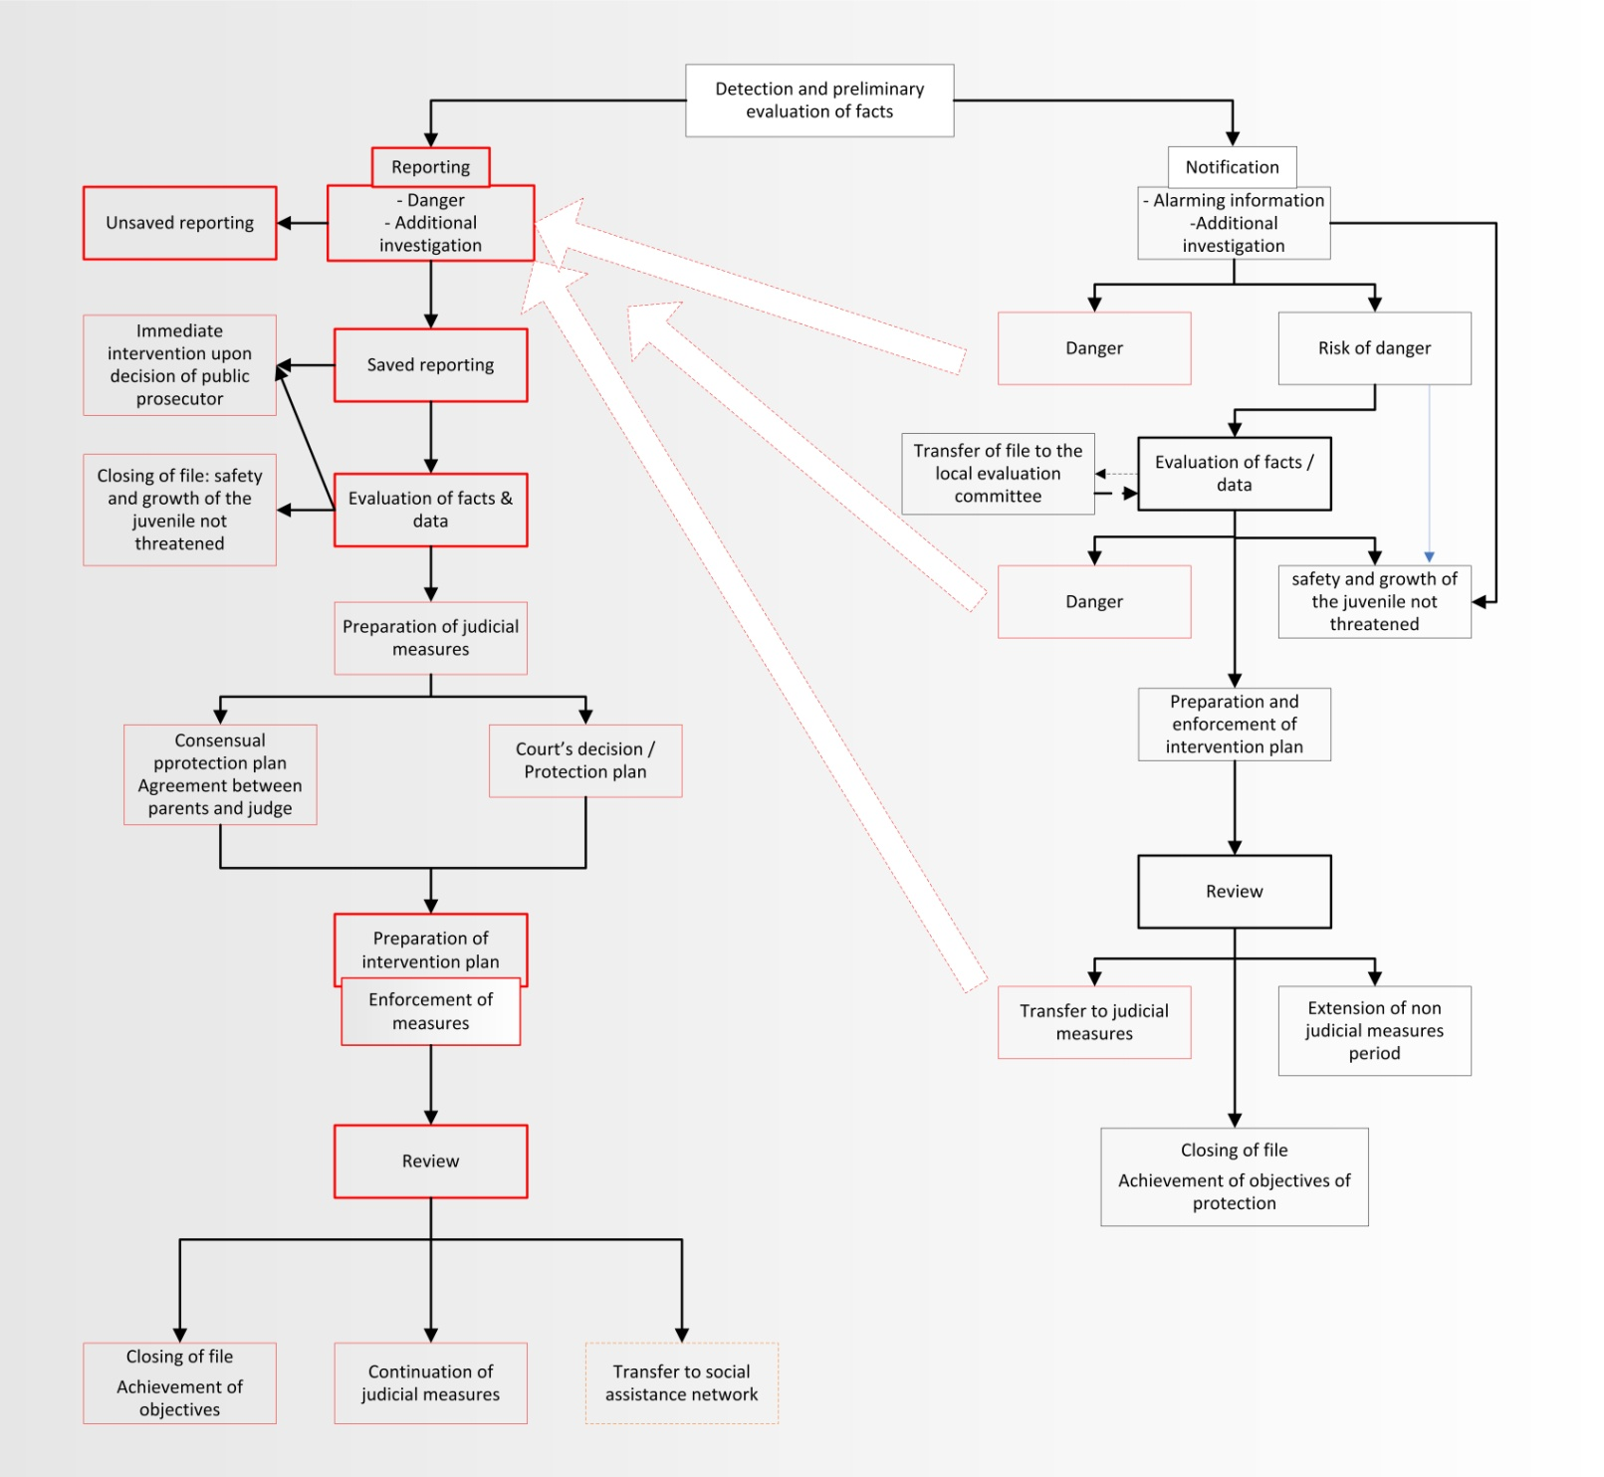
Diagram 5: Graphic Track of Protection

2.1- Judicial measures

Reporting is defined as any direct contact with the judiciary through judicial police or the juvenile judge, or in writing to the Office of the Public Prosecutor. Also it is possible to contact the offices of social representatives certified from the Ministry of Justice in all governorates. Contact is divided into two types:
- Known
- Anonymous
- Spontaneous
Known contact: Every contact made by schools, public and private hospitals, public health institutions, social institutions or social health centers, practicing professionals, or other relevant authorities having a juridical person to report a risk case that needs protection intervention. The contact can also be from any individual who wishes to disclose his identity.
Anonymous contact: Every contact made by a citizen who does not want to disclose his/her identity, and this is a right guaranteed by the law, but only after making sure of his/her credibility and intentions. Accordingly, the reporting shall be processed or not.

Informing is related to a penal offense occurred on the juvenile and its source will be an informer who knew or heard about the offense. The public prosecution does not accept any informing if not written and signed by the informer or his/her representative.

Spontaneous contact: The juvenile judge can react automatically upon knowing about a case of danger. (Personal views or through the media)

Mandatory reporting

Reporting to the judicial authorities is a doorway to protect juveniles exposed to danger. The earlier the reporting is, the more the gravity of the consequences on the life of the juvenile is reduced. Hence reporting protects the juvenile from danger, and not committing to it results in consequences for the non-reporting line parties, each according to its position (Flowchart 6: mandatory reporting)

- From the citizen, civil institutions or private sector: Article 28 of the Code of Criminal Procedure stipulates that it is incumbent on every person who witnessed an assault on public security or human safety, life or property to inform the Appellate Public Prosecutor or one of his/her assistants. In case of refraining without a legitimate excuse, he/she shall be criminally prosecuted and shall be fined an amount of two hundred thousand LBP to two million LBP.

- The citizen practicing a health profession: Article 26 of Law 422/2002 stipulates that any notification by a health professional about any danger threatening a juvenile is not considered disclosure of a professional secret and is not subject to the penal code provisions. Medical doctors and specialists are exempted from the professional secrecy if, while exercising their profession, they knew of or witnessed the existence of one of the dangers prescribed by law. If the doctor discovers during work a case of arbitrary detention of a legally incapacitated person or a minor or mistreatment or deprivation or rape or sexual assault, he/she must inform the competent authorities (lift professional secrecy in court only and not the Judicial Police) (Article 14 of Law 240) and Article 400 of the Penal Code reads as follows: “Anybody who, while practicing a healthcare profession, assists a person who appears to have been the victim of a felony or a misdemeanor that may be prosecuted without complaint, and who does not report the matter to the authorities, shall be subjected to a penalty......”

- Public servant: According to Article 399 of the Penal Code: “Any public servant charged with finding or prosecuting offences who fails to inform or delays informing the competent authority of a felony or a misdemeanour that comes to his/her knowledge during or in connection with the performance of his/her duties shall be sanctioned with a fine.

Therefore the reporting is deemed mandatory in case any official entity or public servant knew about a juvenile exposed to danger and if they not report, they shall be subjected to sanction or fine.
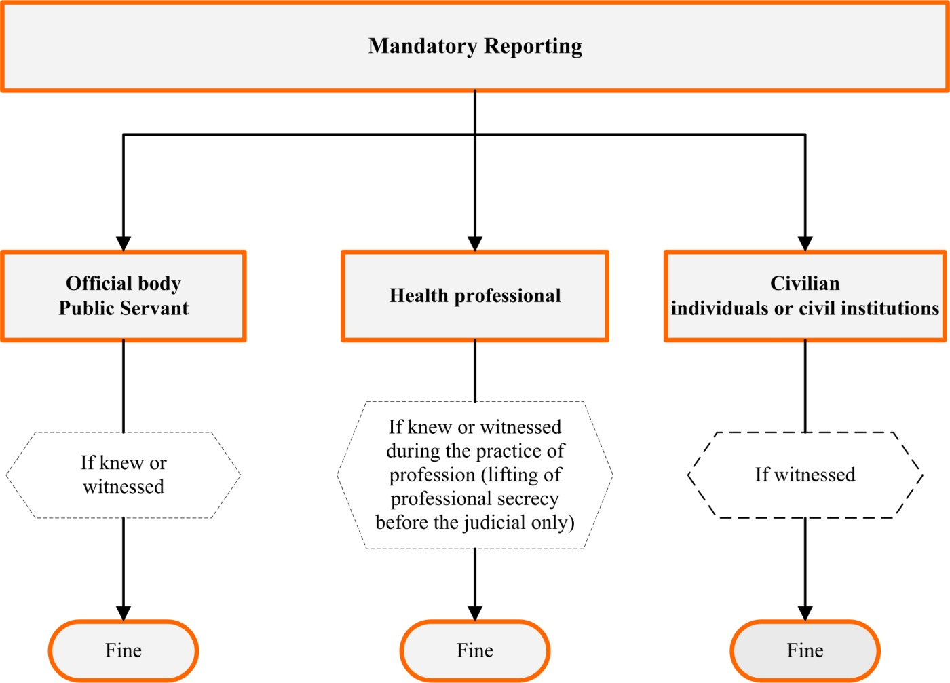

Diagram 6: Mandatory Reporting
Classification of reporting

Reporting is classified according to the ongoing circumstances as follows:

1) Emergency cases requiring immediate intervention according to Art. 26 of Law 422/2002

2) Non-emergency cases follow ordinary procedures

Processing the reporting

Upon receipt, the reporting is processed by legal authorities and in accordance with the adopted and determined track. Reporting is considered when there is proof of documented damage to the physical or psychological health or intellectual, emotional and social development of the juvenile. In such a case, judicial procedures shall be taken by the following authorities:
- Public Prosecution
- Juvenile court

Public Prosecution: The public prosecution receives notifications or reporting on the danger threatening the juvenile in order to assess the situation or request additional information. According to the initial investigation, Then the public prosecution can open a file on the case and initiate investigations through the judicial police which may require the following:
- Documenting the complaint and opening a special file on the case.
- A first hearing of the aggressor to interrogate him about the facts subject of the reporting or complaint.
- Hearing the juvenile himself/herself in the presence of the accredited social representative.
- Hearing suspects or arrest them.
- Ensuring the immediate protection of the juvenile.
- Gathering evidence.
- Conducting investigations through the judicial police or conducting a social investigation by the social representative.
- Hearing witnesses.
- Calling the forensic doctor when necessary
- Conducting technical inspection
- Requesting lab tests
- Referring the minutes to the public prosecution which shall send it to the juvenile court along with the report of the social representative if available.
- Inform the public prosecutor of the findings of preliminary investigations so as to take necessary legal actions.

The Juvenile judge, whether the reported file was sent by the public prosecution or any other source, can:
- Hear the juvenile and his/her parents or one of them or anyone who is useful to the case.
- Conduct investigations and verify facts.
- Commission the social representative of the NGO contracted by the Ministry of Justice to complete and verify the data through visits to the juvenile’s parents or social and educational environment in order to have an integrated point of view of facts or data that were behind the complaint or the reporting.
- Assign one of the institutions contracted by the Ministry of Justice to prepare a medical/psychological report in the event of lack of data or a need to confirm them.
- Find information with the help of judicial police.
- Take protection or probation or reformation measures when necessary.

The accredited social representative: The Social Representative is the person who is commissioned by the Juvenile court and belongs to one of the NGOs contracted by the Ministry of Justice and whose task is to accompany the juvenile during all stages of judicial procedures. He/She must be familiar with Law 422/2002 on the Protection of Juveniles and its enforcement mechanisms, and able to:
- Receive reporting and verify its seriousness and conduct additional social investigations i (see Appendix 2: Filing of the case of the juvenile upon receipt of reporting - notification)
- Assess the situation according to the adopted scientific standards
- Express his/her opinion and propose measures that can be taken
- Follow up and implement the protection plan
- Draft an intervention plan based on the protection plan and implement it or supervise its implementation.
- Review the case and its progress and inform the juvenile judge of the results in principle every 3 months (see Appendix 15: Sample of the Protection Measures Review)

Tasks of the body receiving the reporting:

The body charged with the reception of the reporting has to:
- Put the reporting in its legal framework
- Classify the reporting according to the juvenile’s circumstances
- Assess the reporting in terms of danger
- Conduct additional verification if necessary
- Open a case file upon receipt of the reporting (see Appendix 2: Filing of the case of the juvenile upon receipt of reporting - notification)
Note: In case the judiciary decides to keep the reporting, a mechanism in the juvenile court shall be developed so the reporting can be transferred to the Department of Juvenile Protection at the Ministry of Social Affairs, which coordinates with accredited social NGOs to assess the situation and conduct social/psychological therapy within a multi-disciplinary team if need be.

When the social representative accredited by the Ministry of Justice is unable to carry out the abovementioned tasks assigned to him (in terms of assisting the juvenile court), a cooperation mechanism approved by the Ministers of Justice and Social Affairs shall be developed to create an emergency unit with social workers under the Ministry of Social Affairs in order to assist the juvenile court, fill the gap in remote areas, attend the preliminary investigations and be available on Sundays, holidays and overnight in a periodic and paid manner. The Juvenile court judges shall be given a list of names to resort to when needed.

Reporting process

Reporting is considered when there is proof of documented damage to the physical or psychological health or intellectual, emotional and social development of the juvenile. In such a case, judicial procedures shall be taken taken by the following authorities: Public Prosecution, Juvenile court and judicial police. The process that the reporting follows can change according to the body receiving it (see Flowchart 7: Track of reporting in case of offence). Reporting does not reach the public prosecution and the juvenile judge except after a complaint including the facts is lodged by the Union for the Protection of Juveniles (Appendix 2).

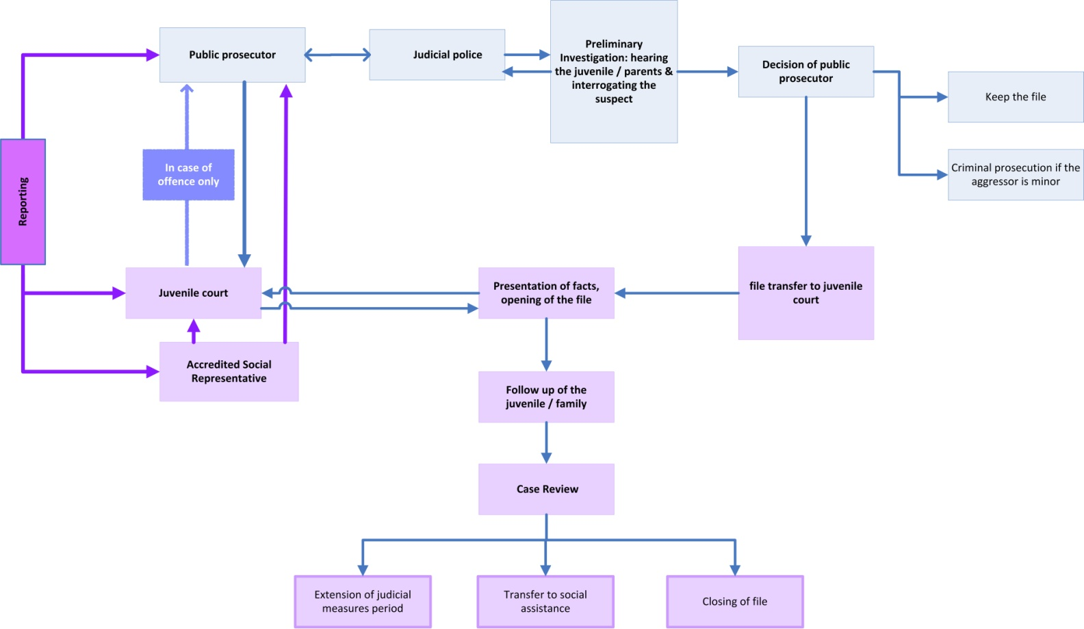
Diagram 7: Track of reporting in case of offence

The reception, processing and assessment of the reporting are technically as follows:

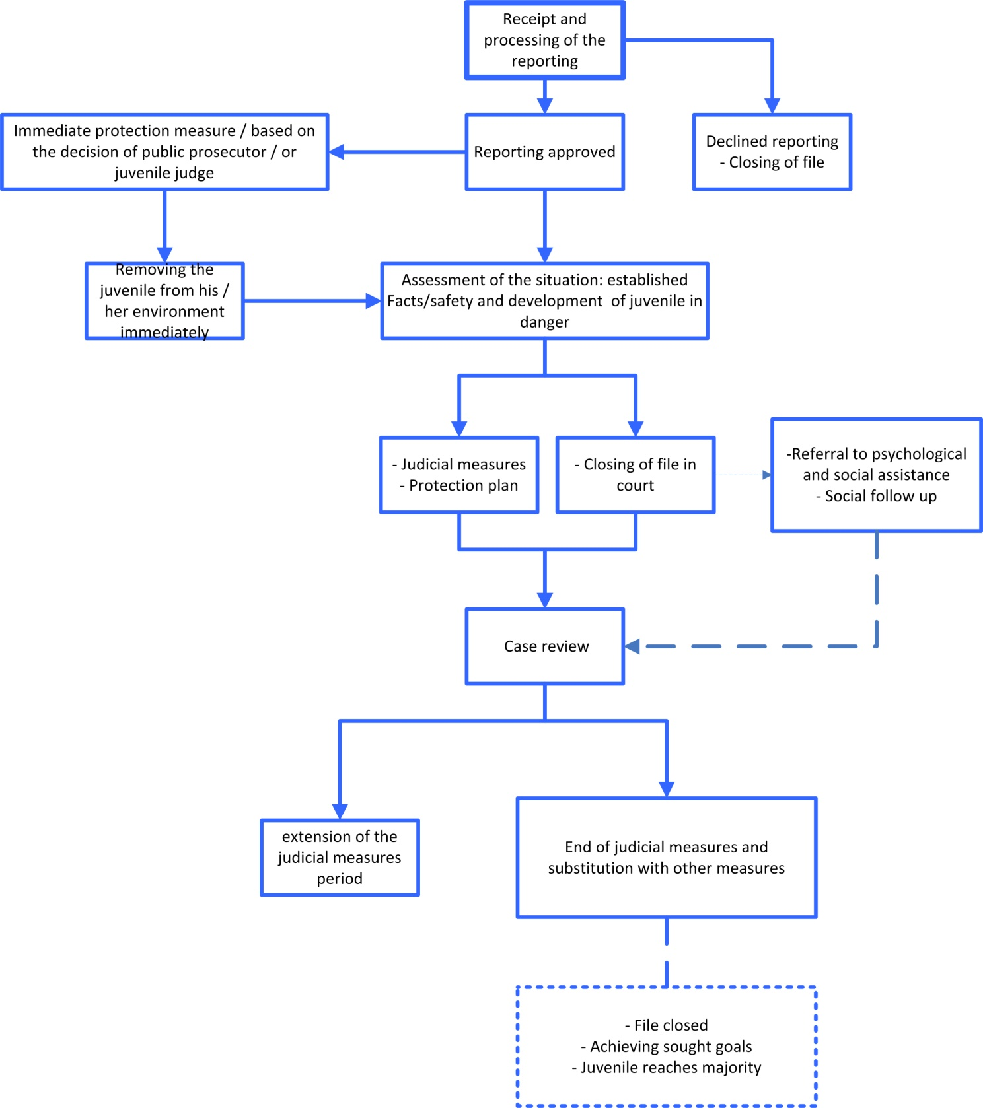
Diagram 8: Reception, processing & assessment of the reporting

Rights of the juvenile and his/her parents during the judicial measures

The juvenile and parents shall enjoy, during all stages of judicial measures, the following rights:
- The right of access to the subject of the protection file: The right to be accompanied/supported: the right to be accompanied and supported by the social representative or the psychologist assigned by the juvenile court for this purpose.

- The right to consult with the juvenile and his/her parents and involving them in all decisions that affect them, and working with them to implement these decisions and find appropriate solutions unless they are the source of danger.

- The right to know the course of protection and the measures taken if they do not constitute a danger for the juvenile.

- The right to hear the juvenile and his/her family and to express their opinion that will be taken into account, as well as to discuss all taken decisions.

- The right of access to quality services (health, psychological, legal & educational) that are suitable for the juvenile’s situation and specific needs.

Track of Non-judicial measures

Non-judicial measures are based on the concept of “the possible existence of danger” which can be practically translated into alarming facts or data. Non-judicial measures are preventive and corrective at the same time and aim at strengthening the capacities of parents and the juvenile together to avoid the occurrence of a particular risk or address the damage resulting from a previous danger through a consensual agreement with them.

The sooner the notification about alarming facts takes place (which warn of a danger on the safety and development of the juvenile), the less serious the consequences on the life of the juvenile are. Notification serves as a doorway to protect the juvenile from danger and help his/her parents.

Notifying about alarming facts

Notification or notice (non-judicial) is defined as any call received by the line authorities related to the Ministry of Social Affairs or the specialized NGOs accredited by the Ministry, the UNHCR and partners or anyone who holds data or facts of concern and believes that the safety and development of the juvenile may be threatened. Calls are divided into two types:
- Known
- Anonymous
Known call: Every call made by schools, public and private hospitals, public health institutions, social institutions or social & health centers, practicing professionals or other relevant authorities having a legal personality, or any individual who wishes to disclose his/her identity (could be the juvenile himself/herself, siblings, parents, relatives, neighbours, etc.).

Anonymous call: Every call made by a citizen who does not want to disclose his/her identity, and this is a right guaranteed by the law but only after making sure of his/her credibility and intentions. Accordingly, the notification or notice (non-judicial) shall be processed.

Reference departments to receive notification

First: The Juvenile protection department at the Ministry of Social Affairs and regional departments constitute the official References authorized to receive protection complaints in the governorates, per region, depending on the domicile of the juvenile. Accordingly, regional departments and centers take notice, proceed with the course of action and take necessary administrative-social actions as follows:

Juvenile Protection Department (2): Beirut Governorate- Mount Lebanon Governorate
North Department: North Governorate
South Department: South Governorate
Nabatieh Department: Nabatieh Governorate
Bekaa Department: Bekaa Governorate

Second: Specialized NGOs contracted by the Ministry to protect and rehabilitate juveniles and follow up and help parents.

Third: Specialized NGOs not contracted by the Ministry but having received official accreditation standards.

Since these specialized organizations play a role in non-judicial measures due to their specialized work, and while accomplishing their role, they might receive notification from various sources about cases requiring protection, (non-judicial or judicial). So in order to organize the non-judicial measures, the contracted organizations (under the contract signed with the Ministry) and the non contracted organizations, but associated with the Ministry through a cooperation agreement in the field of non-judicial measures, should submit periodic reports to the Ministry (six months) showing the number of notifications received as well as the results of follow-up and the adopted track so as to ensure for the Ministry the possibility of verification of the implementation of the procedures provided for in this document as well as the officially approved working tools.

Fourth: The Hotline Service In parallel to the abovementioned, anyone can call the hotline provided by the Ministry of Social Affairs to report information of concern specific to a certain juvenile whose situation requires non-judicial measures. It is noteworthy that the hotline is a mean to receive the notification and transfer it to the specialized entity for follow up. Sometimes the assessment of the case requires to report to the judiciary so legal necessary actions can be taken.

Fifth: UNHCR & partners: In order to avoid the emergence of a third track for refugees and displaced people that is incompatible with the contents and essence of Law 422-2002 , the Ministry of Social Affairs in collaboration with the Ministry of Justice try to establish a coordination mechanism to ensure that the juvenile is benefiting from the protection measures provided for in the above-mentioned law for every child on Lebanese territory within the two adopted tracks as per this document.
In order to reach an optimal system for the protection of children, whatever their nationality or legal status is, there is an urgent need to several measures that the Ministry of Social Affairs must take in order to ensure it accomplishes its role that is supposed to be as follows:

- The Ministry has to establish and start implementing a system of accreditation standards.
- Modify the contract signed between professional organizations working on the protection of vulnerable children and those working with battered mothers and their children & the Ministry so as it includes the above-mentioned periodic report.
- Enter into Cooperation agreements with specialized non-contracted organizations so as to guarantee the provision of these organizations of the above-mentioned report.
- The Minister of Social Affairs must issue a circular to NGOs non-specialized in the protection of juveniles and contracted with the Ministry and another circular to the staff working at the Ministry of Social Affairs and SDCs (Social Development Centers) whereby it shall be requested to transfer detected cases to the juvenile protection department at the central level, in Mount Lebanon governorate as well as the other five accredited departments to do the necessary.
- The Minister of Social Affairs must issue a circular to nominate coordinators of the Protection of Juveniles from SDCs and units with social workers.
- The adoption of a common mechanism linking non-judicial measures and judicial measures by taking a common decision with the Minister of Justice.

Classification of the notification
Every notification or notice on data of concern is automatically approved when received by the Juvenile Protection Service, the six centers of the Ministry of Social Affairs authorized to receive protection complaints, by the specialized accredited NGOs or by the UNHCR and partners. It shall be then classified and processed in accordance with the approved and specified track:
- Consultation
- Inquiry about the procedures and means of intervention, protection measures and related services
- Transfer the notification to the competent authority (reporting)

Tasks of the body receiving notification
The entity receiving the notification must:
- Identify the source of information of concern
- Classify reasons of the call
- Put the information of concern in a legal and social framework
- In case the notification indicates an existing danger, the call receiver shall inform the caller of the necessity of reporting.
- Provide legal, social and psychological advice or refer to specialized authorities.
- Provide answers or information that may be requested by the caller.
- Provide needed assistance
- Conduct additional verification of the information except in cases of sexual assault
- Prepare to visit and meet the parents
- Open a specific file for the juvenile (Appendix 2: Filing of the case of the juvenile upon receipt of reporting - notification)
- Automatic referral of the file to the entity in charge of assessing the case

The principles for taking non-judicial measures decision

The principles for taking non-judicial measures decision³ are:

The juvenile and his/her parents acknowledge or recognize the existence of danger and the need to put an end to it according to the following indicators:
- Recognizing and acknowledging the fundamental factors underlying the case of danger
- Recognizing that these factors indicate a pathological or problematic condition that with negative repercussions on the juvenile
- Finally acknowledging the need to put an end to this condition and vowing to prevent its recurrence.

Parents’ self-motivation: Parents show enthusiasm and commitment to the implementation of decisions aimed at changing the situation according to the following indicators:
- Actively participating during the assessment phase of the situation and the degree of risk
- Showing discomfort, restlessness and discontent of the current situation
- Recognizing the need for help to solve the problem
- Demonstrating the ability to listen in an objective manner to other points of view different from theirs
- Showing willingness to participate in the planning, programming and committing to solutions

Capacities and qualifications: Required Capabilities and qualifications are what enable the parents and the juvenile to commit to non-judicial measures in accordance with the following indicators:
- Ability to express and communicate approval in a free and informed way.
- Ability to observe some of the factors associated with the problem and the means to be adopted to solve the problem
- Previous initiatives to solve the problem
- Awareness of the magnitude of the efforts required to rectify the situation
- Willingness and sufficient qualifications to learn and acquire necessary skills
Equally, it is necessary to be aware of the constraints that might appear at the level of the parents and / or juvenile who:
- Have specific needs such as mental retardation, physical disability or psychological problems
- are addicted to drugs
- live in a criminal environment

______________________
Inspiré du guide du choix des régimes et des mesures 2010, Association des centres jeunesse du Québec.

Assessment

The assessment process governs all judicial and non-judicial tracks or choices, since it would result in taking a decision to determine whether the safety and development of the juvenile are threatened. Based on this decision, appropriate measures will be chosen. Assessment is a collective participatory process, hence any report, even if prepared individually by the appointed coordinator, should reflect the point of view of the multidisciplinary team and every professional in case the situation calls for his/her intervention.

Objectives of the assessment

- Diagnose the reality to find out if the juvenile is in an imminent or potential danger and its sources.
- Collect of accurate and complete facts as much as possible.
- Analyze the family and social status of the juvenile with regard to the level of the parents’ awareness of the problems faced by the juvenile.
- Analyze the capacity and resources of the family and their level of willingness to participate in the intervention plan.
- Estimate the nature and degree of risk faced by the juvenile and which forms the basis for the proposal of protection measures or networking with NGOs if the need arises, with the consent and participation of parents.

The body in charge of assessment

Assessment process may vary according to the body in charge and the objectives. The juvenile judge takes necessary or immediate protection measures in case of imminent danger. The representative of the Ministry of Social Affairs, the delegated comprehensive service centers or contracted specialized institutions and the UNHCR & partners shall use the voluntary and consensual nature as a reference in planning and coordinating the non-judicial measures or in referring the file to the juvenile court in order to take judicial measures if necessary (see Flowchart 9: Evaluation process of alarming facts).

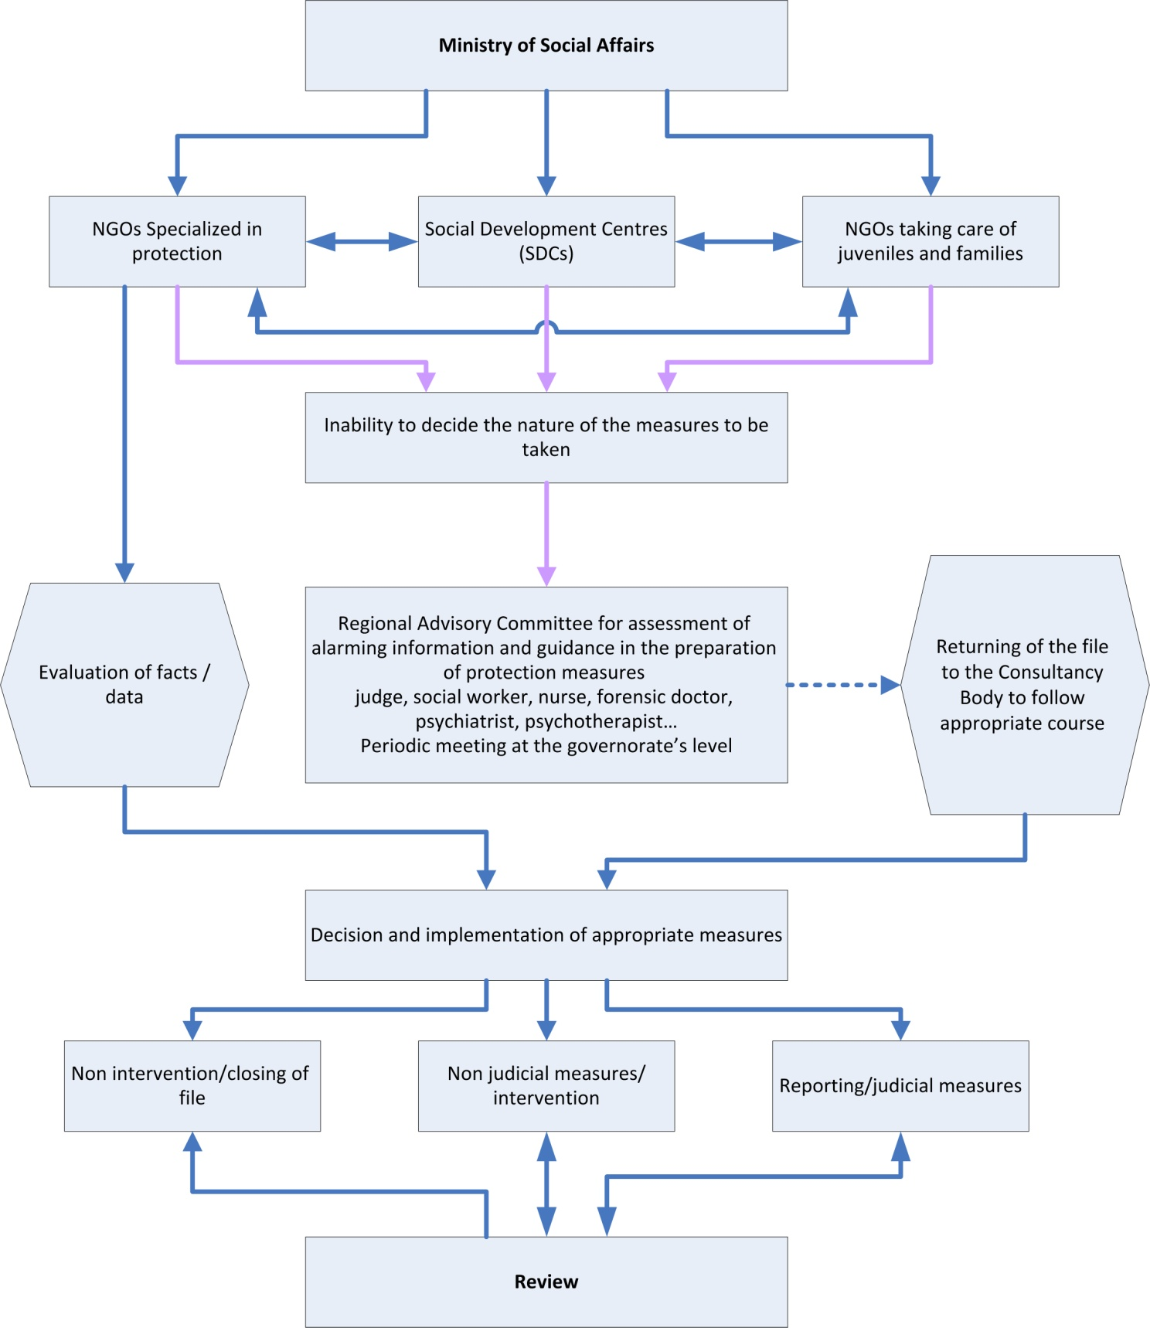
Diagram 9: Evaluation process of alarming facts
Clinical activities required from the person in charge of assessment

The above-mentioned objectives shall be achieved through concerted activities and multiple and specific sources as follows:

Checking the facts
- Meeting the parents and the juvenile
- Discussing with parents and family members
- Accurate and detailed description of the situation of the juvenile
- Monitoring or examining the juvenile in his/her familiar places of living
- Searching for useful facts within the social environment of the juvenile
- Note: In case of a family refusal, a judge’s intervention becomes necessary.
Analysis of the situation and living conditions of the juvenile
- Give a comprehensive description of the situation according to the four protection factors (see the elements of the decision of protection)
- Coordinate with the appropriate judicial and non-judicial (social and psychological) resources according to the situation and needs
- Willingness to participate in a expanded meeting with all professionals involved
- Comparison of the views of professionals from different disciplines and institutions by respecting the rules of confidentiality regarding the transfer and exchange of data
- The exchange of information between concerned specialists shall be limited to all that is necessary to protect the juvenile.
- Provide the parents and the juvenile (depending on age and maturity) in advance with available information unless the interest of the juvenile states otherwise.
- To discuss the proposal resulting from the assessment process and based on the intersection of data and views.
- Include the approved proposal in the assessment minutes and give an opinion about the danger to facilitate taking decision and to propose appropriate protection measures and attach it to the assessment report (Appendix 8: Assessment Report Drafting Sample)
- Inform the parents and the juvenile or the caller (if he/she was a professional) of the results.

All these above-mentioned activities are mentioned in the drafting of the final report (see Appendix 8: Assessment Report Drafting Sample)

Note: A coordinator for the protection project is appointed for each juvenile so he/she follows up with the juvenile at all stages, from assessment to review, in coordination with the specialists, provided that the number of files assigned to him/her does not exceed 20.

Preparation of the protection measures

The proposal of protection measures is based on two facts:

First, the level and size of the danger faced by the juvenile in addition to the family’s inability to confront the danger and the fact that non-judicial measures are impossible and insufficient. This would require resorting to judicial measures through the juvenile court.

Second, parents’ recognition of the scale of the problem and their willingness to assume their responsibilities, and therefore complete the transfer of the file to the track of non-judicial measures.

- In case it’s not possible to suggest the nature of the measures to be taken by the end of the assessment process, anyone can refer to the regional evaluation Committee (see Flowchart 9: Evaluation process of alarming facts) of the Ministry of Social Affairs in all governorates on condition that this entity has completed the drafting of the juvenile’s file in full. (See Appendix 8: Assessment Report Drafting Sample)

Regional Committee on the evaluation of alarming information and preparation of protection measures

It is a collection point at the local level to process and sort the alarming information concerning a juvenile in suspected condition with regard to an existing danger and it has not been possible to evaluate it nor to give an opinion on appropriate protection measures.

Its Task is to provide technical support to public and private institutions and to contribute to the preparation of the necessary protection measures by a multidisciplinary team in order to guide the file according to the degree of the detected danger.

Function and role:
• Contribute to the assessment of cases of juveniles at risk that could not be decided upon nor evaluated by social and social-health centers.
• Propose measures that help parents to assume their educational responsibilities.
• Provide Medical - psychological - social - legal consulting for professionals on mysterious or vague situations of risk.
• Guide professionals in the preparation of the protection measures to be implemented.
• Determine the nature of the alarming information that could constitute a penal offence and ensure reporting if needed.

Structure:
* Administrative unit: Its function is to receive and classify files.
* Technical Unit: Its function is to ensure periodic and permanent consultation (at judicial - psychological - educational - social levels). It’s headed by a judge and composed of a medical doctor, a psychiatrist, social workers, educators and all persons needed to be consulted ...
The Ministry of Social Affairs must develop a detailed reference framework which governs the establishment and work methodology of the unit so as to ensure the continuity of its existence and its success in achieving the desired objectives.

- Implementation of protection measures:

Protection measures are based on two types of plans:

The protection plan concerns only the judicial measures as it falls automatically from the court's decision and includes the general objectives to be achieved and mentioned, at a later stage, in an intervention plan that contains the specific objectives and operational means for the protection of the juvenile and the implementation of the judge's decision.

The intervention plan includes the judicial and non-judicial measures and is the only way to be followed in order to provide the juvenile with protection and help in coordination with his/her family and other resources. It also includes specific goals and operational means to protect the juveniles.

Main tasks of the entity preparing and implementing the protection plan:
- Develop the intervention plan based on reports or the results of the assessment (psychological, social, educational and judicial)
- Determine behaviors required from the juvenile at the level of autonomy, social and educational independence, skills to be developed, etc.
- Determine behaviors and changes required from parents
- Individual accompaniment for the juvenile
- Coordinate services to be provided to the juvenile if need be for the intervention of a larger number of institutions is involved in the protection of the juvenile
- Organize meetings on a regular basis for parents and juveniles to help them implement protective measures in order to remedy the current situation
- Follow up on cases that have been placed in alternative care institutions
- Draft a report on the status of the juvenile and work objectives (criteria to decide to place the juvenile in an alternative care institution [Appendix 10] )

These tasks shall vary between monitoring – accompaniment and assistance – accompaniment

Concerning the judicial files
The juvenile court social representative shall intervene as an observer to follow up on the case and ensure the implementation of the protection measures documented in the court’s decision.
-Continuous communication with the family and the juvenile and ensuring the safety of life standards
-Follow up on the case with institutions providing services, especially care institutions
-Assessing with the specialists the progress in the intended goals
-Review and reconsider the diagnosis when needed
-Ensure that protection measures are appropriate and ask to reconsider them when needed
-Consult the juvenile, parents and people involved
-Submit a report on the juvenile case review periodically to the competent judicial authority
-Discuss with the judge (consult the immediate supervisor)
-Follow up on measures taken after review
-Ensure the file is closed

Concerning the non-judicial files
The social worker at the Ministry of Social Affairs or any other social center shall provide non-judicial measures in centers related to and/or contracted by the Ministry. His/Her role shall consist of following up and helping the juvenile and his/her parents in providing protection and ensuring the situation does not aggravate.
-Continuous communication with the family and the juvenile and helping to ensure the safety of the juvenile
-Follow up the case with institutions providing services, especially care institutions
-Assessing with the specialists the progress in the intended goals
-Review and reconsider the diagnosis when needed
-Ensure that protection measures are appropriate or ask to reconsider them
-Consult the juvenile, parents and people involved

Review of protection measures

Review is the last stage in the course of protection. It is a corrective and not an administrative stage and aims at determining objectively the real situation of the juvenile through the implementation of judicial or non-judicial protection measures.

Review during the implementation of judicial protection measures is:
- Formal and legal
-A duty of the judicial authorities and social institutions
-A right for the juvenile
-A commitment by accredited social representatives

Objectives
- Evaluate the results of progress and modification in the protection
- Reconsider periodically and if necessary, the taken measures by initiative of the judge or as per the request of any person who has the right to access the file (Article 46)
-Help the judge to take the appropriate decision as for continuing the judicial protection measures or transferring the file to non-judicial Protection measures by mandate of the Court
Tasks of the social representative at this stage:
- find, along with specialists, the juvenile and parents, logical indicators that confirm the continuous presence of danger or vice versa.
- Submit a report on the juvenile case review periodically (to be specified by the judge) and discuss it with the judge (consult the immediate supervisor)
- Follow up the implementation of measures taken after review
- Ensure the file is closed

Review during the implementation of non-judicial measures

It is an operation that requires reviewing intervention plans and programs for every juvenile in case protection measures followed a non-judicial track. It includes:
- Find, along with specialists, the juvenile and parents, logical indicators that confirm the continuous presence of danger or vice versa
- Draft a report on the juvenile case review periodically (4 months) to discuss it with the interveners and the immediate supervisor
- Follow up the implementation of measures taken after review
- Ensure the file is closed or transferred to the judicial authorities when necessary

In both cases, the review is based on the following three factors:

Degree of recognition of the situation of danger

Capacity of the juvenile and the mother / father to participate in implementing protection measures

Actual commitment of the father / mother and the juvenile to the implementation of protection measures and showing willingness to cooperate

CHAPTER 3: Case management methodology
Case management methodology in the field of protection of juveniles is based on an organized approach of intervention that aims to find a solution to address the danger threatening the development and safety of the juvenile. Case management methodology follows a track composed of five stages that must be followed by the intervener regardless of his/her specialization, whether the case had judicial or non-judicial course. The graph below shows how each stage of the case management methodology has a specific goal and operational tools to ensure scientific rigor and operational correlation as demonstrated in the following flowchart (Flowchart 2: Case management methodology).
Chapter 3: Case management methodology
First Stage: Detection of the case & preliminary assessment
Second Stage: Assessment
Third & Fourth Stages: The Preparation and implementation of protection measures
Fifth Stage: The Review

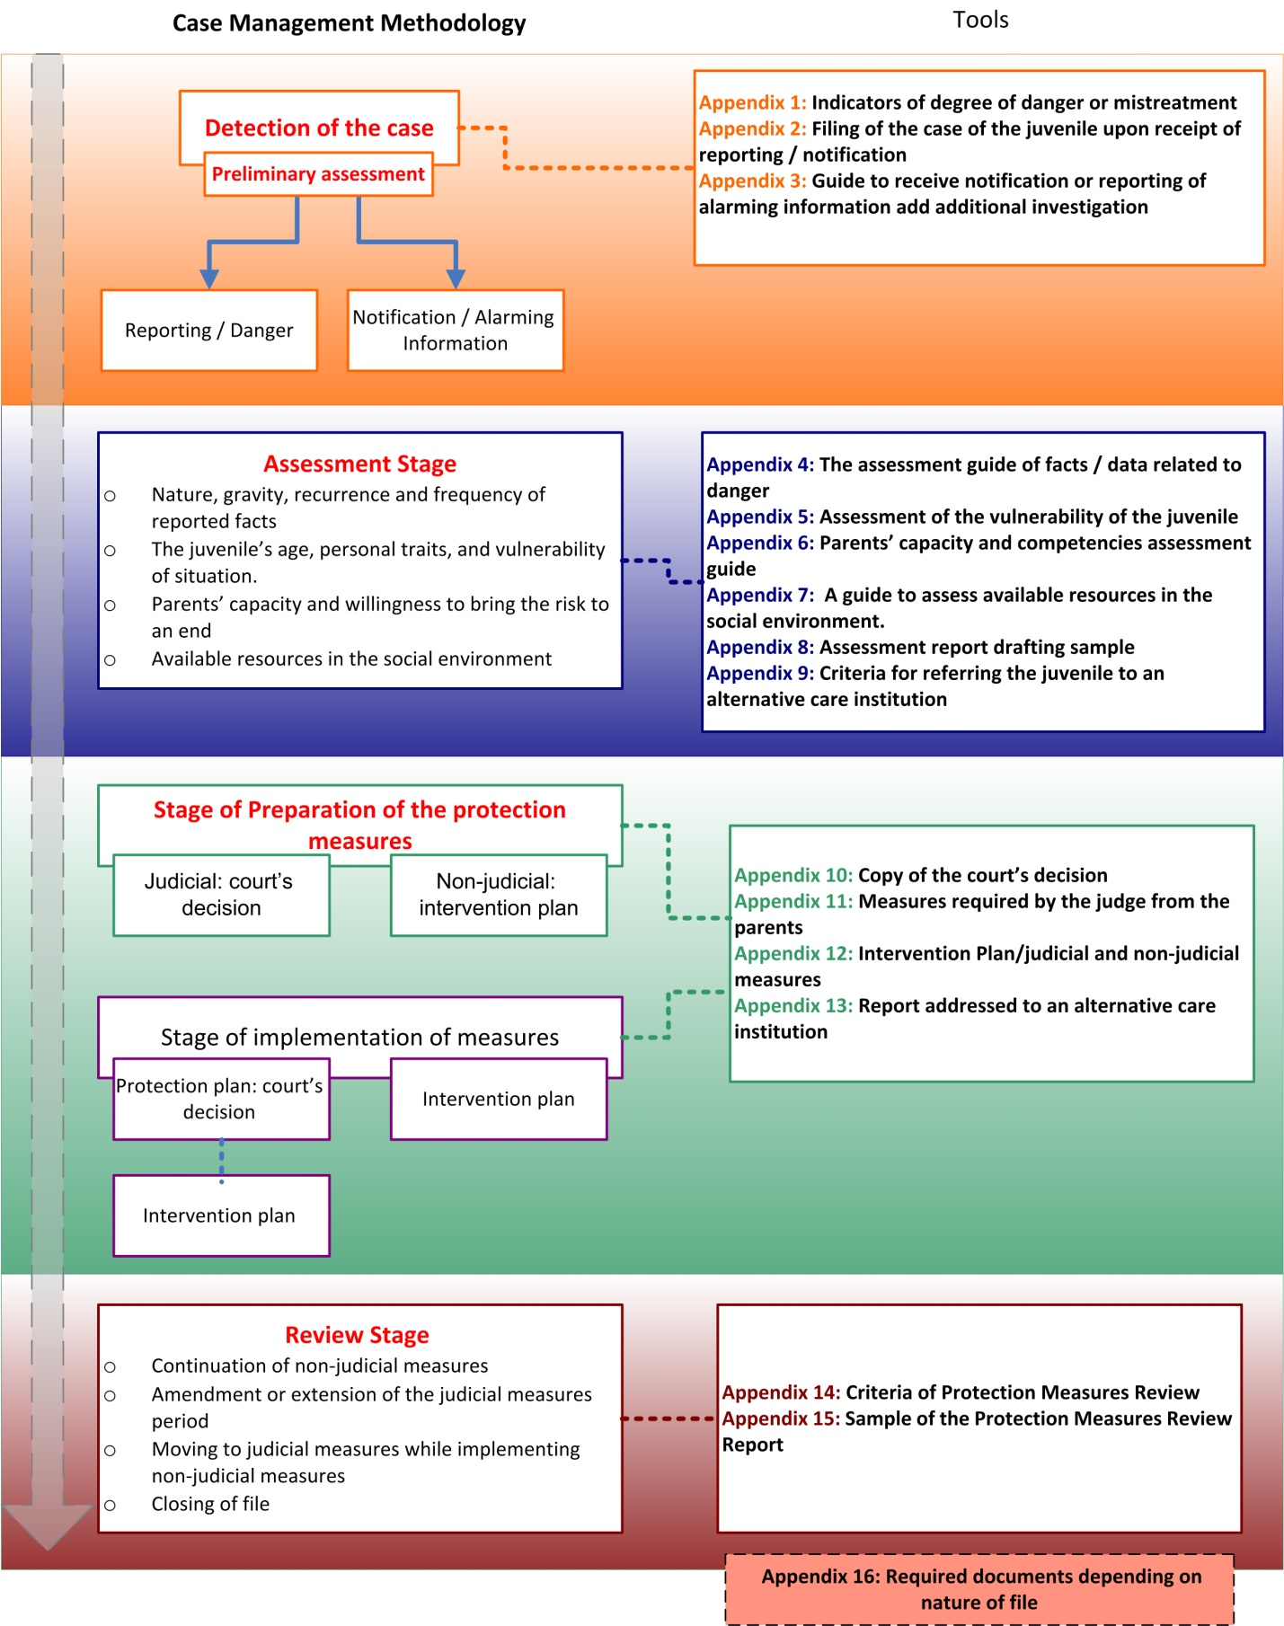
Flowchart 2: Case Management Methodology
- The first and second overlapping boxes, in orange, refer to the phase of case detection and preliminary assessment, which will lead to take the appropriate decision in case the safety and development of the juvenile are imminently threatened or not, and the initial decision on the measures to be taken to ensure the safety of the juvenile (by reporting or addressing the alarming information without existing worrying signs of danger). The opposite box directly linked to this stage, indicated with a dashed line, refers to the four operational and practical tools which help the intervener to identify the degree of danger and assess it in the required scientifically rigorous way and reduce discretionary or arbitrary decision-making.

- The third box, with dark blue color, refers to the assessment phase of the juvenile’s situation and conditions for the purpose of diagnosing the reality, checking facts and give an opinion according to the four elements mentioned in the box: the nature, the gravity and recurrence of the facts; age, personal traits and vulnerability of the situation of the juvenile; parents’ capacity and willingness to bring the risk to an end; available resources in the social environment of the juvenile and his/her parents. Since the assessment process is accurate and controls all the tracks and options whether judicial or non-judicial, and in order to facilitate requires clinical activities, the parallel dark blue box , connected directly with a dashed line, includes all operational and practical tools to help the person conducting the assessment to carry out a therapeutical analysis that could be a basis for decision-making according to accurate, detailed and correlated facts.

- The fourth box with a green color indicates the stage of preparation of protection measures, which pops up with two squares: one refers to the judicial measures and the other refers to non-judicial measures in a separate and semi- independent way.

- The court's decision constitutes a " plan/ framework for the protection” and contains the general objectives to be fully implemented. Accordingly an intervention plan is developed, automatically falling from the court's decision and including operational objectives for the implementation of protection measures in order to rectify the existing reality.
- In the case of a non-judicial course, an intervention plan shall be prepared on the psychological , social and educational levels for the juvenile, his/her family and the social environment surrounding him/her so as to help parents to assume their responsibility to eliminate the danger .

In both cases and in order to facilitate the preparation of the intervention plan that incorporates objectives formulated in the form of desired results in addition to the means to be adopted, the parallel green box connected directly with a dashed line combines all operational and practical tools to help the intervener to prepare operational plans that aim to involve the parents and the juvenile as well in the preparation process.

- The fifth box in violet refers to the stage of implementation of the plan that has been prepared and followed-up in order to remove the danger threatening the juvenile. This phase emerges automatically from the stage that preceded it.
- The sixth and last box in red-brick symbolizes the review stage which allows to reconsider periodically the status of each juvenile who has undergone judicial or non-judicial measures. This box includes the options that could be adopted as follows:
• Continuation of the non-judicial protection measures;
• Extension or amendment of the period of judicial measures;
• Transfer to judicial measures while implementing the non- judicial measures;
• Placing the juvenile in an alternative care institution.
The parallel red-brick box refers to the operational tools that must be based upon for an objective assessment of the real situation of the juvenile and the stages of development so as the therapeutical review phase be objective and useful.

First Stage: Detection of the case & preliminary assessment

The phase of case detection concerns every person, whether professional or not, who has doubts or information which make him/her believe that there is a juvenile exposed to danger. In such a case, this person has to report to the judicial authorities or the Ministry of Social Affairs and NGOs so they can take an initial decision on measures to be taken according to the nature of the danger and the two adopted tracks emanating from Law 422/2002 (on Protection of juveniles in conflict with law and exposed to danger) in the Lebanese system.

Judicial measures

Receipt of the reporting
Reporting is exclusively received by the following judicial authorities:
- Public Prosecution
- The Juvenile Court (the juvenile judge or the social representative to the court)
- Judicial Police

Then the reporting is processed and appropriate protection measures chosen pursuant to a decision that determines the nature of the danger that threatens the safety and development of the juvenile.

Note: Non-judicial authorities are only involved in assessment and consultation upon the request of the juvenile judge.

Identifying the source of the reporting

- A citizen:
- The person to whom the juvenile resorted.
- Any person who knows about the situation of the juvenile.
- Any person who has logical data indicating that the juvenile is in danger.
- The parents or guardians of the juvenile / or the juvenile himself/herself.

- Entities with legal personality:
- Civil society organizations and private sector institutions that deal with juveniles
- Social-health centers
- Schools and nurseries
- Professionals & specialists

- Hospitals: physicians, nurses.... etc.
- Public institutions or public servants.

Legal characteristics of the reporting

The reporting shall be according to the legal characteristics provided for in Article 25 of Chapter 3 of Law 422/2002.

The safety and security of the juvenile are considered at risk in the following cases:
- If the juvenile was found in an environment exposing him/her to exploitation, threatening his/her health, safety, ethics or upbringing.
- If the juvenile suffered sexual abuse or physical violence exceeding the limits of what is allowed by custom as a method of harmless disciplining.
- If the juvenile was found begging or homeless.

(See Appendix 1: Indicators of degree of danger or mistreatment)

Required behavior upon receipt of the reporting
  - Refrain from insisting to obtain the caller’s name unless he/she is a professional or specialist.
  - Inform the caller that if he/she reveals his/her identity, he/she may be asked to witness before the judge in the absence of the juvenile and his/her parents.
  - Guarantee to the caller that his/her identity shall not be disclosed to the family under any circumstances, and reassure him/her that the law guarantees the confidentiality of both the reporting and the identity of the reporter, in the same way as it guarantees the confidentiality of post-reporting services provided for the juvenile and his/her parents.
  - Obtaining information from the caller about every action or solution that any of the parents took or adopted.
  - Inquiring about the address and phone number of the juvenile or his/her parents.
  - Focusing on tangible and concrete facts that indicate the gravity of the reported danger instead of emphasizing fears and concerns only (See Appendix 3: Guide to receive notification or reporting of alarming information and additional investigation).

Evaluation and credibility of the reporting
Every reporting should take the following into consideration:
- The nature of the reported facts in terms of tangibility and concreteness.
- The motive behind reporting.
- The relationship with the juvenile and his/her parents: neighbour, friend or member of the family.
- The relationship between the victim and the aggressor.

The decision on Approving or keeping the report
A report is approved or kept in the case of an offence or danger so as Judicial procedures are taken according to the following authorities: Public Prosecution Office and the Juvenile Court.

Tasks upon receiving the reporting:
- Transferring the file to the Juvenile Court
- Opening a file for the juvenile (see Appendix 2: Filing of the case of the Juvenile upon receipt of reporting / notification)
- Investigating the factors that made up the reporting
- Discussing the reported facts or data
- Ensuring the file shall be kept (for lack of sufficient evidence) eventhough the reporting can be saved for a maximum period of two years if the file is closed and five years in case of referral to the judicial measures.

Additional investigation
In case of lack of information, the public prosecutor shall assign the social representative of the organization contracted by the Ministry of Justice, to do the following:
- Conduct additional investigation (social investigation)
- Visit the house without prior notice.
- Verify the facts mentioned in the reporting.
- Notify the parents of the reporting without disclosing the identity of the reporter under any circumstances.
Based on the data collected from the various sources, a report shall be drafted on the situation of the juvenile. In the light of this report, the Public Prosecution may take the following appropriate measures in order to:
- Ensure the safety of the juvenile
- Initiate criminal prosecution against the aggressor
- Order the placement of the juvenile in an alternative care institution and inform the Juvenile Judge thereof at a later stage.
- Resort to reconciliation with parents within a specific timeframe that the judge can interrupt to take appropriate measures if the results indicate the persistence of the danger that is threatening the juvenile.
- Keep the file, i.e. closing it judicially for lack of evidence.
See Appendix 3: Guide to receive notification or reporting of alarming information and additional investigation
See Appendix 2: Filing of the case of the juvenile upon receipt of reporting / notification

Non-judicial measures
It is possible that the declared facts warn of the incidence of a danger, however they require protection measures and fast assessment of the situation and intervention (especially for very young juveniles). To protect the juvenile, these cases require non-judicial measures which are officially related to the Ministry of Social Affairs by virtue of Law 422/2002 that encourages the handling of such issues within the scope of the parents who can assume their responsibility to protect the juvenile.
Non-judicial measures are based on the concept of “the likelihood of the danger” or “alarming information”, and are mainly aimed at strengthening the capacities of the parents and the juvenile to prevent a certain danger or address the damages resulting from the juvenile’s exposure to a previous danger.

Receiving the alarming information/ notification
A notification is any call conveying alarming information received by:
- The Juvenile Protection Department at the Ministry of Social Affairs, the five accredited regional centers and the hotline.
- NGOs not contracted with the ministry
- Social-health centers
Those institutions are responsible for:
- Collecting, processing and evaluating alarming information related to a juvenile at risk.
- Completing the adopted track and proceed to the judicial or non-judicial measures
- Providing advice on any legal, social or psychological issue... etc.
- Providing answers when needed.
- Referring the case to the competent body including the regional assessment committee

Identifying the source of the notification
Contacts may be made through the phone or any other means of communication to report alarming information that threatens the safety and development of a juvenile. Notification can be carried out by:

- A citizen:
- The person to whom the juvenile resorted.
- Any person who knows about the situation of the juvenile.
- Any person who has logical data indicating that the juvenile is in danger.
- The parents or guardians of the juvenile / or the juvenile himself/herself.

- Entities with legal personality:
- Civil society organizations that deal with juveniles
- Social-health centers
- Schools and nurseries
- Professionals & specialists

- Hospitals: physicians, nurses.... etc.
- Public institutions or public servants.

Legal and social characteristics of the alarming information
The safety and development of a juvenile are considered at risk when there are doubts anchored in the concept of “likelihood of risk” and aimed at strengthening the capacities of the parents and the juvenile to prevent a certain danger or address the damages resulting from the juvenile’s exposure to a previous danger.
Alarming information paves the way for the protection of the juvenile. That’s why the said information should be classified according to the ongoing circumstances and as follows:

- Urgent cases that require immediate reporting
- Non-urgent cases based on alarming information that indicate the likelihood of a danger threatening the safety and development of the juvenile.
- Cases of aggression against a juvenile but the danger has ceased and the damages need to be addressed in the framework of the non-judicial measures.

Note: The mentioned centers/departments should not keep for themselves the data related to offences or sexual aggressions. Actually they must inform the Public Prosecution or refer to the regional assessment committee to help in taking the decision.

In order to determine the degree of danger, refer to Appendix 1: “Indicators of degree of danger or mistreatment”

Classification of the motives behind the notification
The call receiver should help the caller specify the aim of the call which can be one of the following:

- Seeking advice
- Seeking information about procedures and means of intervention, protection and the related services that are provided.
- Requesting to start helping the juvenile and his/her parents.
- Authorizing the reporting of a case

The required behavior upon receipt of alarming information
- Refrain from insisting to obtain the caller’s name unless he/she is a professional or specialist.

- Obtaining information about every action or solution that the parents used or made in the context of the risk.
- Obtaining information from the caller about every action or solution that any of the parents took or adopted.
- Inquiring about the address or any other details that are help to reach the juvenile and his/her parents (school, neighbourhood...etc.).
- Focusing on tangible and concrete facts that indicate the degree of the reported danger instead of emphasizing fears and concerns only.
- Verifying the existence of a judicial or non-judicial file of the family or the juvenile. If yes, where and since when?
- Informing the caller of the possibility of reporting the case.
- Inform the caller that if he/she reveals his/her identity, he/she may be asked to witness before the judge in the absence of the juvenile and his/her parents.

- Guarantee to the caller that his/her identity shall not be disclosed to the family under any circumstances, and reassure him/her that the law guarantees the confidentiality of both the reporting and the identity of the reporter.

- Open a file for the juvenile: Appendix 2: Filing of the case of the juvenile ipon receipt of reporting / notification

Additional investigation
If the data was found confusing or mysterious and impossible to be verified, an additional investigation procedure is carried out through a field visit to the family in order to check the alarming information (with the exception of sexual aggression cases).
Note: When the family refuses, a judicial intervention becomes necessary.
This process takes place as follows:

- Preparing for a visit or meeting with the parents

- Develop a plan on how to approach the family without causing any additional danger or burden to the juvenile already at risk.

- Communicating with the juvenile and the parents and, if possible, trying to engage them in the analysis and understanding of the alarming information and trying to figure out the way they deal with the notification and understand it and its contents.

- III. Contacting the professionals who are aware of the situation of the juvenile to obtain
additional information but further to notifying the parents in advance in order to prevent any
possible conflict with the juvenile’s interest. This exchange must be limited however to all
what is necessary to fulfill the task of protecting the juvenile.

- Informing the parents and the juvenile in advance of the shared information, unless the interest of the juvenile otherwise requires.

Based on the data collected from various sources, the drafting of the preliminary report is completed (Appendix 2: Filing of the case of the juvenile upon receipt of reporting / notification). Thus the nature of the danger is clarified so the file can be transferred to the judicial authorities for immediate protection of the juvenile or in order to continue the assessment phase.

Appendix 3: Guide to receive notification or reporting of alraming information and additional investigation

Second Stage: Assessment
- Assessment governs all tracks or options –whether judicial or non-judicial- that lead to the decision acknowledging whether or not the safety and development of the juvenile are threatened, and to the selection of the appropriate protection measures accordingly.
- The assessment stage starts after processing the notification or the reporting
- And continues until a protection decision is made (within a maximum period of three months, unless the case is an emergency).

The assessment principle vary depending on the evaluating agent.
The court-commissioned agent focuses on the mandatory legal aspect as a basis for fact-finding and taking appropriate or immediate protection measures according to the nature of the danger.

The Ministry of Social Affairs’ representative or commissioned SDCs, contracted specialized institutions or other civil institutions focus on the voluntary and consensual aspect as a basis for assessing the case and proceeding with the protection process according to the nature of the assessed danger.

Assessment is a participatory collective process.
It should reflect the standpoints of :
- The multidisciplinary group
- The parents who are involved participate in the analysis of data unless they constitute a source of additional danger to the juvenile.
- The juvenile depending on his/her age.
- The aim is a deeper understanding of the juvenile’s status and living conditions.

Objectives of the Assessment stage
Diagnosis of the situation to verify whether the juvenile is facing a real or potential danger, and if so, identify the sources of the danger.
Analysis of the family and social status of the juvenile taking into consideration the parents’ awareness of the problems faced by the juvenile.
Estimation of the nature and degree of the danger faced by the juvenile and which constitutes the basis for suggesting protection measures.
Networking with civil society organizations when need be, with the parents’ approval and participation.

Components of the assessment and the protection
- Nature, gravity and frequency of reported facts (see Appendix 4: The Assessment Guide of facts/data related to danger)
- Age, personal traits and vulnerability of the juvenile (see Appendix 5: Assessment of the vulnerability of the juvenile)
- Parents’ capacity and willingness to bring and end to all what threatens the safety or development of the juvenile (see Appendix 6: Parents’ capacity and competencies assessment guide)
- Resources available in the social context and which may help the juvenile and his/her parents (see Appendix 7: Guide to assess available resources in the social environment)

The assessment process is programmed according to three steps:
1- Description of the case of danger based on existing facts
2- Clinical Analysis of the situation
3- Giving opinion on the danger and proposing necessary protection measures
This phase shall end in drafting a report (Appendix 8: Assessment report drafting sample) and rely on the following Appendixes:
Appendix 4: The Assessment Guide of facts/data related to danger
Appendix 5: Assessment of the vulnerability of the juvenile
Appendix 6: Parents’ capacity and competencies assessment guide
Appendix 7: Guide to assess available resources in the social environment

Description of the case of the danger by collecting existing facts (or existed already) and only listing them accurately and objectively without any analysis.
Meeting with the parents and the juvenile in the environment where they live and trying to gain their trust and build a good relationship with them.
Communicating with the parents and members of the family to know the extent of attention given to the juvenile, understand the educational approach used in the family and verify the accuracy, objectivity and consistency of the facts reported about those persons (without taking a form of interrogation).
Establishing an accurate and detailed description of the status of the juvenile in order to know the opinion of each and every family member, including the juvenile, concerning basic development needs (physical, psychological, mental, social, in addition to health and safety) and the nature of the juvenile’s relationship with his/her parents and the parents’ ability to commit to the juvenile’s protection plan, in addition to the family and background situation affecting the safety and development of the juvenile.
Monitoring or observing the juvenile in his/her familiar living places by accurately registering his/her statements (informing the juvenile that part of his/her statements will be used to protect him/her). The statements shall be reported verbatim along with an indication of the reasons of their disclosure. When statements are conveyed by a third party, the name of the conveyor shall be mentioned in the report, in addition to the reasons of such disclosure, provided that the conveyor transmits the statements of the juvenile faithfully using the juvenile’s own wording.
Searching for pertinent and relevant facts through the social environment or professionals/specialists who are in constant contact with the juvenile and his/her family, after notification of the parents and due consideration of the best interest of the juvenile.
In case obvious signs of violence are seen on the body of the juvenile, it is imperative to document the case with a forensic doctor’s report.

Clinical Analysis of the situation
- The clinical analysis of the status of the juvenile and the circumstances of his/her living take the form of a linking process of the most important existing facts that were listed with the reasons leading to them in order to show the extent of their impact on the safety and development of the juvenile.
- The analysis includes explanation of fears and obsessions of the intervener, that he/she has to build in accordance with the sensory and accurate indicators mentioned above.
- The analysis is carried out by comparing the opinions of professionals of different disciplines and respecting the requirements of confidentiality when transmitting and exchanging data.

- The estimation of the gravity of the situation relies on the dynamic analysis of the following four elements:
- The nature, gravity and recurrence of the factors and reported facts.
- The age, personal traits and vulnerability of the minor.
- The parents’ capacity and willingness to end any danger that threatens the safety and development of the juvenile.
- The resources that are available in the social environment and that can help the juvenile and his/her parents.

Providing an opinion about the danger
The end of the assessment stage is based on one of the following facts:
First, the documented facts that are still available and indicate that the safety and development of the juvenile are threatened by a danger from within the house, and that this danger still exists.
Second, the documented and currently non-existing facts which indicate that the safety and development of the juvenile were threatened in the past and that the resulting damages should be addressed.
Third, no danger threatening the safety and development of the juvenile.
- Only judicial authorities are entitled to validate the first fact; therefore, it is imperative to report when the assessment agent is not commissioned by the court.
Based on the reports of the concerned professionals, appropriate measures for the protection of the juvenile are suggested:
In the judicial files, such as:
- Not intervening and keeping the file.
- Continuing or modifying the judicial measures, including addressing the status quo or placing the juvenile in an alternative care institution.
- Through the judge, obtaining a commitment from the parents to immediately stop any type of danger, identify the methods to be followed to correct the status quo (resorting to the hospital, refraining from meeting specific people...) including the request of social accompanying from any specialized and contracted institution if need be.

In the non-judicial files, such as:
- Suggesting the appropriate measures for the protection of the juvenile and the means for assisting the parents in coordination with the concerned institutions to provide protection.
- Referring the case file to the Juvenile Court to take the necessary legal action.
- Non intervention
Note: When it is necessary to suggest placing the juvenile in an alternative care institution, a special report shall be drafted (Appendix 9: Criteria of referring the juvenile to an alternative care institution & Appendix 13: Report addressed to an alternative care institution)

Drafting the assessment report
At the end of the assessment process, a joint report shall be drafted based on the reports of the concerned multi-disciplinary professionals. The report should clearly state the opinion of each of these professionals in order to give an overarching representation of the case.
The assessment should also be participatory and include all members of the family, especially with families who had previously contributed efficiently to the assessment process (unless in the exceptional cases such as sexual abuse).
[see Appendix 8: Assessment report drafting sample]
Discussing the Suggested Protection in a joint meeting to discuss the cross-cutting data and opinions of professionals. The selected suggestion is indicated in the assessment minutes and attached to the report.

Main Appendixes in the assessment stage are:

Appendix 1: Indicators of degree of danger or mistreatment

Appendix 4: The assessment guide of facts / data related to danger

Appendix 5: Assessment of the vulnerability of the juvenile

Appendix 6: Parents capacity and competencies assessment guide

Appendix 7: A guide to assess available resources in the social environment

Appendix 8: Assessment report drafting sample

Appendix 9: Criteria of referring the juvenile to an alternative care institution

Appendix 13: Report addressed to an alternative care institution

Third and Fourth Stages: The Preparation and Implementation of protection measures

The Juvenile Protection representative from the Ministry of Justice shall follow up on the implementation of judicial measures decided by the Juvenile court.

The representative of the Ministry of Social Affairs or of any other social center seeks to provide help to put end to danger and protect the juvenile through non-judicial measures.

The preparation and implementation of the measures are based on two kinds of plans according to the type of the adopted track and the decided measures.

- Protection plan - intervention plan: judicial measures
- Intervention plan: non-judicial measures

The protection plan concerns only the judicial measures as it falls automatically from the court's decision and includes the general objectives to be achieved and that shall be reflected, at a later stage, in an intervention plan which includes specific objectives and operational means for the protection of the juvenile and the implementation of the judge's decision. It is the responsibility of the juvenile protection representative who will draft the intervention plan and follow up the implementation of judicial measures with the judge in juvenile court.

The intervention plan concerns judicial and non-judicial measures at the same time. It is the individual way that should be followed to ensure the protection of the juvenile and help him/her in coordination with his/her family and other resources, and includes specific goals and operational means to protect the juvenile.
The intervention plan is about an action plan that aims at:
      - Providing a better protection for the juvenile.
      - Ending the state of danger and seeking to prevent its recurrence.
      - Implement the adopted protection measures.

Characteristics of the Plan
The intervention Plan that covers psychological, social and educational dimensions involves the juvenile, his/her parents and the surrounding social context (schools, health centers, specialized centers.....etc). It helps the parents in carrying out their responsibilities with regard to protecting their child from danger.
The Plan includes the following:
- A description of the facts that threaten the safety and development of the juvenile and which are approved by the parents and the juvenile.
- An identification of the behaviors required from the juvenile in terms of autonomy, social and educational independence, and the skills to be developed.... etc.
- An identification of the behaviors and changes required from the parents to remedy the relationship between them and the juvenile.
- The coordination of the juvenile-related services where the intervention of a larger number of juvenile protection institutions is needed.
- The formulation of goals as desired results directly and exclusively linked to the protection of the juvenile against danger.
- A detailed listing of the means that the parents and the juvenile are supposed to use and commit to or activate to protect the juvenile against danger.
- Achieving concrete desired results within a time-scheduled specific plan of action.

Appendix 12: Intervention Plan/judicial and non-judicial measures

Fifth Stage: The Review
- The review is an official and legal mechanism that consists of the the reconsideration, every 3 months in principle, of the state of all juveniles. It allows juveniles to benefit from protection services by virtue of Law 422/2002.
- The review is a mechanism that allows the reconsideration of the state of every juvenile and allows him/her to benefit from non-judicial services from any public or private social specialized or non-specialized center.

Objectives of the Review
The review leads to one of the following options:
- Continuation of the non-judicial measures
- Transfer to judicial measures while implementing non-judicial measures
- Extension or amendment of the judicial measures period
- Closing of the file
Every option is subject to specific and precise considerations and criteria. (Appendix 14: Criteria of protection measures review)

Components of the Review
Opting for the continuation of the judicial or non-judicial measures is based on specific criteria including the search for logical indicators that prove the persistence of the danger or otherwise. In both cases, the review stands on the three following factors:
The degree of acknowledgement of the state of danger by the parents
The capacities of the juvenile and his/her mother/father to take part in the implementation of protection measures
The effective commitment of the father/mother and the juvenile to the implementation of the protection measures and willingness to cooperate.
(See Appendix 14: Criteria of Protection measures review)

Drafting Review Reports
In the judicial measures, the Social Representative commissioned by the Ministry of Justice shall submit quarterly reports to the Juvenile Court, whereby he/she explains the progress or regression of the protection of the juvenile.
In the non-judicial measures, the Social Representative commissioned by the Ministry of Social Affairs or any other organization, shall submit, every 4 months, reports whereby he/she explains the improvement and progress of the situation regarding the existence of danger.
If the review phase showed a decline in the status of the juvenile in terms of development and safety or failure of the parents to respond and put an end to the detected danger, the social representative in charge shall have to propose the referral to the judicial track.

(see Appendix 15: Sample of the Protection Measures Review Report)

Appendix 14: Criteria of Protection measures review

Appendix 15: Sample of the Protection Measures Review Report

Chapter 4: Operational Tools of every stage:
Appendix 1: Indicators of the Degree of danger or mistreatment
Appendix 2: Filing of the case of the juvenile upon receipt of reporting / notification
Appendix 3: Guide to receive notification or reporting of alarming information and additional
investigation
Appendix 4 : The Assessment Guide of facts/data related to the danger
Appendix 5 : Assessment of the vulnerability of the juvenile
Appendix 6 : Parents capacity and competencies assessment guide
Appendix 7 : A guide to assess available resources in the social environment
Appendix 8 : Assessment Report Drafting Sample
Appendix 9 : Criteria for referring the juvenile to an alternative care institution

Appendix 10: Protection plan –the Court’s decision according to the case: NOT AVAILABLE)
Appendix 11: Measures required by the judge from the parents
Appendix 12: Intervention Plan/judicial and non-judicial measures
Appendix 13: Report addressed to an alternative care institution
Appendix 14: Criteria of Protection Measures Review
Appendix 15: Sample of the Protection Measures Review Report
Appendix 16: Required documents depending on nature of file
(judicial or non-judicial)
(All appendixes are in the SOP Operational Tools folder).

Alföldi Francis (2010) évaluer en protection de l’enfance : théorie et méthode DUNOD : 141

