Annex A: Technical Specification to UKRKI / RFQ / 2024-021
for one-off procurement of household appliances.

The United Nations High Commissioner for Refugees in Ukraine invites qualified suppliers of goods to submit their proposals for one-off procurement of household appliances, in accordance with the technical specification.

Item | Photo | Minimum Requirements | Estimated Quantity
Dishwasher | 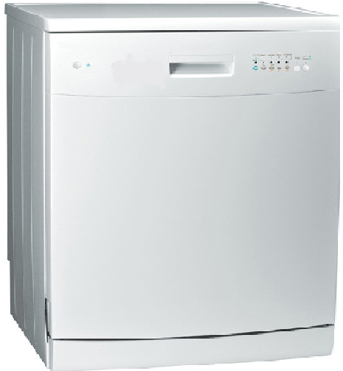 | - Min 5 programs  - Capacity:12 place setting  - 1800-2100 Watt  DIMENSIONS: (±%10)  - Depth: 60.0 cm  - Width: 59.8 cm  - Height: 85.0 cm | 15

