Annex A - Technical Specifications
The goods and services are to be provided in Kyiv, Vinnytsia, Chernivtsi, Odesa, Kharkiv, Dnipro, Uzhhorod and Lviv (8 locations).

1. Bottled Drinking Water 18.9 L
1.1. Product Quality Requirements:
• The bottled water, subject to deep purification, extracted from underground drinking water sources, should have the following primary physical and chemical characteristics:
No. | Indicator | Unit of Measurement | Standards
 | Hydrogen index | pH | 6,5-8,5
 | Total iron | mg/dm³ | ≤ 0,2
 | Total hardness | mmol/dm³ | ≤ 7,0
 | Total alkalinity | mmol/dm³ | ≤ 6,5
 | Iodine | mg/dm³ | ≤ 50
 | Calcium | mg/dm³ | ≤ 130
 | Magnesium | mg/dm³ | ≤ 80
 | Manganese | mg/dm³ | 2 - 20
 | Copper | mg/dm³ | ≤ 1,0
 | Polyphosphates (by PO4-3-) | mg/dm³ | ≤ 0,6 (3,5)3
 | Sulfates | mg/dm³ | ≤ 250
 | Dry residue | mg/dm³ | ≤ 1000
 | Residual free chlorine | mg/dm³ | ≤ 0,05
 | Chlorides | mg/dm³ | ≤ 250
 | Zinc | mg/dm³ | ≤ 1,0
 | Residual bound chlorine | mg/dm³ | < 0,05

• The water quality must comply with the Law of Ukraine dated 10.01.2002 No. 2918-III "On Drinking Water and Drinking Water Supply", and the standards of DSanPiN 2.2.4-171-10 "Hygienic Requirements for Drinking Water Intended for Human Consumption". The product must be certified and have a relevant quality certificate issued to the manufacturer for any previous batch of the product.
• The drinking water manufacturer must have enterprise certification in accordance with the requirements of the Food Safety System Certification FSSC 22000.
• Drinking water is to be supplied in polycarbonate bottles with a capacity of 18.9 liters, indicating the filling date.
• Shelf life: at least 3 months. The product's shelf life at the time of delivery must be at least 90% of the total shelf life indicated on the label/cap.
• Storage conditions: at a temperature from 5°C to 20°C.
• All necessary materials, tools, equipment, special clothing, insurance services, etc., which may be used by the Supplier during the delivery of deep-purified drinking water, are included in the contract price.
• Bottled water is delivered by the Supplier personally using their own tools, transport, and appropriate means.
1.2. Requirements for the bottle:
- Material: Polycarbonate.
- Cap and Neck: Each bottle must be sealed with a disposable cap and an appropriate polymer security sticker indicating the product’s authenticity and protecting it from counterfeiting. The manufacturing date and batch number should be indicated on the cap/bottle.
- Labeling: Each bottled drinking water container must have a label indicating:
  - The name of the drinking water, type (natural), non-carbonated.
  - The shelf life or the expiration date for consumption.
1.3. Terms of Cooperation:
- Order Placement: The supplier accepts orders for the delivery of deep-purified bottled water by phone until 5:00 PM on the day before the delivery, in accordance with a pre-issued Purchase order.
- Delivery: The supplier delivers the deep-purified bottled water using their own transport on the day agreed upon with the Buyer.
- Order Fulfillment: The supplier delivers the deep-purified bottled water based on the Buyer's order and provides it for acceptance within the timeframe agreed upon with the Buyer.
- Quality Compliance: The supplier must deliver the deep-purified bottled water in accordance with the Buyer's order and ensure it meets the general quality standards applicable to such products.
- Acceptance of Delivery: The acceptance of deep-purified bottled water takes place at the moment of transfer to the Buyer at the Buyer’s address, based on a Vendor’s delivery note.
- Delivery Cost: Delivery of the water is at the supplier's expense.
1.4. Documents Required to Confirm the Quality of Drinking Water and Bottle:
To confirm the quality of the drinking water and the container/bottle, the Participant must provide the following documents as part of their proposal (in electronic (scanned) form):
- Test Protocol for Drinking Water: A certified copy (signed by the authorized representative of the Participant and stamped, if applicable) of the test protocol for drinking water compliance with national, international, and regional standards. For enterprises with multiple water sources, a separate test protocol for each source should be provided, considering its specific features. The protocol must be issued by accredited laboratories of public drinking water supply enterprises or institutions of the state sanitary and epidemiological service of Ukraine and valid at the time of the Participant's proposal submission.
- Sanitary-Epidemiological Conclusion for the Container (Bottle): A certified copy (signed by the authorized representative of the Participant and sealed, if applicable) of the sanitary-epidemiological conclusion for the container (bottle), confirming its compliance with the current sanitary legislation of Ukraine. The conclusion must be issued to the container (bottle) manufacturer and valid at the time of the Participant's proposal opening.
- FSSC 22000 Certificates: Certified copies (signed by the authorized representative of the Participant and stamped, if applicable) of the FSSC 22000 certificates issued to the product manufacturer for their own production of the product subject to this procurement.
- The technical and quality characteristics of the procurement item must include the necessity for environmental protection measures, complying with the requirements of the Laws of Ukraine "On Environmental Protection", "On Ensuring the Sanitary and Epidemiological Well-being of the Population", and other current normative legal acts of Ukraine regarding environmental safety, environmental protection, fire and technological safety, labor protection, and industrial sanitation (provide a certificate in an arbitrary form).
2. Coolers for Bottled Drinking Water with Heating and Cooling Functions
2.1 Technical Requirements for the Equipment (Table 2.1)
Equipment Description | Technical Specifications
Water dispenser with cooling and heating functions | Type of installation: floor-standing  Bottle placement: top external  Cooling: 4°C-10°C  Heating: 85°C-95°C  Paper Cup holder capacity: 185 ml  Faucet type: cup press  Power supply: 220V  Power consumption: up to 1.8 kW/day  Cooler cooling type: compressor  Heating power: 430W  Cooling power: 120W  Heating capacity: 4-5 L/hour  Cooling capacity: 4-7 L/hour  Height: 95 to 110 cm  Width: 30 to 35 cm  Depth: 30 to 35 cm  Protection from leakage and overheating  Exchange warranty
- Condition and Safety: Equipment provided for temporary use must be in working condition, free of mechanical damage and contamination, and safe to use (provide a guarantee letter).
- Compensation Information: The participant must provide information about the equipment, including the compensation value in case of loss/damage per unit, to be provided for temporary use, and fill out Table 2.2.
- Sanitary Treatment: Sanitary treatment and disinfection of the equipment must be carried out every 6 (six) months during the contract term (provide a guarantee letter).
- Sanitary Treatment Process: Sanitary treatment must be conducted in specially equipped premises of the Vendor in compliance with sanitary requirements, with mandatory labeling of the treatment date. During the sanitary treatment, the Seller provides the Buyer with similar equipment for temporary use or replaces it with already sanitized equipment. Equipment removal and return are documented by an Equipment Acceptance-Transfer Act and carried out at the risk, expense, and by the efforts of the Supplier (provide a guarantee letter).
Table 2.2 (Equipment to be Provided for Rent)
No. | Equipment Name* | Technical Specifications Proposed by Bidder** | Compensation Value*** (USD with/without VAT)
1
2
3
4
- *In the column "Equipment Name", indicate the brand and manufacturer name.
- **In the column "Technical Specifications Proposed by Bidder", indicate the equipment's technical specifications, installation type, heating/cooling temperatures (°C), power consumption (kW), etc.

3. Natural Mineral Table Water, Still and Slightly Sparkling, Packaged in PET
3.1 Labelling Requirements for Packaged Drinking Water:
The label on packaged drinking water must include:
- The designation "Drinking water"
- Its name and type (processed, unprocessed (natural), artificially mineralized, artificially fluoridated, artificially iodized, with optimal mineral content, carbonated (highly, moderately, slightly) or non-carbonated, etc.)
- Composition ("drinking water" and a list of added substances, including preservatives, macro- and microelements)
- Actual values of the physiological completeness of the mineral composition of drinking water according to Table 3 (DSanPiN 2.2.4-171-10)
- Storage conditions
- Bottle volume
- Manufacture date and expiration date
- Name, location, and contact details of the manufacturer and the place of production
- Type of source water, location of the underground drinking water source, well number and depth
- Production batch number
- Name of the regulatory document defining the quality requirements for drinking water
3.2 Quality Standards for Packaged Natural Mineral Table Water:
Packaged natural mineral table water must comply with the requirements of DSTU 878-93 "Packaged Mineral Waters. Technical Specifications" and have a valid certificate of conformity.
3.3 Required Certifications:
Certified copies (signed by the authorized representative of the Participant and stamped, if applicable) of FSSC 22000 certificates issued to the product manufacturer for their own production of the product subject to this procurement.
4. Disposable Paper Cups
Type of Product | Paper Cups
Color of Product | White, kraft
Material | Single-layer cardboard
Volume | 185 ml; 270 ml; 340 ml
Density | 185-205 g/m²
Intended Use | For cold and hot beverages
Temperature Resistance: | 95 °С
Related documents | • SES Conclusion (Sanitary and Epidemiological Service)  • Certificate of quality/conformity of the product (density, color, volume, material)
Reference photo of a white cup | 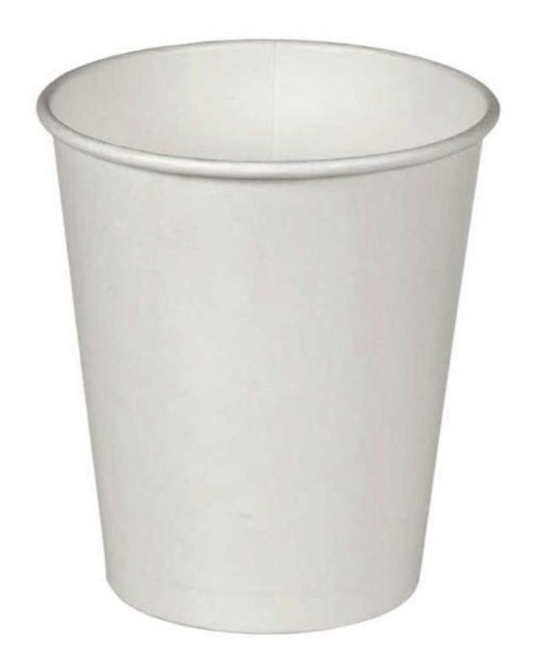

5. Floor stand for 4 bottles with a capacity of 18.9 liters
Height | 100 - 105 cm
Depth | 30 - 35 cm
Width | 30 - 37 cm
Material | Wood or metal
Weight | 4 - 8 kg
Warranty | 24 months
Reference photo | 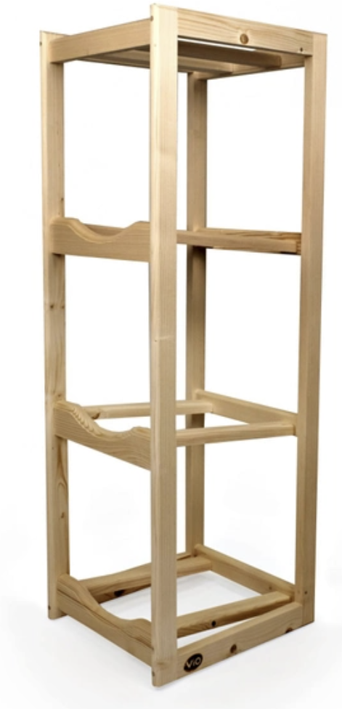

6. Wooden stirrers for beverages
Length | 140 mm
Width | 6 mm
Thickness | 1.5 mm
Material | Natural untreated wood
Reference photo | 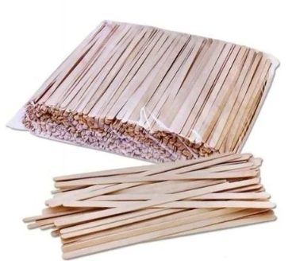

7. Estimated annual consumption/costs for 8 office locations
Estimated expenses/consumption for the period of 12 months
# | Items | UOM | Estimated Quantity for 8 office locations
Consumables
1 | Wooden stirrers (1 pack x 800 pcs) | pack | 200
2 | Paper cup WHITE 270 ml (1 pack x 100 pcs) | pack | 200
3 | Paper cup CRAFT PAPER 270 ml (1 pack x 100 pcs) | pack | 400
4 | Paper cup WHITE 185 ml (1 pack x 100 pcs) | pack | 300
5 | Paper cup CRAFT PAPER 185 ml (1 pack x 100 pcs) | pack | 800
6 | Paper cup WHITE 340 ml (1 pack x 100 pcs) | pack | 160
7 | Water 0.5L still PET | each | 20000
8 | Water 0.5L lightly sparkling PET | each | 1600
9 | Wooden stand for 4 bottles 18.9 L | each | 20
10 | Deposit cost for 1 refill bottle of 18.9L | each | 100
11 | Refill water bottle with drinking water of 18.9 L | each | 9000
Monthly Rent
12 | Rent of 1 already used freestanding water dispenser with a cooling and heating function to be refilled with 18.9 L bottles and equipped with a holder for paper cups 185 ml | each / month | 50
13 | Rent of 1 brand new freestanding water dispenser with a cooling and heating function to be refilled with 18.9 L bottles and equipped with a holder for paper cups 185 ml | each / month

above information to be provided by the awarded bidder prior delivery of the rented equipment

