UKRKI/ RFQ 2023-138 ENG

ANNEX A1 – Technical Specifications

House Chimney Kit

QUANTITY OF PRODUCTS

SN # | MATERIAL Description | Measurement Unit | *Total Quantity
1 | Stainless steel chimney bracket diam. 180 mm, thickness 0.5 mm – 5 pieces per kit | pcs | 4 690
2 | Wall clamp for stainless steel chimney diam. 180 mm offset 0 - 100 mm thickness 0.5 mm | pcs | 938
3 | Stainless steel chimney cap for the insulated pipe 120/180, 0.5 mm | pcs | 938
4 | Stainless steel chimney bracket 400 mm thick 2 mm | pcs | 938
5 | Stainless steel chimney condensation drain diam.180 mm, 0,5 mm | pcs | 938
6 | Stainless steel unloading platform for double-walled chimney diam. 120/180 | pcs | 938
7 | Double-walled stainless steel chimney tee in galvanized steel casing 120/180, 0.5 mm | pcs | 938
8 | Double-walled chimney pipe made of stainless steel in a casing made of galvanized steel 120/180, 0.5mm – 5 pieces per kit | pcs | 4 690

*The total quantity stated in the above table is for 938 kits.

All elements must be assembled into one chimney, all of them must be compatible

UNHCR will only accept items with the exact same specifications as stated below.
If an awarded bidder in their bid confirm that they would deliver the items as per the below specifications, but during the implementation of the frame agreement they cannot deliver the awarded items with the exact same specifications as stated below, such deliveries will be rejected without any financial compensation to the awarded bidder; if the awarded bidder repeatedly (3 times) fails to deliver the awarded items with the exact same specifications as stated below, the frame agreement will be terminated.

SPECIFICATIONS

Stainless steel chimney bracket diam. 180 mm, thickness 0.5 mm – 5 pieces per kit
Скоба для димоходу з нержавіючої сталі діам. 180 мм товщина 0,5 мм  Stainless steel chimney bracket diam. 180 mm, thickness 0.5 mm |  | 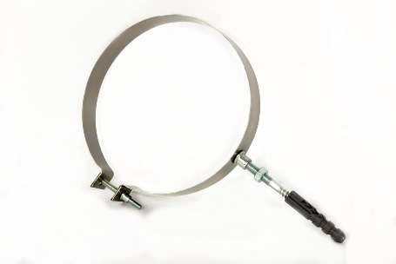
Матеріал: | нержавіюча сталь AISI 304 | Material: | AISI 304 stainless steel
Діаметр, мм: | 180 | Diameter, mm: | 180
Товщина сталі, мм: | 0.5 | Steel thickness, mm: | 0.5

Wall clamp for stainless steel chimney diam. 180 mm offset 0 - 100 mm thickness 0.5 mm
Хомут настінний для димоходу з нержавіючої сталі діам. 180 мм винос 0 - 100 мм товщина 0,5 мм.  Wall clamp for stainless steel chimney diam. 180 mm offset 0 - 100 mm thickness 0.5 mm. |  | 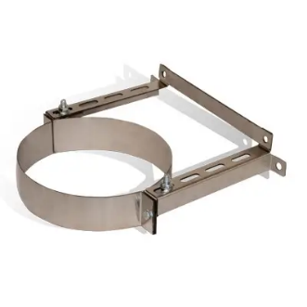
Матеріал: | нержавіюча сталь AISI 304 | Material: | AISI 304 stainless steel
Діаметр, мм: | 180 | Diameter, mm: | 180
Товщина сталі, мм: | 0.5 | Steel thickness, mm: | 0.5

Stainless steel chimney cap for the insulated pipe 120/180, 0.5 mm
Димохідний грибок для труби з термоізоляцією з неіржавіючої сталі 120/180, 0,5мм  Stainless steel chimney cap for the insulated pipe 120/180, 0.5 mm |  | 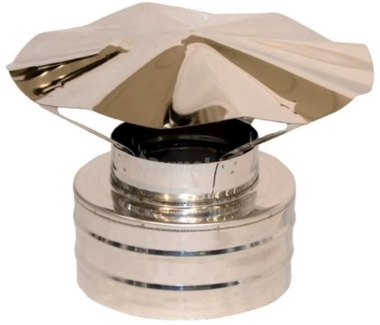
Матеріал: | нержавіюча сталь AISI 304 | Material: | AISI 304 stainless steel
Діаметр, мм: | 120/180 | Diameter, mm: | 120/180
Товщина сталі, мм: | 0.5 | Steel thickness, mm: | 0.5
Має бути сумісним з виробом 1 |  | Must be compatible with item 1

Stainless steel chimney bracket 400 mm thick 2 mm
Кронштейн для димоходу з нержавіючої сталі 400 мм товщина 2 мм  Stainless steel chimney bracket 400 mm thick 2 mm |  | 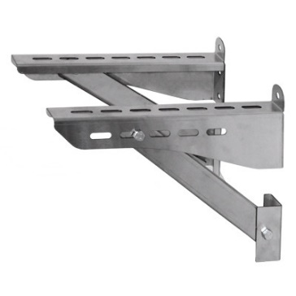
Матеріал: | нержавіюча сталь AISI 304 | Material: | AISI 304 stainless steel
Довжина, м: | 0,4 | Length, m: | 0,4
Товщина сталі, мм: | 2 | Steel thickness, mm: | 2
Має бути сумісним з виробом 3 |  | Must be compatible with item 3

Stainless steel chimney condensation drain diam.180 mm, 0.5 mm
Лійка димохідна з нержавіючої сталі діам. 180 мм товщина 0,5 мм  Stainless steel chimney condensation drain diam.180 mm, 0.5 mm |  | 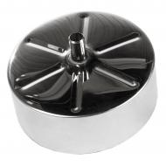
Матеріал: | нержавіюча сталь AISI 304 | Material: | AISI 304 stainless steel
Діаметр, мм: | 180 | Diameter, mm: | 180
Товщина сталі, мм: | 0.5 | Steel thickness, mm: | 0.5
Має бути сумісним з виробами 1, 2 та 3 |  | Must be compatible with items 1, 2 and 3

Stainless steel unloading platform for double-walled chimney diam. 120/180
Платформа розвантажувальна з нержавіючої сталі для двостінного димоходу діам. 120/180, 0.5 мм  Stainless steel unloading platform for double-walled chimney diam. 120/180 |  | 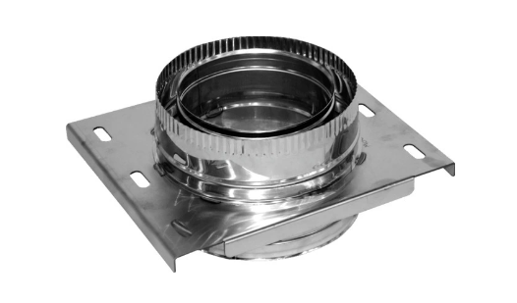
Матеріал: | нержавіюча сталь AISI 304/ | Material: | AISI 304 stainless steel / galvanized steel
Діаметр, мм: | 120/180 | Diameter, mm: | 120/180
Товщина сталі, мм: | 0,5. | Steel thickness, mm: | 0,5
Має бути сумісним з виробами 1 та 2 |  | Must be compatible with items 1 and 2

Double-walled stainless steel chimney tee in galvanized steel casing 120/180, 0.5 mm
Трійник димоходу двостінний з нержавіючої сталі в кожуху з оцинкованої сталі 120/180,  0,5 мм  Double-walled stainless steel chimney tee in galvanized steel casing 120/180, 0.5 mm |  | 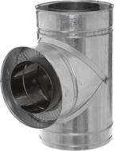
Матеріал: | нержавіюча сталь AISI 304/ оцинкована сталь | Material: | AISI 304 stainless steel / galvanized steel
Кут, градуси: | 85…89 | Angle, degrees: | 85…89
Діаметр, мм: | 120/180 | Diameter, mm: | 120/180
Товщина сталі, мм: | 0,5. | Steel thickness, mm: | 0,5
Теплоізоляція | Базальтове волокно | Thermal insulation | Basalt fiber
Має бути сумісним з виробом 1 |  | Must be compatible with item 1

Double-walled chimney pipe made of stainless steel in a casing made of galvanized steel 120/180, 0.5 mm – 5 pieces per kit
Труба димохідна двостінна з нержавіючої сталі в оцинковцi 120/180, 0.5 мм  Double-walled chimney pipe made of stainless steel in a casing made of galvanized steel 120/180, 0.5 mm |  | 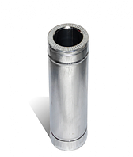
Матеріал: | нержавіюча сталь AISI 304/ оцинкована сталь | Material: | AISI 304 stainless steel / galvanized steel
Довжина, м: | 1 | Length, m: | 1
Діаметр, мм: | 120/180 | Diameter, mm: | 120/180
Товщина сталі, мм: | 0,5. | Steel thickness, mm: | 0,5
Теплоізоляція | Базальтове волокно | Thermal insulation | Basalt fiber

All elements must be assembled into one chimney, all of them must be compatible

