How to add images to questions in your SENS survey

Table of contents

1. Content of this guide 2
2. How to add a picture to a question in a SENS questionnaire 2
2.1. Prepare the image(s) 2
2.2. Adapt the XLS form 2
2.3. Upload and deploy the adapted XLS Form on the server 3
2.4. Upload the images to the deployed XLS form on the server 3
2.5. Access the questions with images on ODK Collect 3

Content of this guide
This is a short step-by-step tutorial on how to add pictures to any of the questions in your SENS survey questionnaires.
- This can be particularly useful for questions 7A-7H in the Child questionnaire, especially if you do not have any samples related to the question to show to the respondent during the interview.

How to add a picture to a question in a SENS questionnaire
In order to add an image to a question in your SENS survey, you need to follow the following steps:

Prepare the image(s)
- You will first need to prepare the images to be added to your survey and save them altogether in a folder. The images need to be saved in .jpg format.
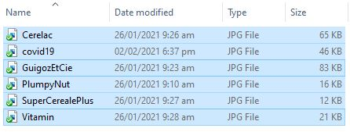
Figure 1: Folder containing all images to be added to the survey
- You can add one media at a time per question in your XLS form: thus, if you need to add several images to a single question, group them in a Word doc for instance, take a screenshot of the group of images needed for that particular question and save it as a .jpg image in the folder containing all other media.

Figure 2: Examples of images or group of images

Adapt the XLS form
- Next you will need to add those images to your XLS Form: insert the full name of your media (i.e. name.jpg) in the “media::image” column of the questions in the “survey” tab.
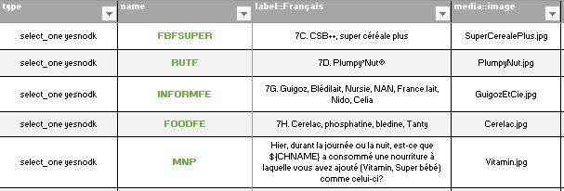
Figure 3: How to adapt the XLS Form

Upload and deploy the adapted XLS Form on the server
- Upload (and deploy) the adapted XLS form on Kobo Toolbox server according to the regular procedure.

Upload the images to the deployed XLS form on the server
- Once your adapted XLS form is uploaded and deployed on the server, add the images in .jpg format to the survey, one by one.
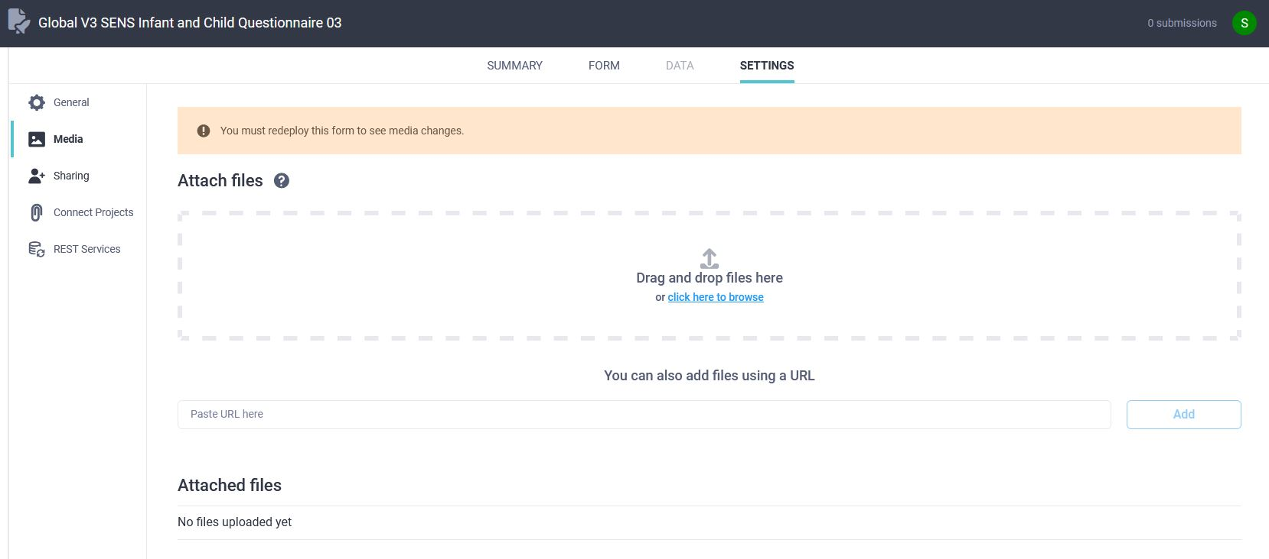
Figure 4: How to add the images to a SENS survey on Kobo Toolbox

Access the questions with images on ODK Collect
- On ODK Collect the question will appear as follows: label, hint, media and then choices.
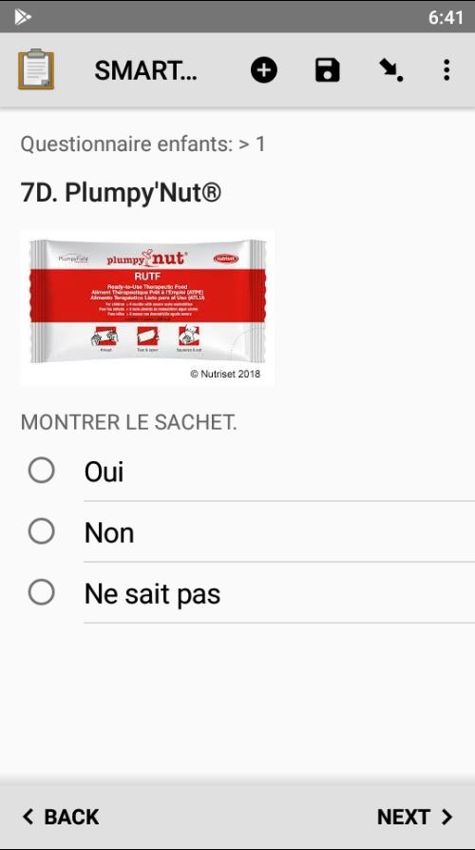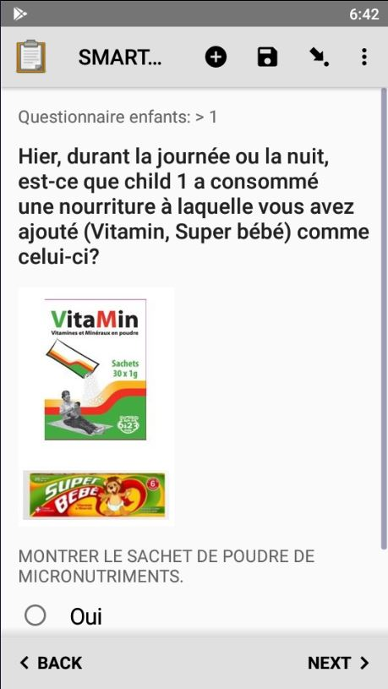
Figure 5: Examples of questions with images on ODK Collect

