Lauching and using the Online server

Exporting data for analysis

Table of contents

1. kobo online server 2
1.1. First Kobo account creation 2
1.1.1. What is Kobo Toolbox 2
1.1.2. Create a UNHCR Kobo account 2
1.2. Accessing the online Kobo Platform and managing your projects 3
1.3. Adding a new project 3
2. configure your phones to connect them to the server 5
2.1. Configure ODK Collect 5
2.2. Download new forms from server 6
2.3. Send filled forms to server 6
3. Export data from Kobo 6
3.1. Login into Kobo and Go to Data 6
3.2. Downloading 7
4. Manually upload data 7
5. Storing the data 8

System used: ODK Collect v2024.1.3 + Kobo Toolbox

kobo online server

First Kobo account creation

What is Kobo Toolbox
Kobo is the survey management tool that is supported by UNHCR. It is recommended to use the online UNHCR Kobo platform (https://kobo.unhcr.org) rather than OCHA's (http://kobo.humanitarianresponse.info) to ensure that all SENS surveys are carried out on the same server in such a way that data can be shared more easily from one user account to another if it is necessary. You will also be able to ask for support from the UNHCR Kobo team if you have issues with the website. To access the UNHCR Kobo website go to: https://kobo.unhcr.org. You will have to start by creating an account (you cannot use the same username as the OCHA platform if you have created an account on that platform already).

Create a UNHCR Kobo account
If you do not have any account on the UNHCR KoBo website you can create one; to do so, follow the steps below:
- Go to http://kobo.unhcr.org
- Click on “Create an account”.
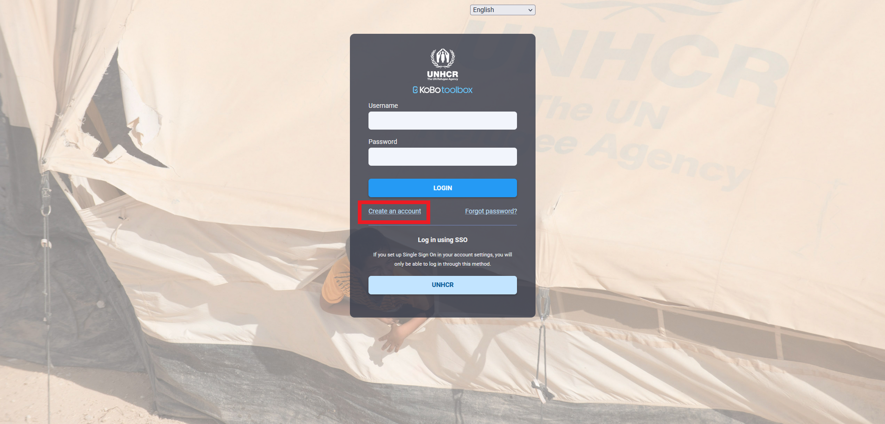
- Fill in form with the necessary information and then check your emails to get the validation email.
- Remember to define a descriptive username (i.e., “sens_country_organisation_role_region”) to facilitate data sharing at a later stage.
- Once you received the email, click to activate the account
- Be careful not to click on the link twice by mistake
- Check your spam if you cannot see the email in your inbox.
- Your Kobo Toolbox account is now ready to use.

Accessing the online Kobo Platform and managing your projects
- By default, you will be directed to the Homepage.
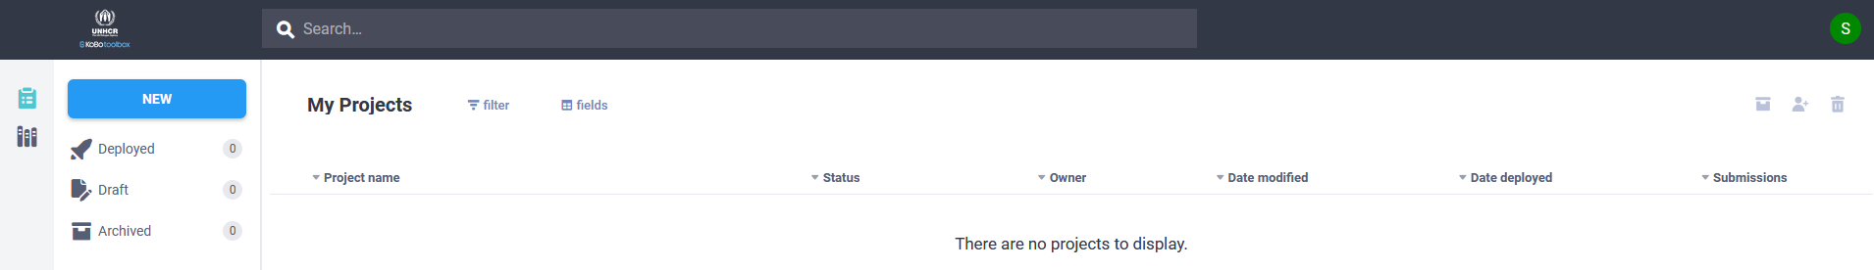
- Your projects when you have some) are organized into three categories:
  - Deployed
  - Drafts (projects that have not been deployed yet, still at the design stage)
  - Archived (finished projects)

Adding a new project
- The standard SENS form is in Excel, in what we call XLSForm format.
- To import the contextualized SENS form (XLSForm file, for more information on how to contextualize the form, please refer to the MDC coding webinar):
  - Click on “New”; this will open a "Create Project" window. Then, click on "Upload an XLSForm”; select the XLSForm you will need for your survey.
  - Then click on "Create project".
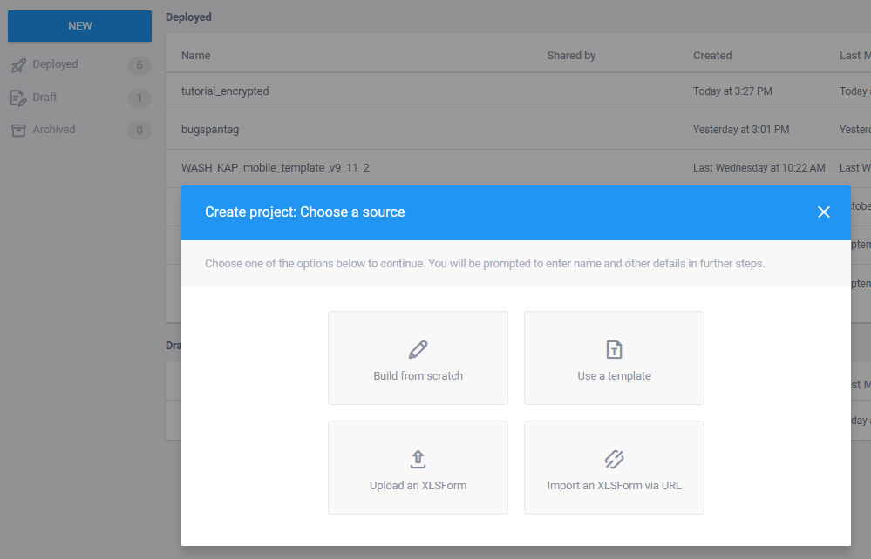
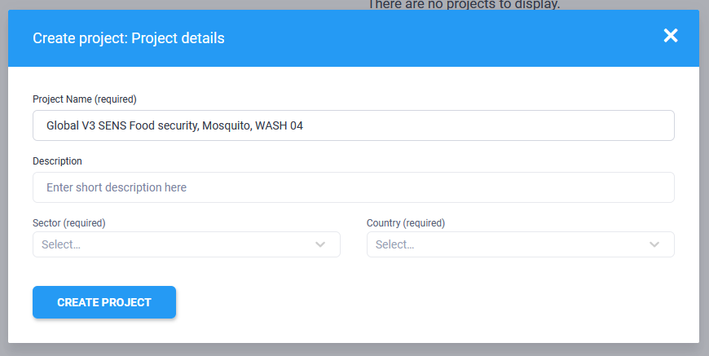
- Once the Import is over, your form will appear on the home screen: it means that the import has been successful. If nothing appears on the screen, it means that the download has failed. An error message will appear shortly, helping you to understand what went wrong. Most of the time, it will be because you have made a change that is not allowed in the XLS form. Ask your HQ Nutrition focal point if it is the case.
- You can now click on "Deploy" to view the form from your mobile.
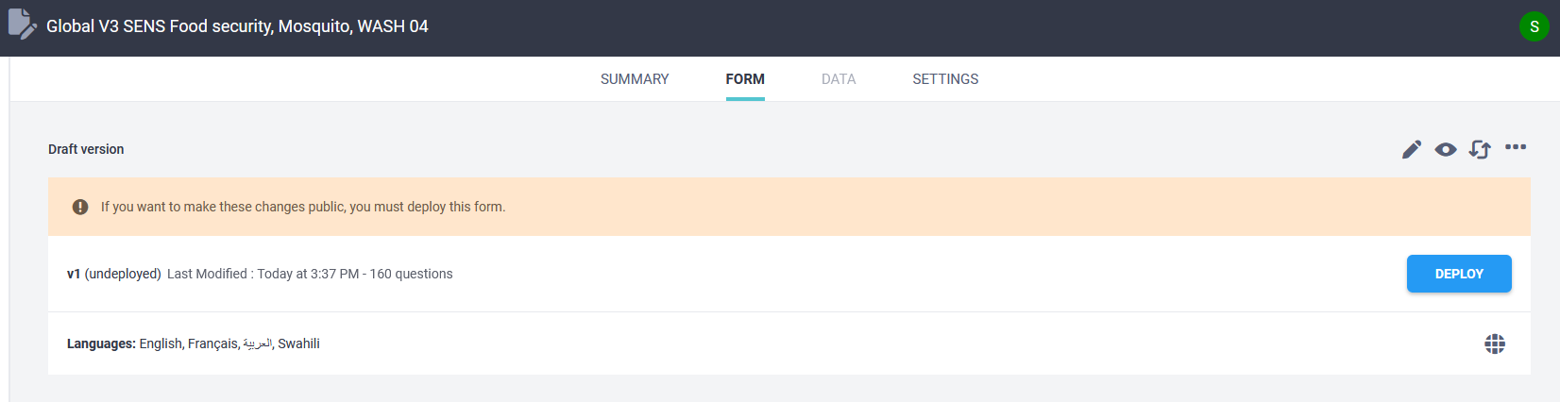
- On KOBO you can find the link which allows to open your form on MDC Tools such as ODK Collect (see below) in the form page.
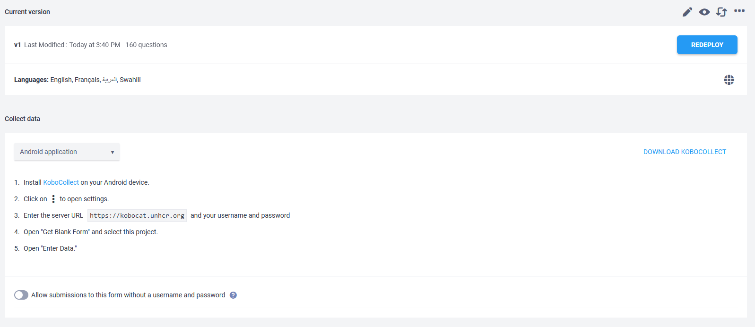

configure your phones to connect them to the server

Configure ODK Collect
- Please ensure your phones have access to the internet (either access to the office Wi-Fi or a sim card with internet data) to download the forms and upload the data.
To test forms and conduct a training, it is useful to create an account on the training server, but for setting the phones up for a real survey, you will need to use the production server.
- Open ODK Collect. Press the three points on the top right screen on the front of the phone). Press on “Settings”.
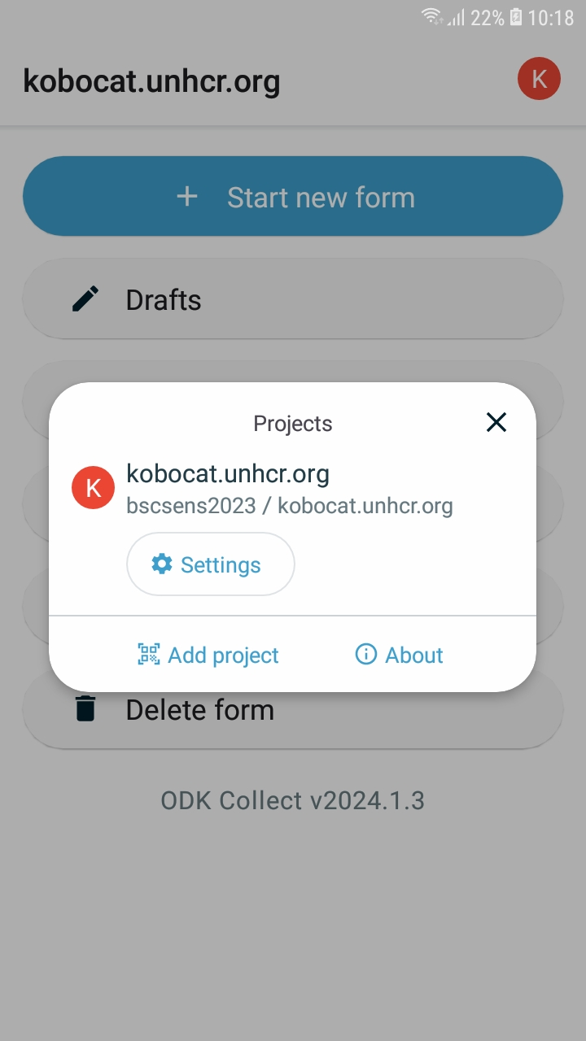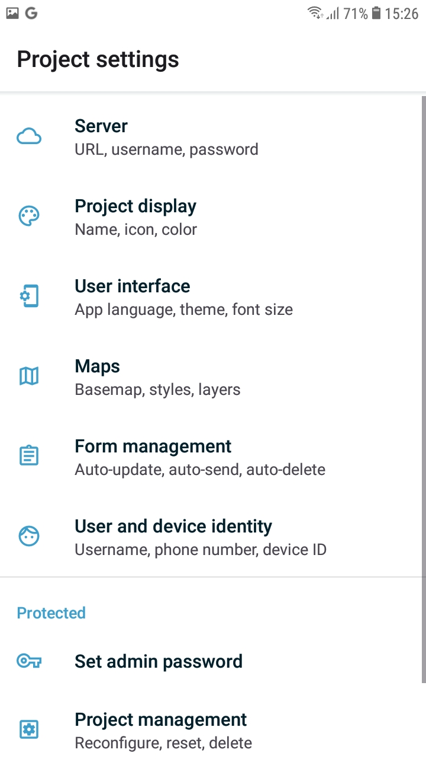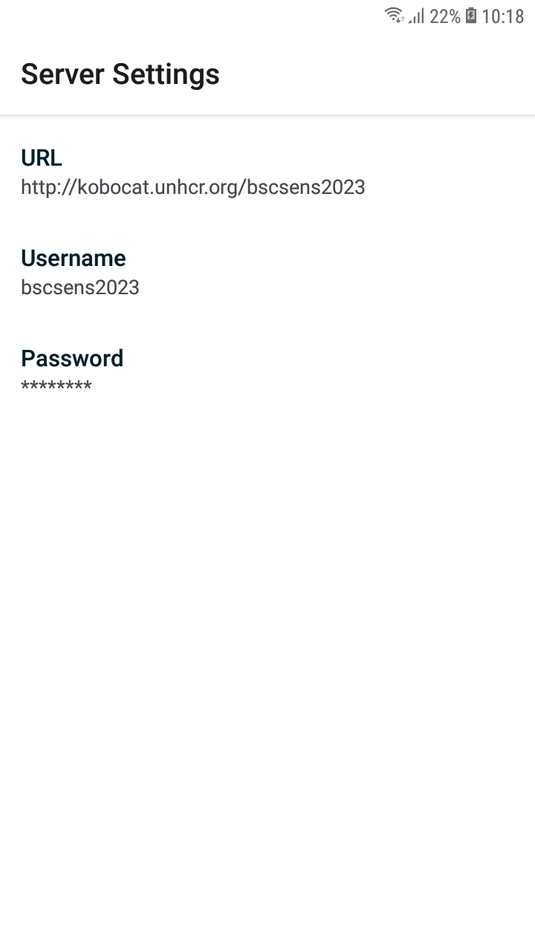
- Select “URL” and enter the URL of your server.
- Username and password are required.
- More information on how you can configure phones and what settings might be useful for your specific context can be found in the MDC Material Powerpoint for Survey Managers as well as MDC Tool 10 How to set up a phone.

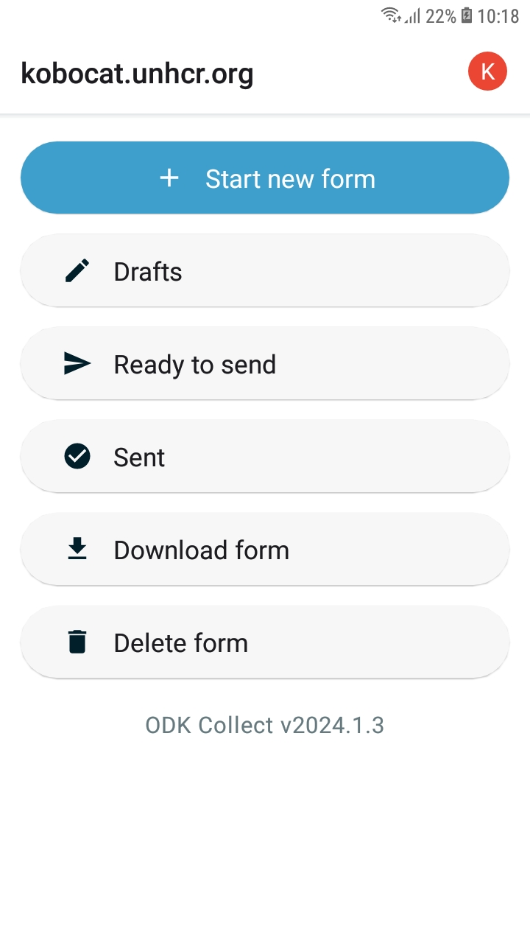

Download new forms from server
- Select “Download form” at the bottom and select the forms you want to load on the smartphone (1.).
2.
- The forms are now on the phone, ready for the surveys.

Send filled forms to server
1.
- Once the survey is completed, you can send the completed submissions to the UNHCR Kobo Toolbox server. Select “Ready to send” (2.). Toggle all and send. A summary comes up where it should say “Success” behind all forms. The forms will now be in the server. All forms that have been successfully sent will appear in “Sent”.

- The forms are also in XML format in the ODK folder. So, if there has been an issue with synchronization, it is still possible to upload them manually. However, if you delete them from the “Delete Saved Form” folder, they will have been deleted permanently from the phone.

Export data from Kobo
This tutorial is going introduce how to export data from Kobo ToolBox.

Login into Kobo and Go to Data
- To access Kobo, go to https://kobo.unhcr.org/ and log in with your username and password. Once logged in, click on the name of the form which you wish to analyze. If the form already contains data, you will see four options (Summary, Form, Data and Settings). If the form does not yet contain any data, the data option will not be displayed in the menu. If data has been recently sent to Kobo for the first time, you may need to refresh the browser page.

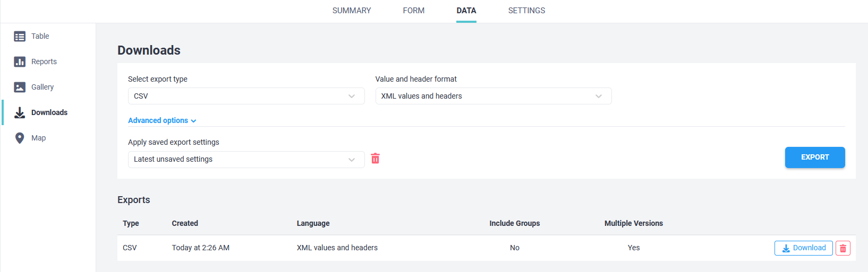
1..
3..
2..
4.
5.

Downloading
- As shown in the image above please click on “Data” at the top of the screen and downloads on the left-hand side. It is then necessary to select the options as displayed in the screen shot. The export type is “CSV” and the value and header format is “XML values and headers”.
- The other options can be left as default, and you can click “Export”. Please note that depending on the size of the data set the export may take a few seconds to run. The exported data should display at the bottom of the screen as shown in the screenshot with a type of CSV and a language of XML. These settings are important as any other format will not be compatible with the analysis tools.

Manually upload data
In certain situations, you might not be able to use the standard uploading option after collecting data. Here’s a step-by-step process on how to upload from the phone if the phone fails to sync.
- You first need to connect your phone or tablet to your computer through a USB cable.
- Then, open the device’s internal storage on your computer.
- Open the ODK Collect folder by following this file’s path :
  - Phone\Android\data\org.odk.collect.android\files\projects
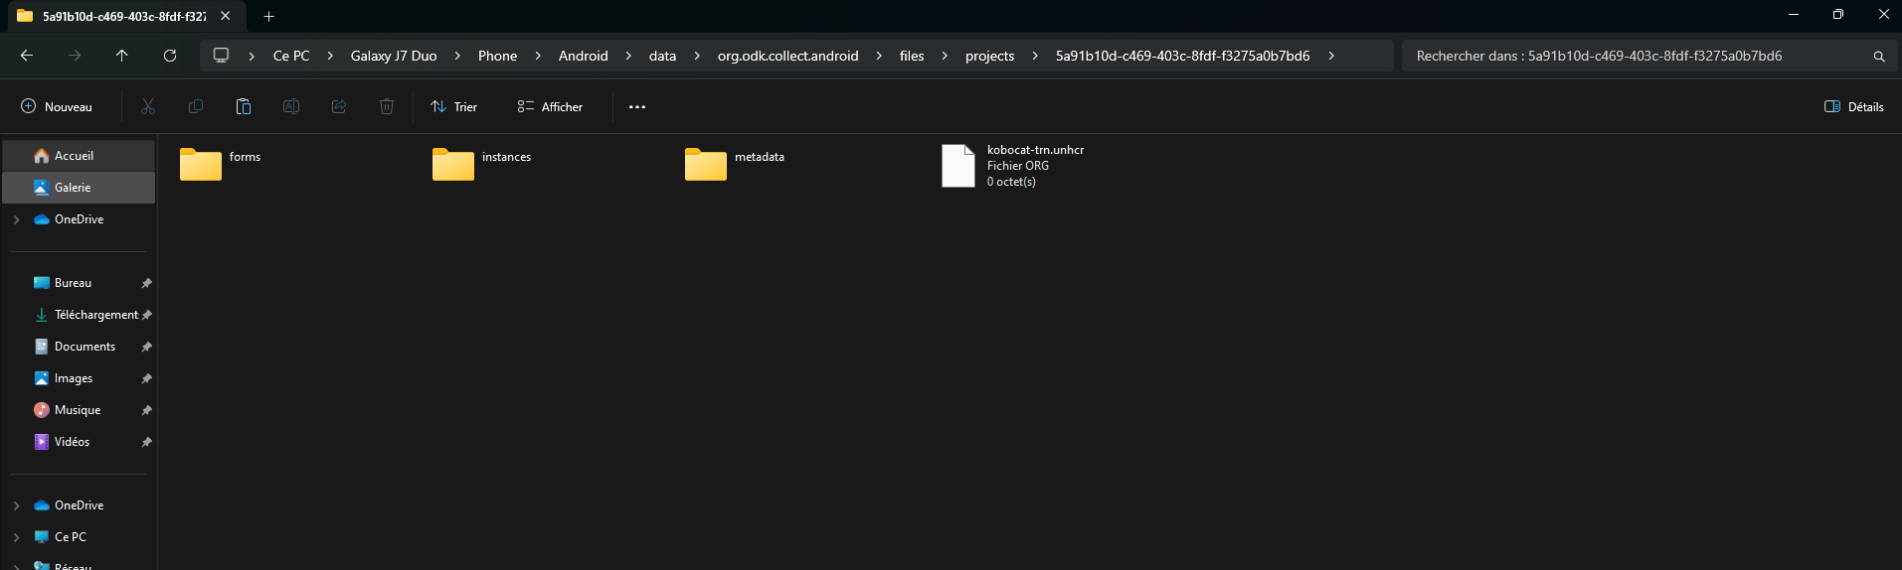
- Copy the “instances” folder and paste it somewhere on your computer.
- Create a ZIP file of the folder.
- Log in the production server.
- Then, copy-paste the following URL and add the username chosen for your account:
  - https://kobocat.unhcr.org/your_username/bulk-submission-form
- Click on “Choose File”, add the ZIP file and then “Submit”
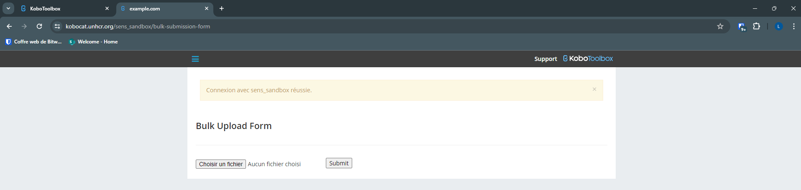

- The window should refresh and display the following message:
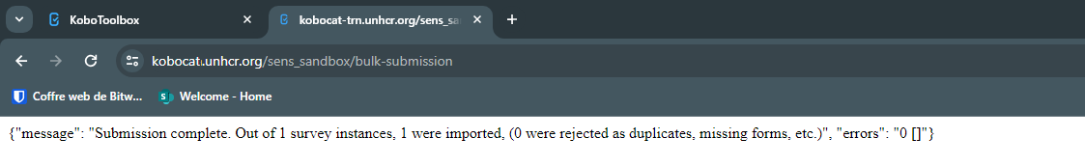
- Your data is now uploaded on the server!

Storing the data
- Please follow the following folder structure for the data export, with one folder per form and per day. Repeat for all forms. Don’t forget to have one download folder per form and per day.

