How to set up an android smartphone for a SENS survey

Table of contents

1. Background 2
2. Content of this guide 2
3. Phone setup 2
3.1. General settings 2
3.2. Home screen configuration 3
4. Installation of Apps 4
4.1. Option 1 4
4.2. Option 2 6
5. Setting up ODK Collect on multiple tablets 8
5.1. Server connection 8
5.2. Customize menus 10
5.3. Form Entry Settings 12
5.4. Setting up an admin password 12
5.5. Exporting the set up to other devices 13

Background
In the last years, due to the increased availability, many operations opt for purchasing new mobile phones directly in their country. In parallel, it has also become more common to use Android smart phones to collect data for the Standardized Expanded Nutrition Survey (SENS). It can therefore be more advantageous to stock Android smart phones throughout the year especially for operations with nutrition programs covering many locations in several regions.
- In 2016, 94% of the operations undertaking the SENS Survey have done so by utilizing mobile phones.

Content of this guide
This is a short step-by-step tutorial that serves as a guide on how to set up your smart phones for first use.
You can also find detailed settings for OpenDataKit (ODK), the application used for the data collection, on the SENS webpage.
- Overview pictures and detailed instructions are based on the Samsung Galaxy J7 Duo .The design or the wording on your phones might vary slightly but should follow the same principle.

Phone setup

General settings
General Settings: SD Cards, Battery, Wi-Fi connection, Language, Time, Protection code, etc.
First, you need to perform the following steps:
- If you have already purchased external SD cards, insert them in the appropriate slot (Purchasing SD cards is good practice especially for larger surveys and/or if you expect to take photographs).
- Insert the battery
- Load the battery by plugging the charger to the phone
If you have already made provisions for permanent protection screens and casings, you need to:
- Remove the clear plastic covers on the phone screen and its back
- Switch on the smart phone using the power button, they can be located on the back, top or on either side, refer to your quick guide if you cannot find it immediately
- Set up the phone language
Phones still packed and straight from the factory typically come with a quick guide. Also, most phones will start the setup process upon first switching on. This process often includes:
- Connect to a WIFI network
- Setup a Gmail account through direct enter or “Tap and Go”
- Create a protection code (pin, tap pattern, fingerprint…)
However, for a regular survey phone you only need to complete the following:
- Enter a working WIFI connection
You can enter the Local Area Network connection you will use for the survey later, when connected to the Internet, settings such as Time and Date can be set automatically which will save you time.
- Set the time zone to your correct time zone
- Set up a protection code (depending on phone this can be a pin code, tap pattern, fingerprint, or any combination of it) only if you think the phones need to be secured. Ensure you write down the codes (LG opts for knock codes, they can be difficult to remove once set up).
- Communicate the codes to Admin or anyone else who will be responsible for safeguarding the devices when not used for surveys
- If you have a smart phone that is regularly used for surveys and isn’t personalized or equipped with a SIM card, it’s not advisable to enter a private Gmail account. If you think that you’ll need to connect to Google Play, or any other service requiring an account, it’s recommended creating a project email account instead.

Home screen configuration
The smart phone comes with a preset home screen that can be customized.
In most circumstances, the smart phone will not be equipped with a SIM Card so it cannot be used for to make phone calls. The person in charge of conducting the survey (an enumerator or you as a survey coordinator) can remove everything that is not used or choose which buttons/widgets he/she wants to easily have access to on the home screen. You can:
- Remove all unnecessary widgets and buttons from the home screen by touching them until they vibrate and become moveable. You can then drop them in the recycling bin.
- Add the buttons/widgets you will need more often, like Settings and File Explorer by touching them until they vibrate and become moveable, then place them wherever you think is convenient.
- On certain smart phone models, it makes sense to add widgets by switching to Airplane/Wi-Fi and changing brightness. However, on many newer smart phones these aspects are already integrated in the top menu bar and can be accessed by sliding it down.
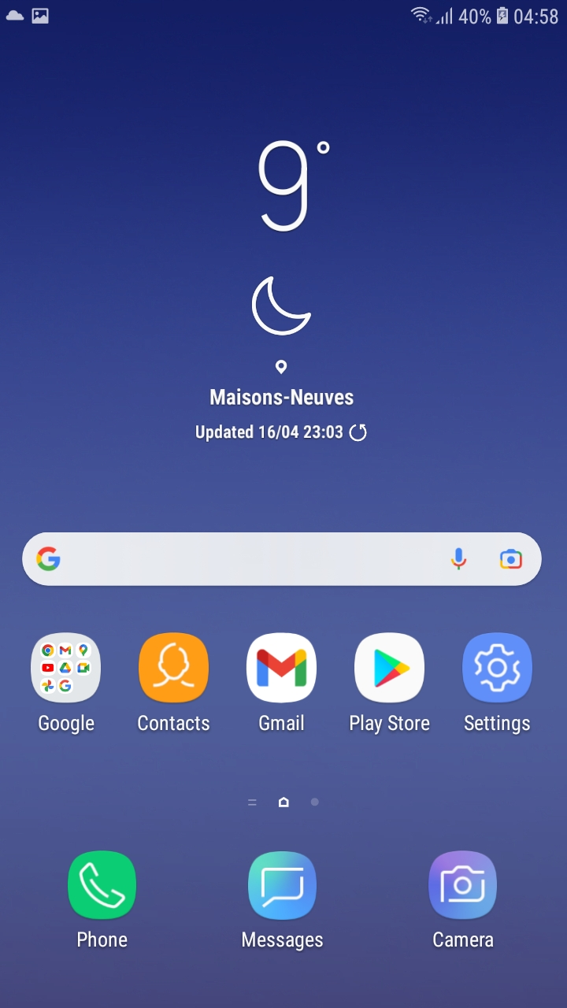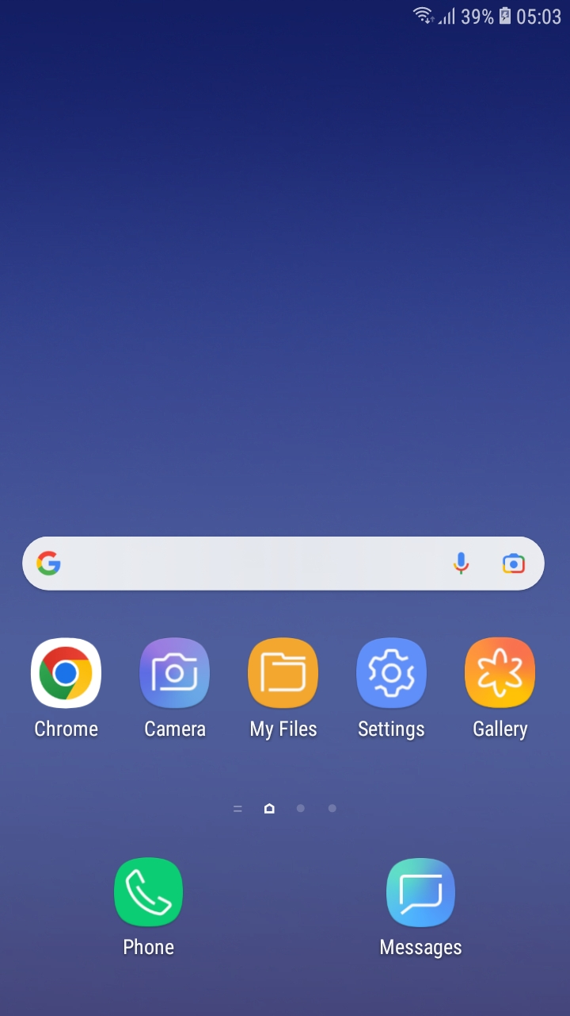
Figure 1: Before removal of widgets and buttons Figure 2: After removal and adding useful buttons

Installation of Apps
- If the phone is regularly used on the Internet, it is advised to install Antivirus Apps such as the free AVG Antivirus app or AVAST. This guideline doesn’t look further into security apps since it is not usually of high priority for smart phones dedicated for mobile data collection. More information on general phone security and useful tips can be found on the Mobile Data Collection Tool Kit, co-created with Terre des hommes.
The following applications need to be installed on the phones:
- ODK Collect, it’s the application required to enter records, store your data and sync them to your server. Installing this app is mandatory.
Good to have, although not often needed for the standard SENS, the following apps can help in specific settings:
- QR & Barcode Scanner, in case you are using more complex household ID’s in your sampling and would like to ensure enumerators use them correctly.
- GPS Test, if you plan to take GPS coordinates in your SENS survey. The app locks your coordinates when at a new site. For more information on how to gather GPS data, please refer to the GPS Coordinates in SENS Survey tutorial.
If your phone is new, has not yet been personalized and consequently does not have Google Play Store set up with a personal account, installing apps for the SENS will require some extra steps: the phone needs to be set up to accept installations of apps from unknown sources.
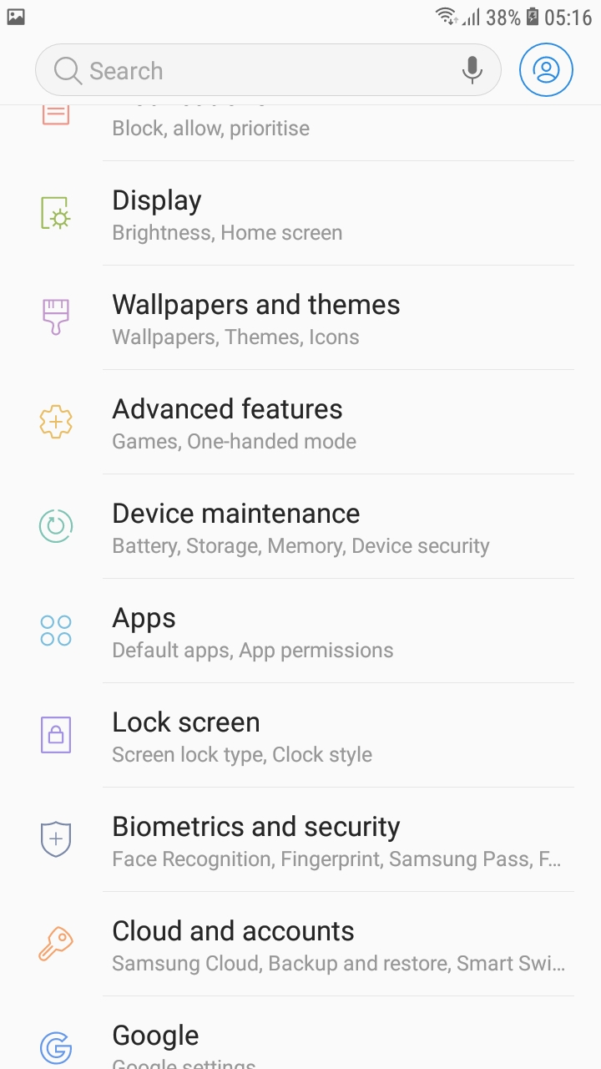
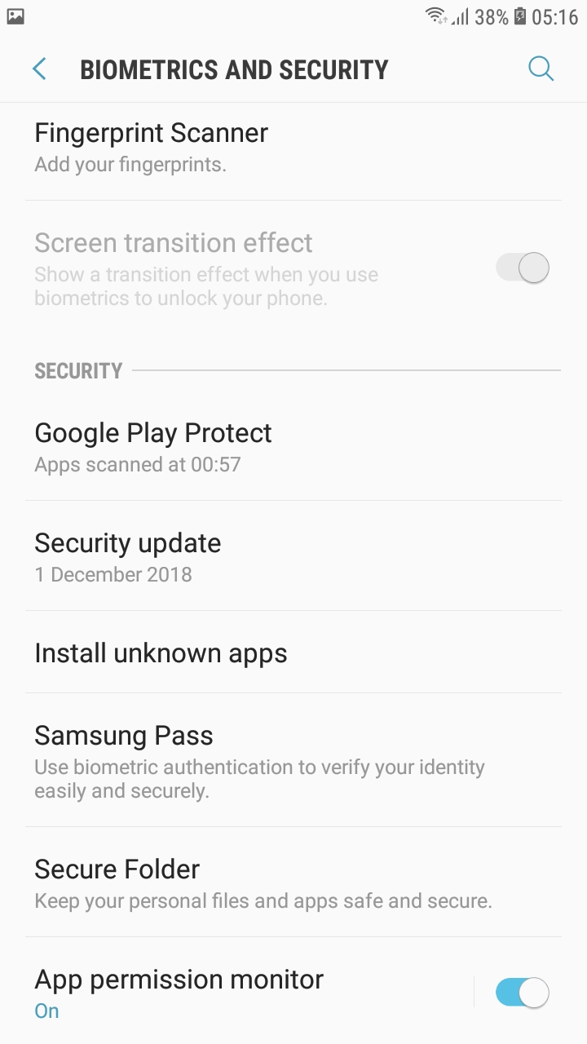
To enable this, you need to:
- Go to Settings/Biometrics and security
- Select Install unknown apps.
- Allow for your web browser and your file explorer to install unknown apps
Now you can start installing the apps you need for the SENS. You have two options to install the necessary apps, depending on whether you have access to a Wi-Fi network (option 1), or you don’t have Wi-Fi access (option 2).

Option 1
If you are connected to the Internet, you can go directly to the ODK webpage, and go to the GitHub ODK Collect link where you will find the latest version of the app. The download section will lead you to Github. Check the release notes before you download.
- In your phone’s web browser, tap the ODK Collect GitHub link and download ODK Collect .apk file.
- After the file has downloaded, you can either slide down the top menu notification bar and tap on the new file; or use your file explorer to navigate to your Download folder and tap here on the apk.
- Follow the instructions needed for the installation process.
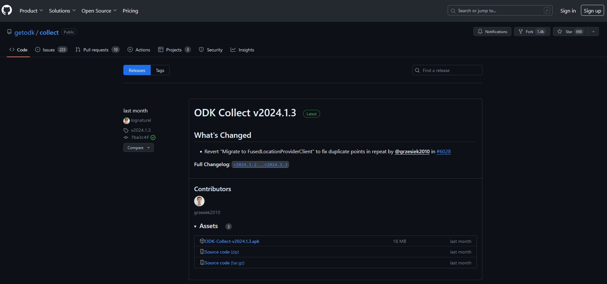
Figure 3 : Download from Github, click on the option .apk and Download
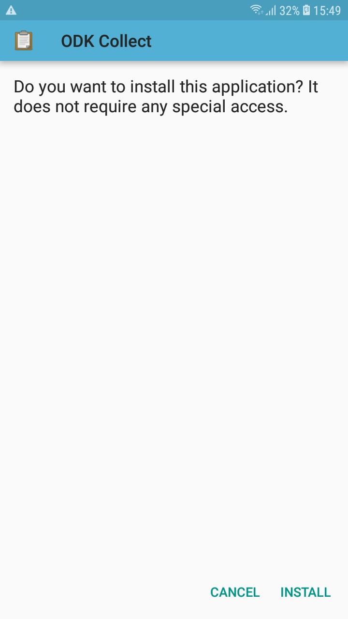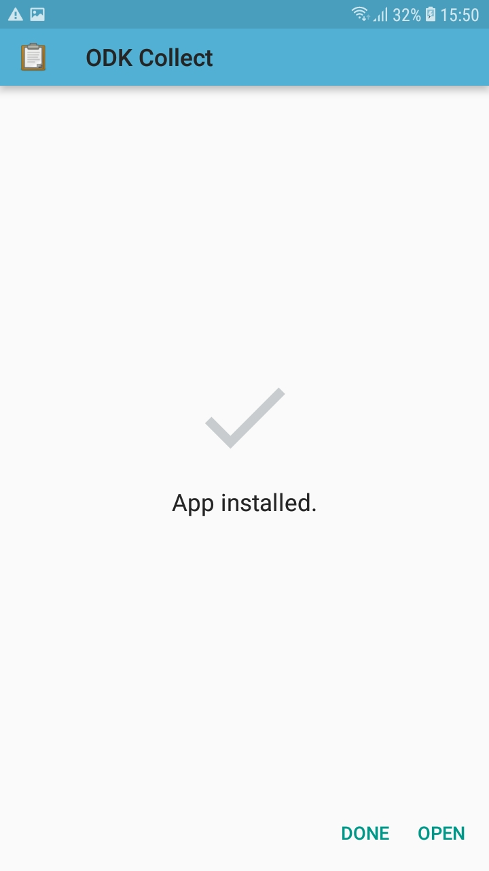
Figure 4: Slide down the top bar after download to tap on the download notification/Follow the prompts | Figure 5: Finalising the installation process

Option 2
If you are either not connected to a Wi-Fi network or you want to save time and have assembled all necessary .apk (file extension for Android apps) files in one place on your computer, you should follow the instructions down below :
You first need to set your phone in developer mode. To do so :
- Go to the Settings of your phone.
- Tap About device or About phone.
- Tap Software information.
- Tap Build number seven times (depending on your device and operating system, you may not need to follow step number 3).
- Enter your pattern, PIN or password to enable the Developer options menu.
- The Developer options menu will now appear in your Settings menu (depending on your device, it may appear under Settings > General > Developer options).

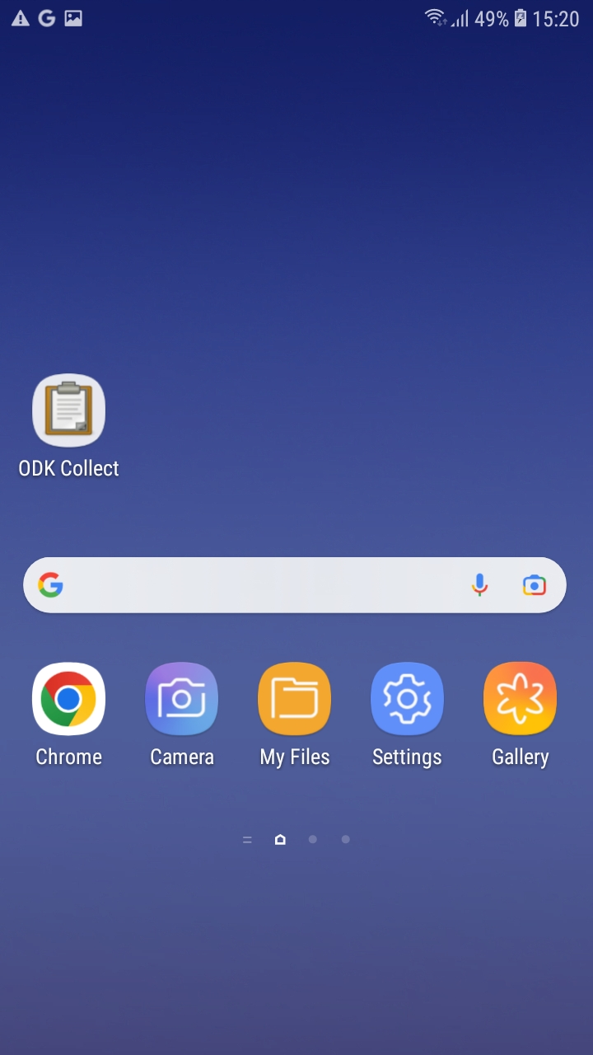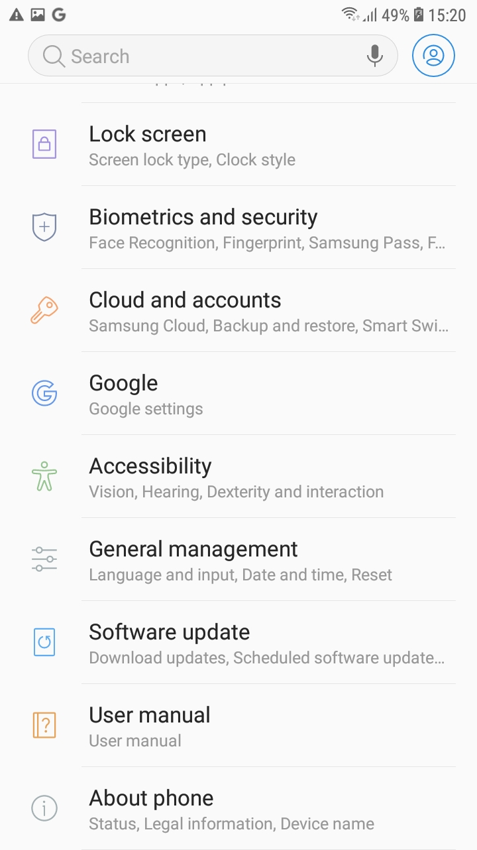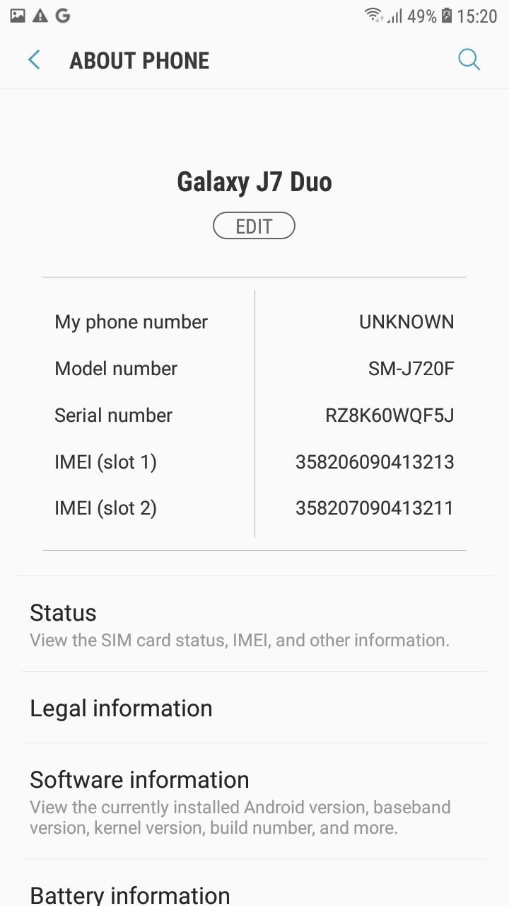
Figure 6: Go to Settings Figure 7: Tap on About Phone Figure 8: Tap on Software information

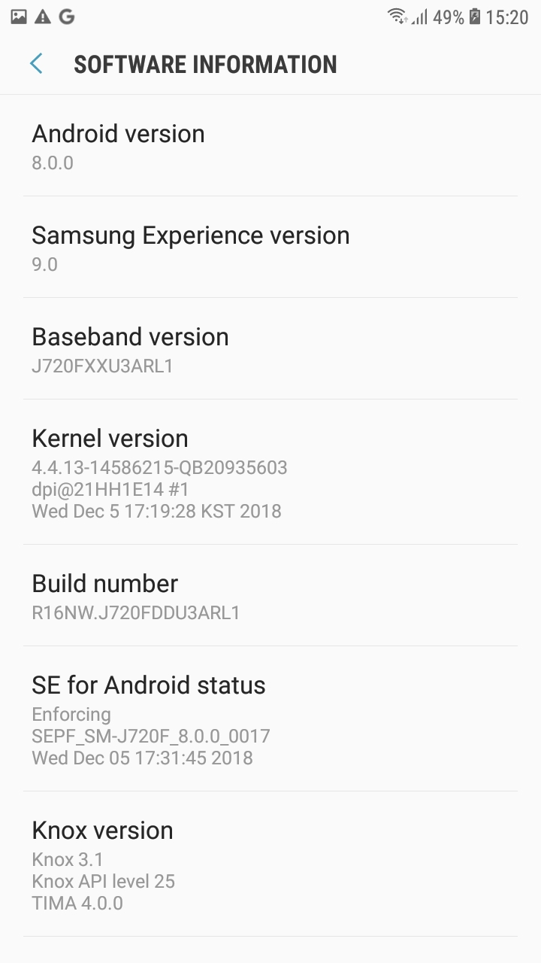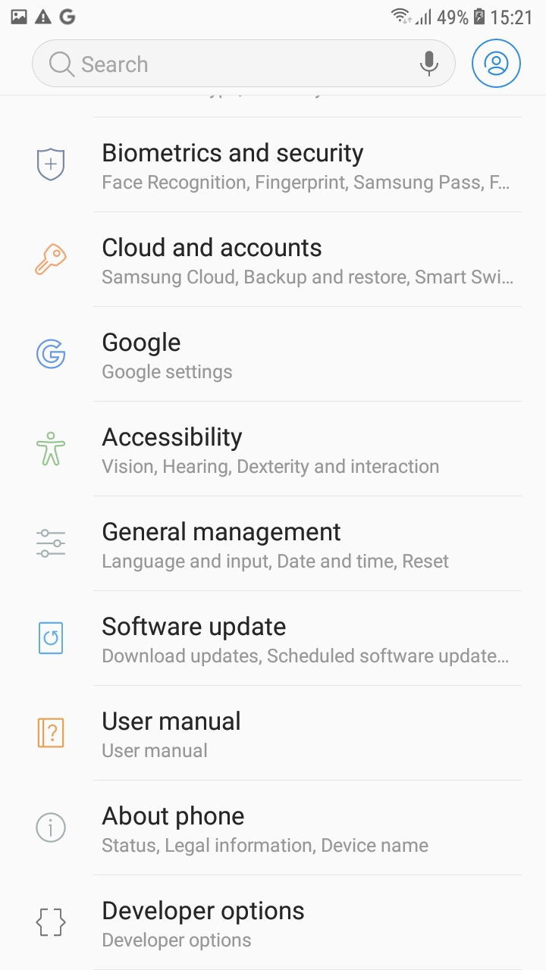
Figure 9: Tap 7 times on Build number Figure 10: Developer mode is now activated

- Connect your phone to your computer with a USB cable and install your phone’s driver if necessary.
How do I know if I need to install a driver?

Most new phones are plug and play devices, where correct drivers are automatically installed if given the permission. If for some reason either your phone or your computer’s operating system doesn’t support self-installation, you will need to download the phone’s driver from the manufacturer or download and install the firmware that most brands provide to let the phone connect with a desktop computer:
If you did not need to install a driver or if the driver installation has been completed successfully, your phone will most likely already mount as Media Transfer Protocol (MTP) device, allowing you to access the phone’s file directory without any additional steps.
If you still do not have access the phone’s file, you need to perform the following steps:
- Slide down the top bar, tap on USB options and choose Transfer files.
- Your phone should now be accessible like any external USB device.
- Copy the .apk files from your computer in the Download folder on your phone.
- Disconnect the phone, navigate to the Download folder and proceed with the installation of the .apk by tapping on the file. If you have many files on your Download folder, you can either sort them by date or search for .apk.

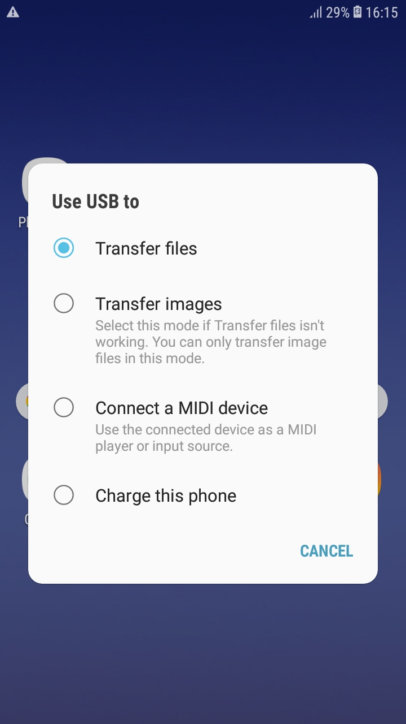 | 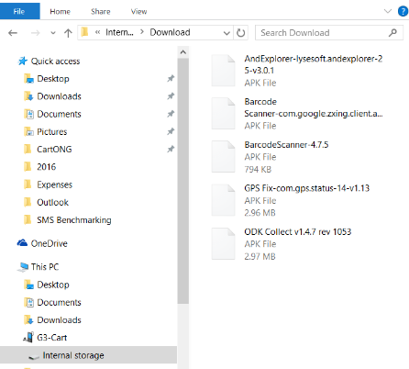 | 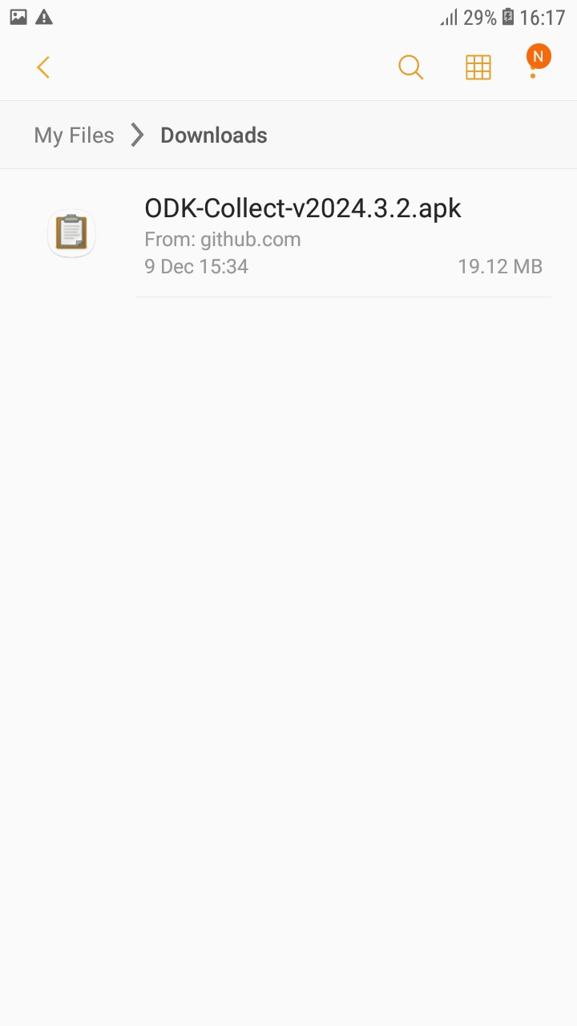
Figure 11: Select Transfer files after connecting the phone | Figure 12: Copy files in the Download folder | Figure 13: Use the file explorer to access the Download folder
Last but not least, to make it easier for your enumerators to find the apps, you can drop a shortcut on the home screen. To enable this, you need to:
- Enter the app menu and touch the ODK button until it becomes moveable.
- Now drop the icon on the home screen by sliding to the left.

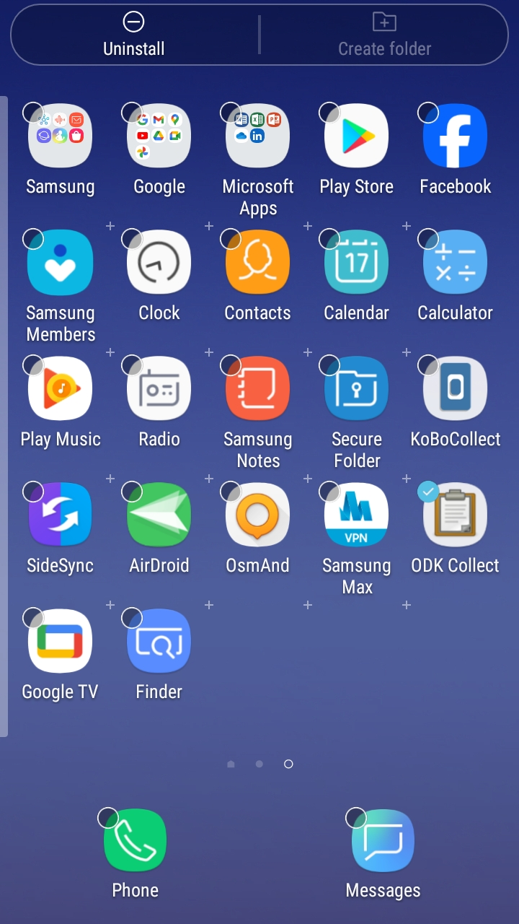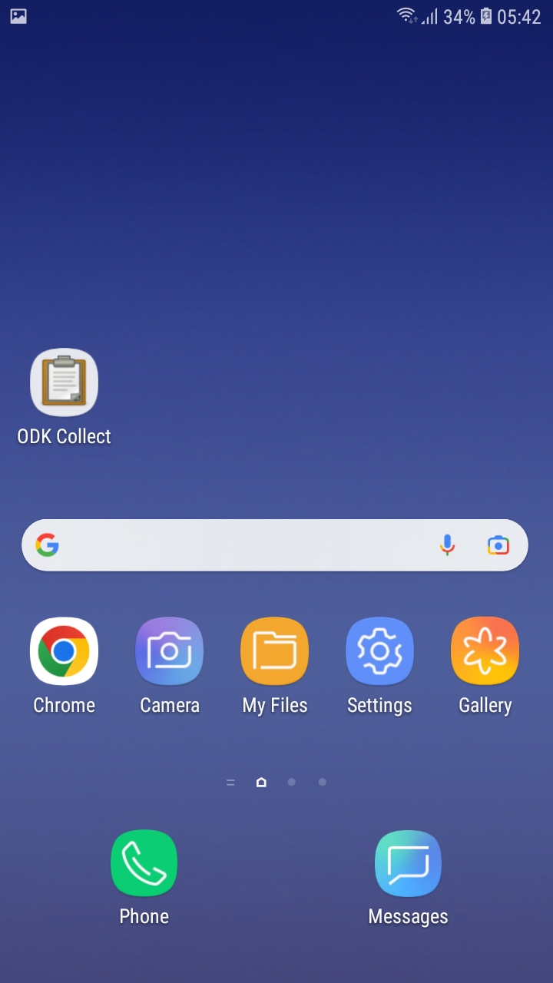
Figure 14: Sliding the icon of the highlighted app on the home screen | Figure 15: Adding the icon on the home screen

Setting up ODK Collect on multiple tablets
The latest ODK Collect version (v2024.3.3) allows supervisors to set up tablets by scanning a QR code within the app. When preparing multiple devices for a survey deployment, this functionality lets you customize menus and set up the logging credentials (server, user ID and password) for all devices at once.
In this section we’ll cover how to customize the Main Menu, how to setup the server connection, how to protect the configuration behind and admin password and finally, how to export the app setup to other tablets using the QR code.
For more detailed information on how to set up ODK Collect, please review the ODK website and documentation.
- Note that the following instructions assume that you have already installed ODK Collect in all of your devices.

Server connection
If you have not before used ODK Collect on your devise, the following steps are applicable:
- Open the app and select Manually enter project details
- Enter the logging credentials by taping on each of the fields: URL, Username and Password. These credentials will apply to all enumerators
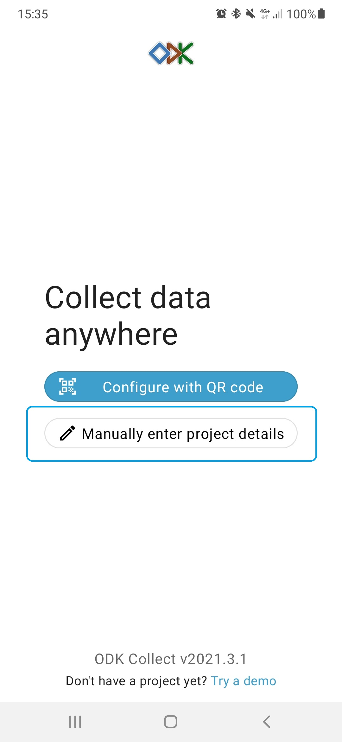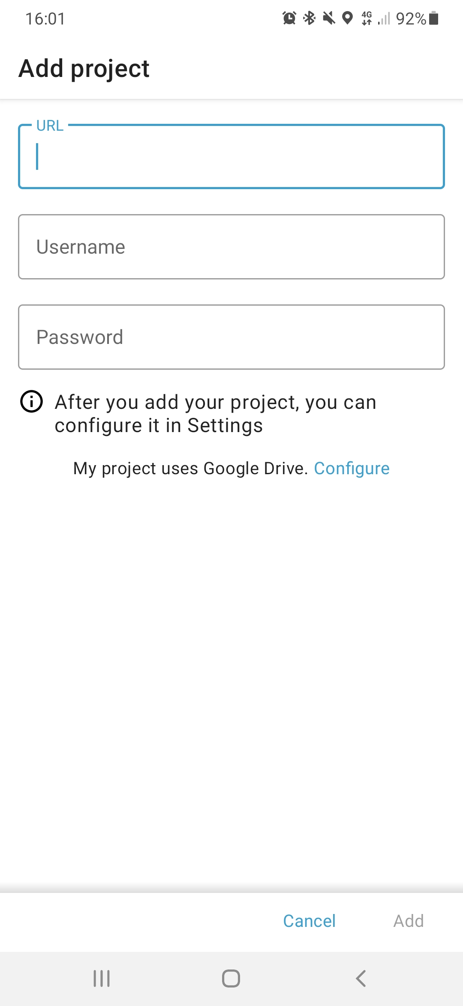
1. Select Manually enter project details | 2. Type the URL, username and password that will be used by all enumerators
- Note that the above instructions assume that you have never opened ODK Collect on your devise before. If you have used ODK Collect previously, you will need to follow the below steps to set-up a new project.
- On the Main Menu, tap on the circular icon on the top right corner of your screen and select Settings
- Tap on Add project
- Tap on Manually enter project details
- Enter the logging credentials by taping on each of the fields: URL, Username and Password. These credentials will apply to all enumerators
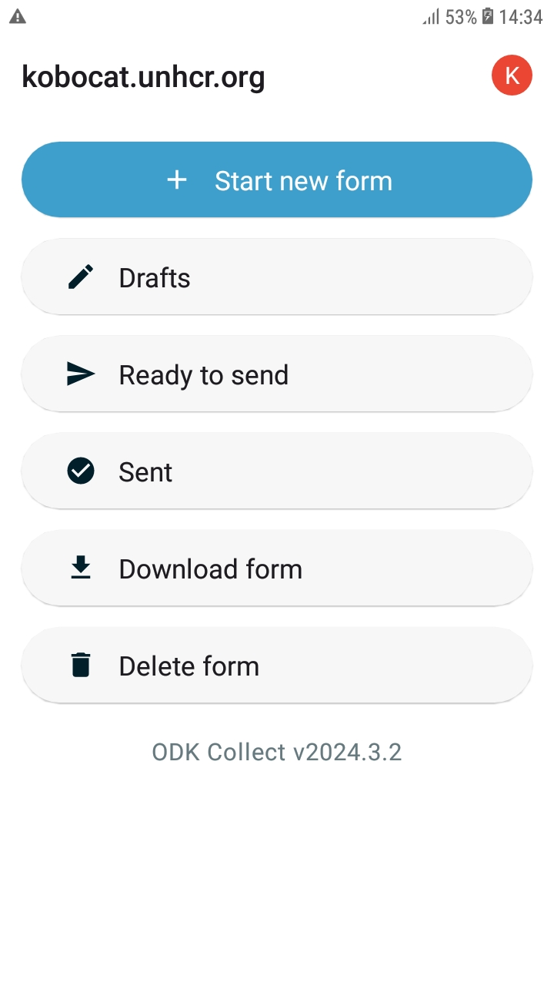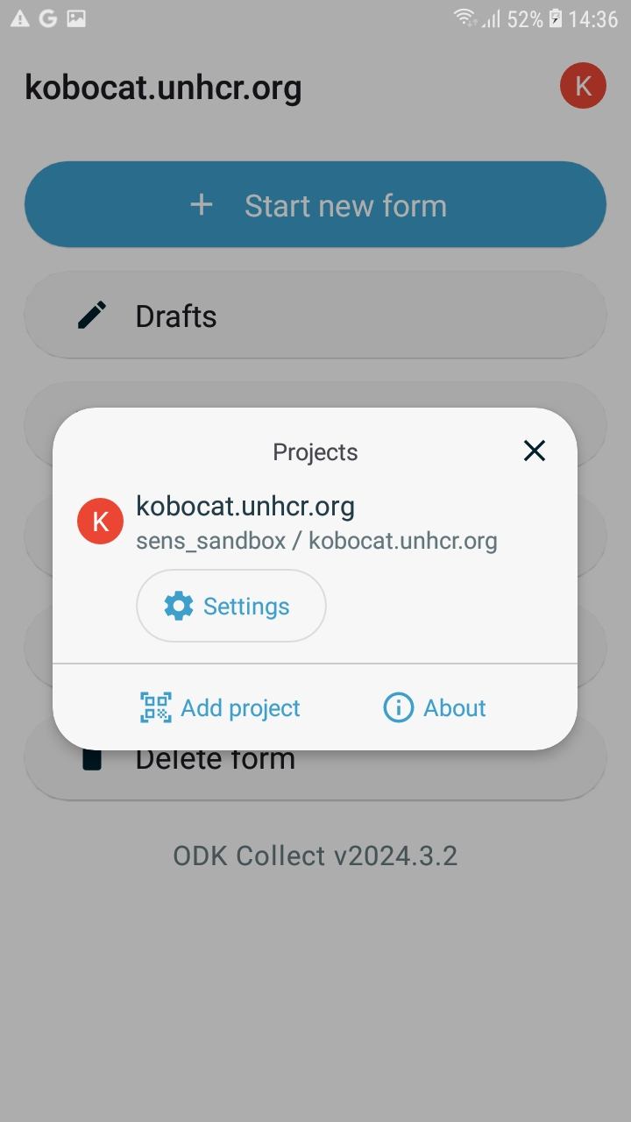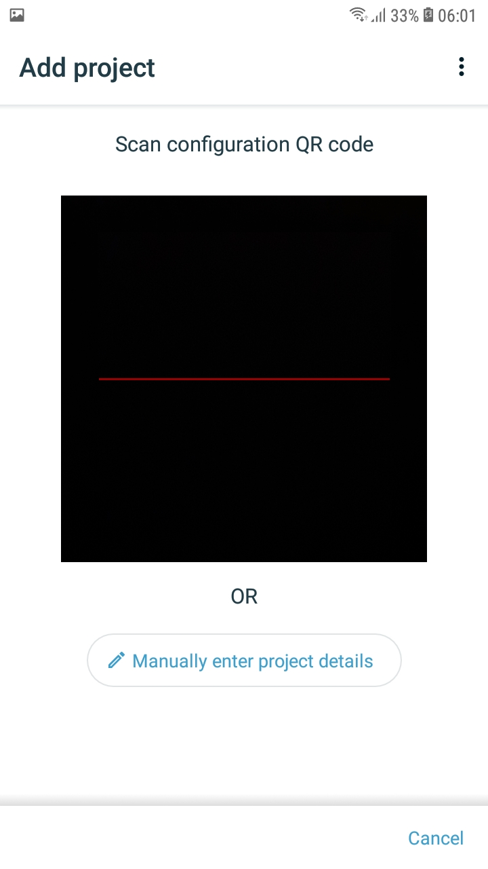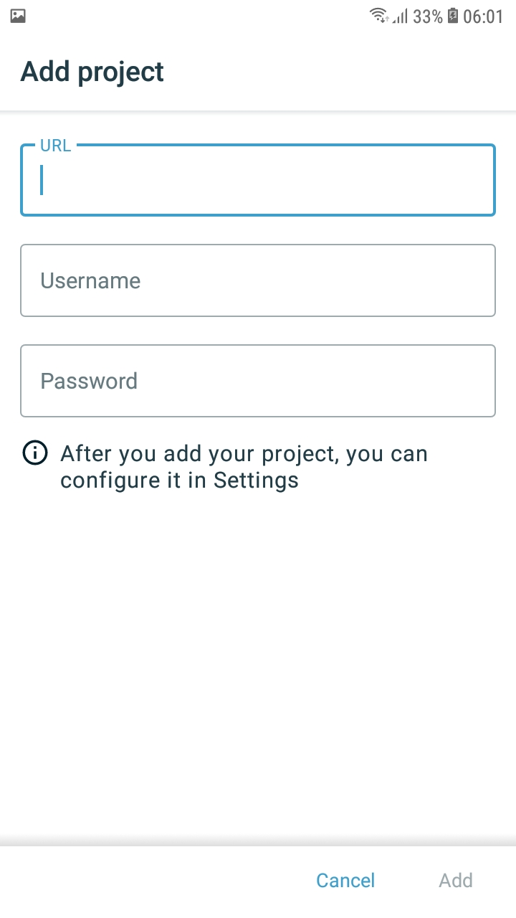
1. Click on the icon at the top of the screen | 2. Select Add project | 3. Select Manually enter project details | 4. Type the URL, username and password that will be used by all enumerators
To later edit the details of your server connection on the project, you can follow the below steps:
- On the Main Menu, tap on the circular icon on the top right corner of your screen and select Settings
- Select Server
Enter the logging credentials by taping on each of the fields: URL, Username and Password. These credentials will apply to all enumerators.
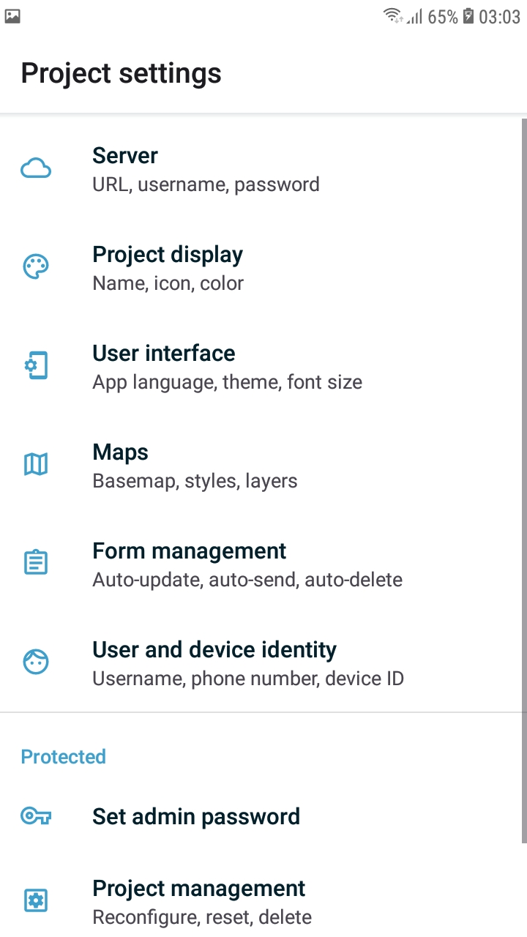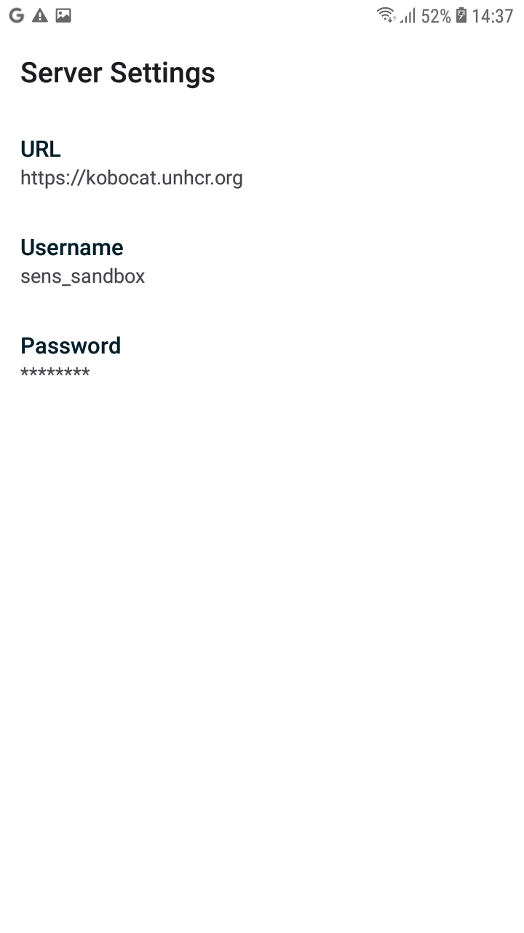
1. Click on the icon at the top of the screen | 2. Select Settings | 3. Select Server | 4. Type the URL, username and password that will be used by all enumerators

Customize menus
Supervisors might want to simplify the ODK Collect interface by limiting the number of options and menus available to enumerators. By default, the Main Menu comes with 6 options as seen in the screenshot bellow. To change these:
- On the Main Menu, tap on the circular icon on the top right corner of your screen and select Settings
- In Project settings under Protected, tap on Access control
- In Access control, tap on Main Menu Settings
- Tap to deactivate the options that you don’t want enumerators to have access to. For example, you can deactivate the function to delete saved forms and options to get new blank forms, which will reduce the number of buttons the enumerator will see and use
- Go back to the main menu and verify the results
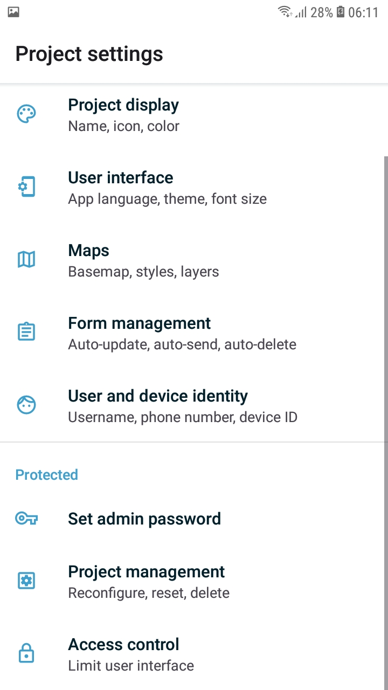
1. Click on the icon at the top of the screen | 2. Select Settings | 3. Tap on Access control
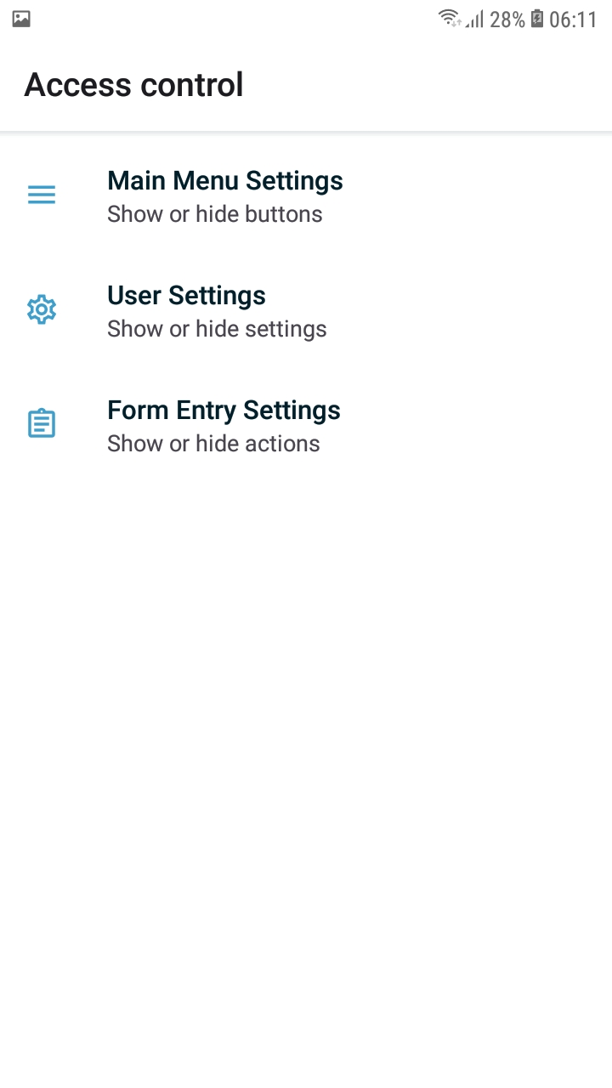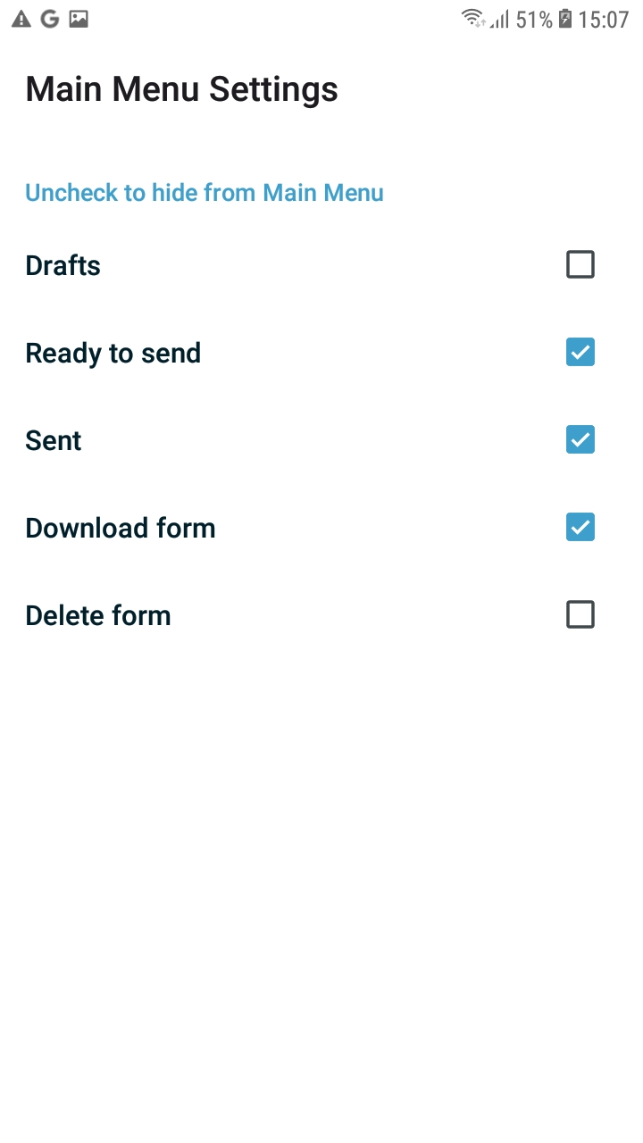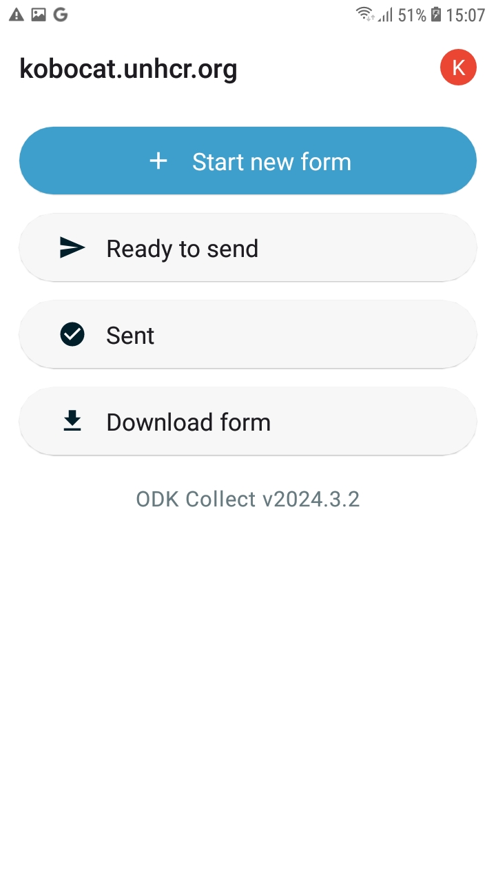
4. Tap on Main Menu Settings | 5. Tap to deactivate options that you don’t want to grant access to | 6. Verify the results

Form Entry Settings
The form management menu lets you customize form behavior and options, e.g. auto-send completed forms, deletion of sent forms, among others. One important option in SENS surveys is letting enumerators deliberately mark a form as completed instead of having it marked as completed by default at the end of each interview.
To change these settings:
- On the Main Menu, tap on the circular icon on the top right corner of your screen and select Settings
- Select Form management – This menu lets you control how, and if, forms are automatically updated, whether completed forms are to be automatically updated and how forms behave when filling them, among others
- To make sure supervisors can review the forms before they mark them as finalized, make sure that Auto send is unticked.
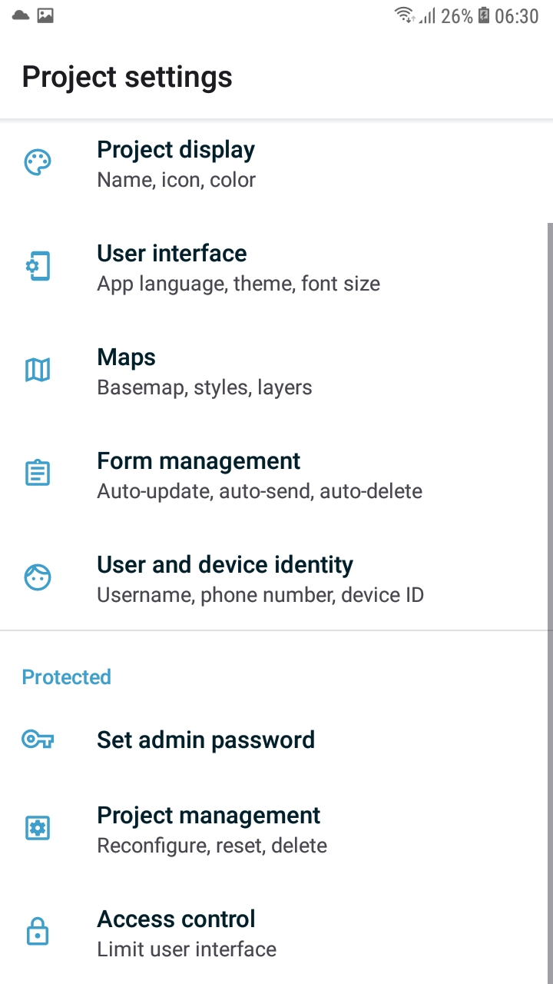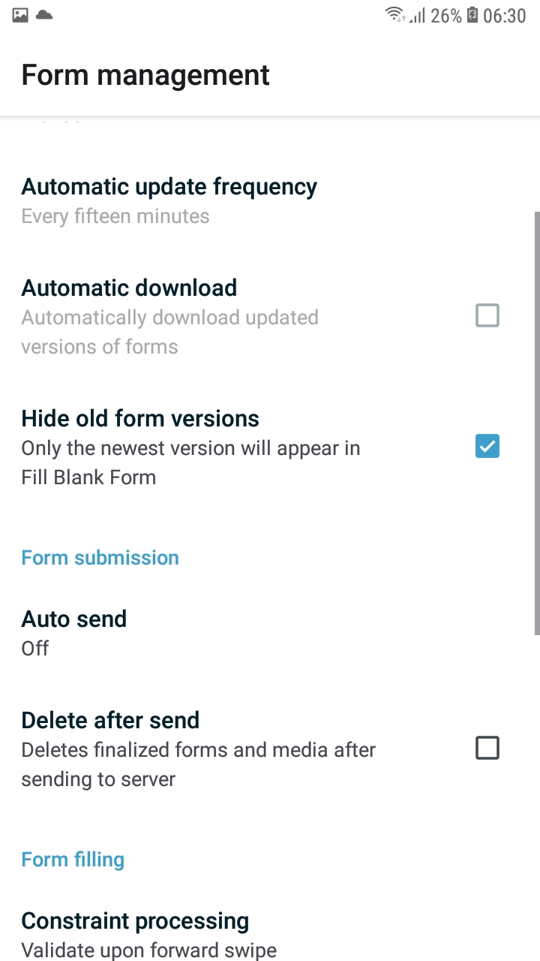
1. Click on the icon at the top of the screen | 2. Select Settings | 3. Click on Form management | 4. Untick Auto send

Setting up an admin password
Enabling an admin password restricts access to key application settings. Options like menu settings, servers, the app reset, will be protected so that enumerators can’t inadvertently modify them. To set and admin password:
- On the Main Menu, tap on the circular icon on the top right corner of your screen and select Settings
- Tap on Set admin password
- Type a password of your choosing making sure you write it down somewhere for later retrieval
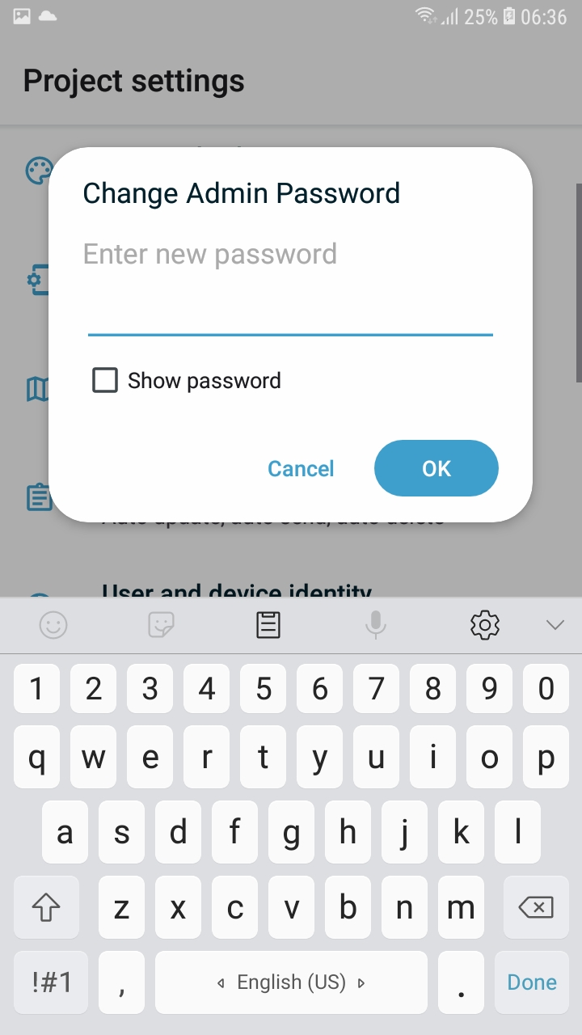
1. Click on the icon at the top of the screen | 2. Select Settings | 3. Select Admin Password | 4. Type a password making sure you keep track of it, then tap OK

Exporting the set up to other devices
Next, create a QR code to export those credentials to the other tablets.
- As in the previous steps, on the Main Menu tap on the icon at top right corner of the screen and select Settings
- Select Project management and then Reconfigure with QR code. ODK will display a screen that allows you to scan a new QR code or will show a QR code that can be exported to other devices
- Leave the QR code open on the tablet
1. Click on the icon at the top of the screen | 2. Select Settings | 3. Select Project management
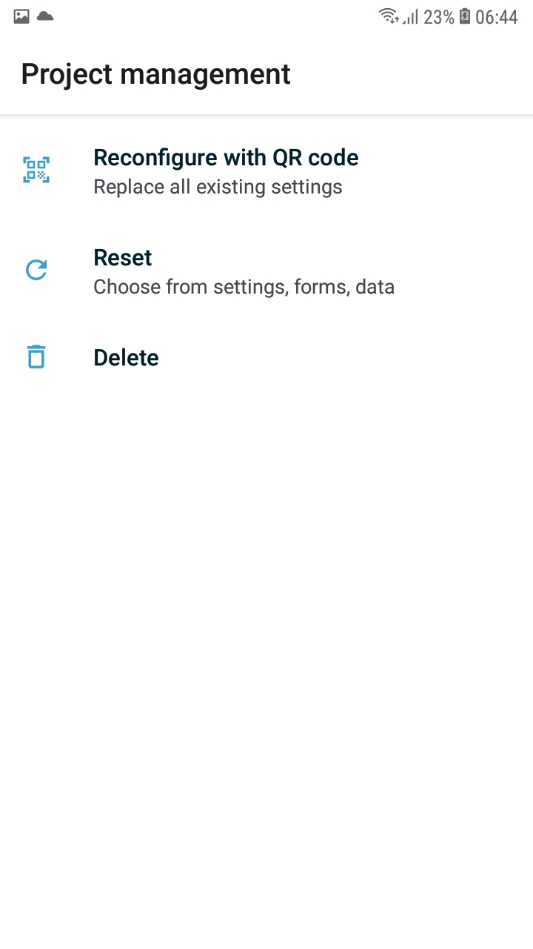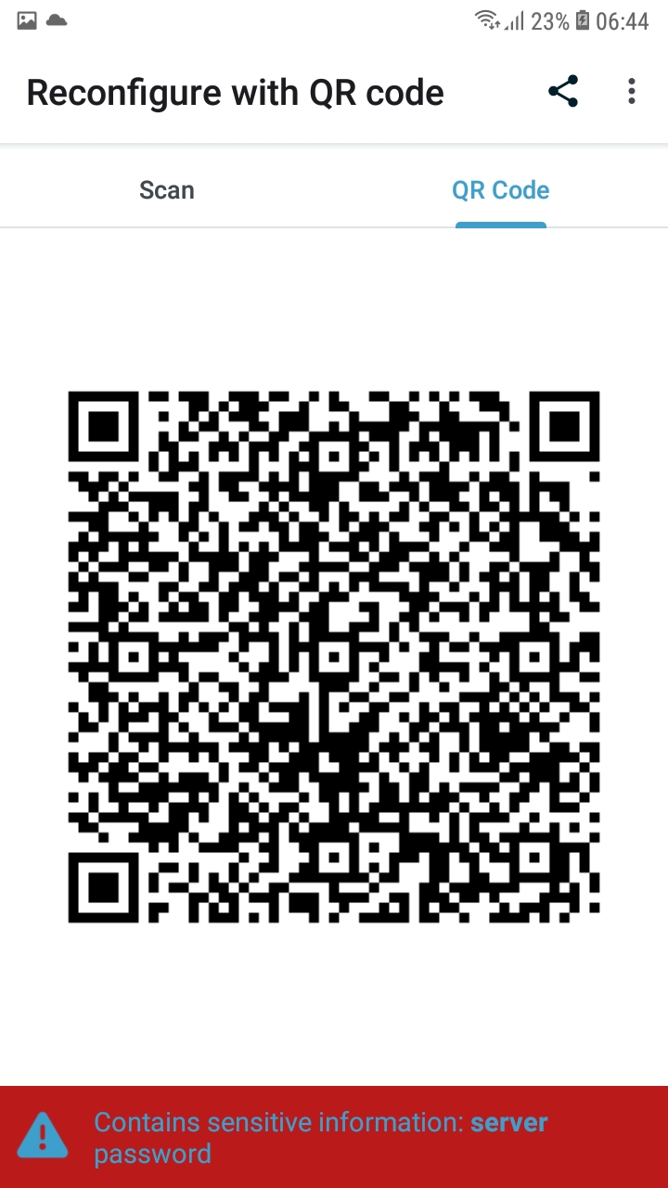
4. Select Reconfigure with QR code | 5. The QR code contains your device setup. Select QR CODE, leave it open and scan it with the other devices
To import the settings in the other tablets, open ODK Collect in the second devise and click Configure with QR Code.
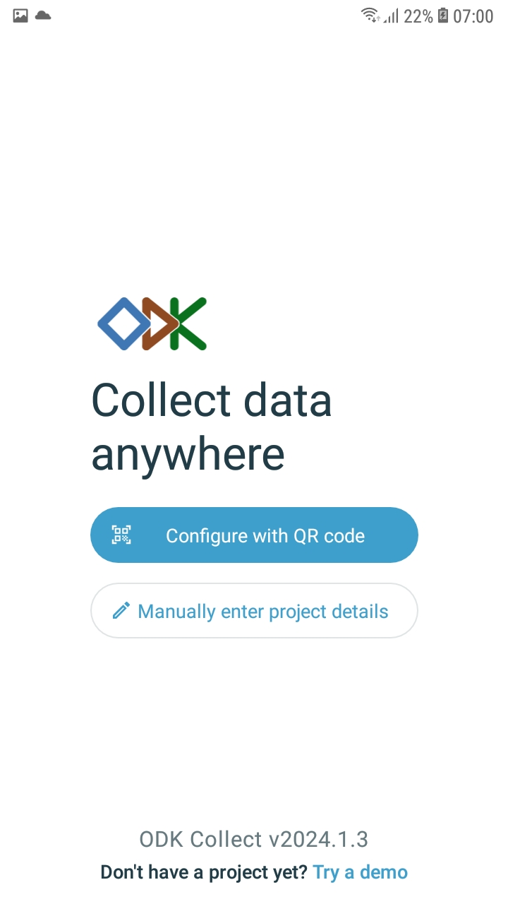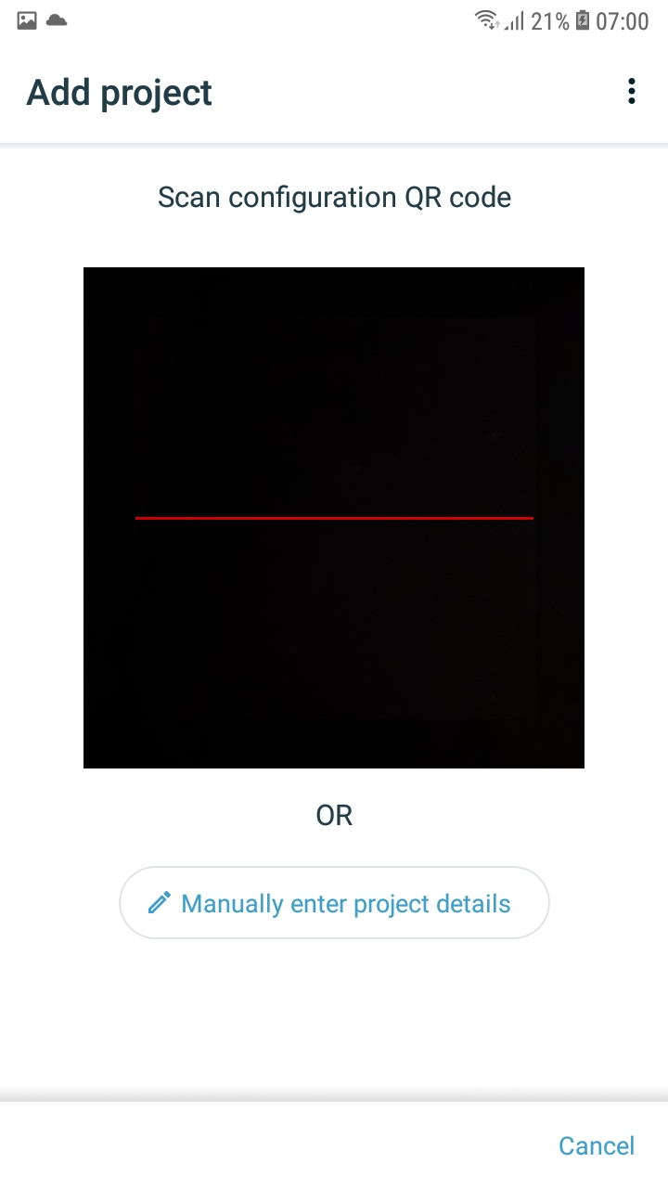
1. Select Configure with QR code | 2. Scan the QR code on the first tablet

- Note that the above instructions assume that you have not before used ODK Collect in your other devices. If you have, you can follow the below instructions:
- Icon on the top right > Add project – If asked, grant ODK Collect access to the device camera.
- Hold the tablet right above the first device and scan the QR code. Make sure to place the code inside the viewfinder rectangle to scan it.
- ODK Collect will immediately set up and you may continue with the next device.
1. Click on the icon at the top of the screen | 2. Select Add project | 3. Scan the QR code on the first tablet
Dark theme
The ODK display parameters can now be switched to Dark Theme. This is particularly useful if your devices have OLED screens, as using a dark screen can help you prolong the charge of the batteries.

Regardless of the type of the screen of your devices, the Dark Theme can make viewing the screen easier in low lighting environments. Encourage your enumerators to test this feature and adjust the settings to their preferences and changing lighting environments.
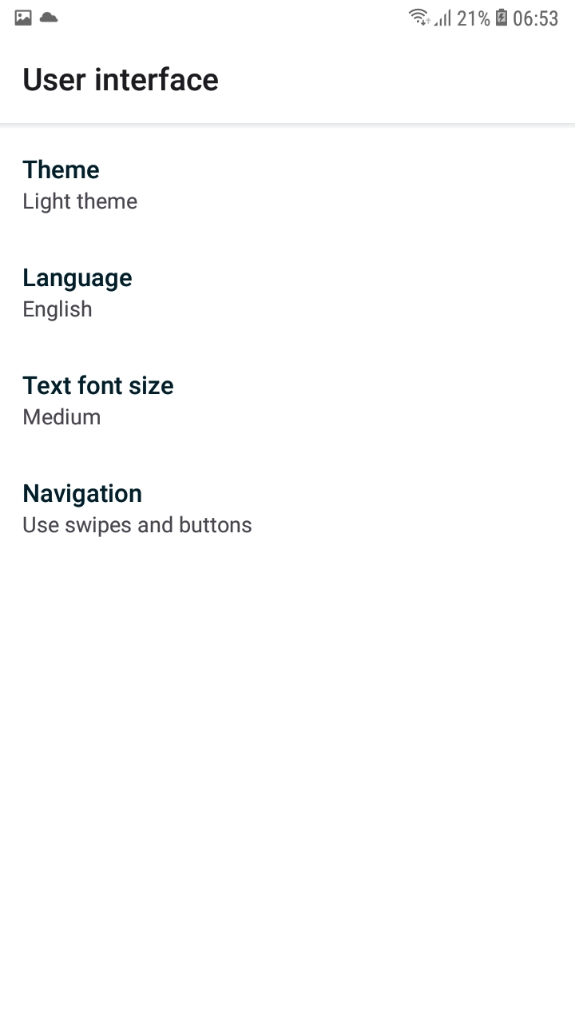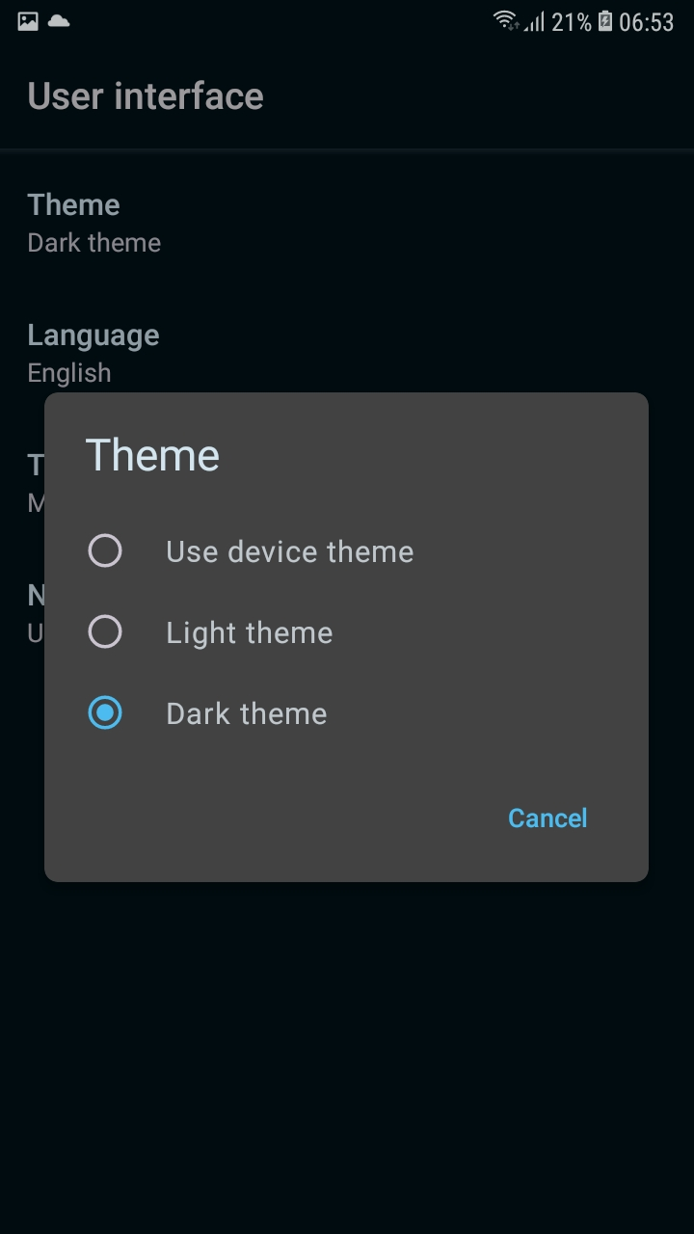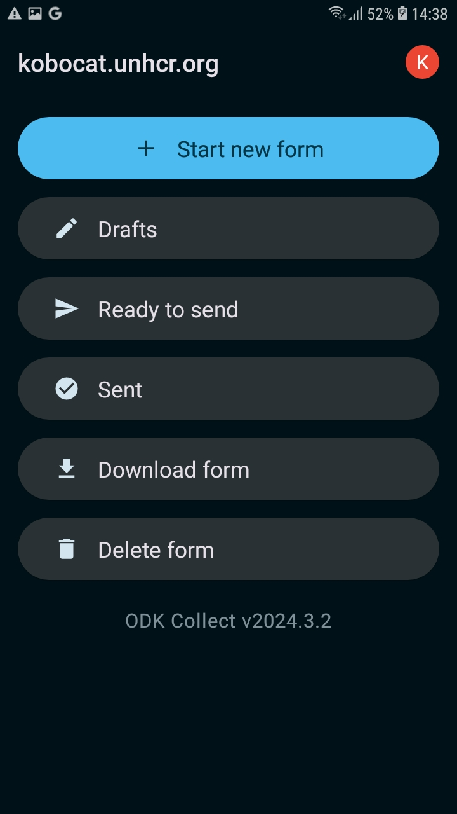
Go to Settings > User interface >Theme and click on Dark theme

