GPS coordinates in SENS surveys

I. Background 1
II. Implications of using GPS points 2
II.1. Data protection 2
II.2. Survey logistics 2
III. How to implement GPS data collection in your survey? 3
III.1. Implement GPS data collection by using ODK collect 3
III.2. Implement GPS data collection by using other applications 4
III.3. How to use GPS data collection applications? 4
IV. How to analyse GPS data? 4

Background
It is more and more common to gather GPS coordinates in SENS surveys for some of the modules, because this allows spatial analysis of the data by:
- Visualizing the same indicator collected in different areas which enables to see if there is any spatial correlation between results and potentially help adjusting assistance if necessary
- Evaluating spatial distribution of the sampling in households
- Allowing to compare survey results with proximity of services (such as water access for example) if maps of camp infrastructure already exist

The first step is therefore to check if any of the points mentioned above may be of interest to you. If it is the case, then you must also determine which indicators may need to be mapped since all modules and collected data do not require GPS coordinates.
Here is a list of the off-the-shelf possibilities of the SENS mapper analysis tool to help you identify what may be of interest from a mapping perspective:
- Child module: distribution within the camp of acute malnutrition, stunting (chronic malnutrition), or anaemia in children under age 5.
- WASH module: quantification and qualification of drinking water, for SENS V3 data it displays households collecting drinking water from protected/treated sources, households with at least 10 litres/person of potable water storage capacity.
- Woman module: distribution of anaemia in reproductive age women in camp.
- Mosquito Net module: distribution within the camp of the use of “Long Lasting Insecticidal Nets” (LLIN) in households

Below is one example of map that has been produced after GPS points have been collected:
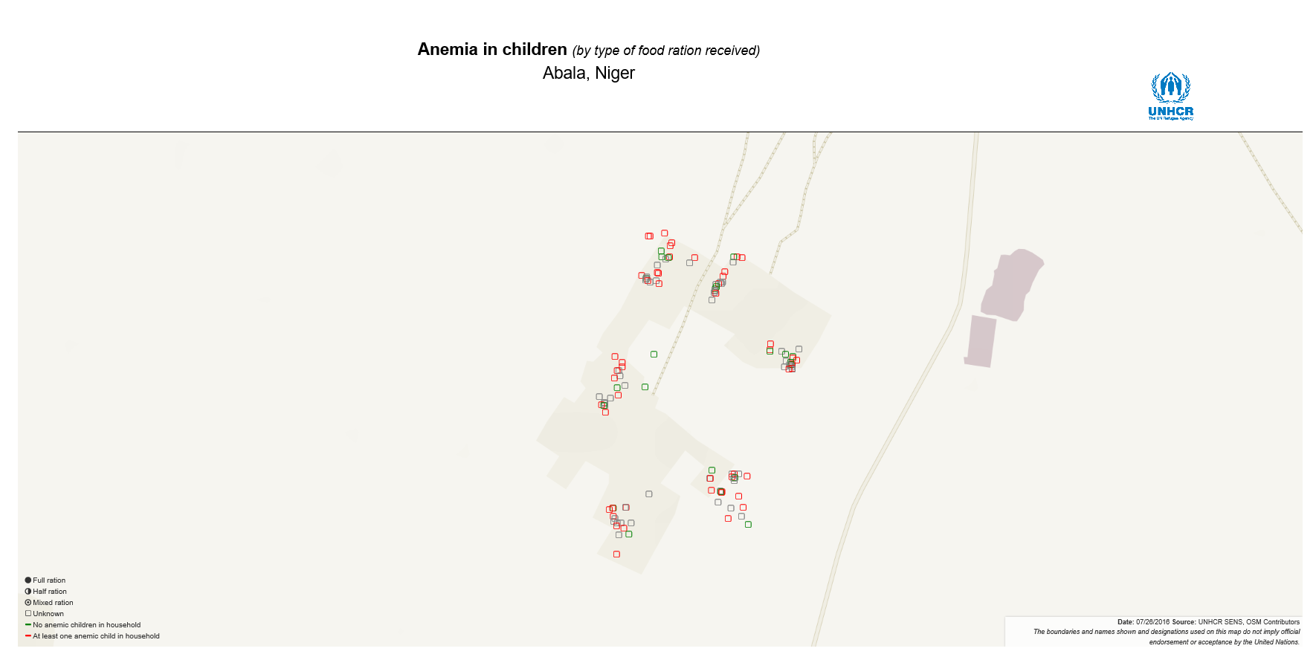
Figure 1: Mapping out Anemia in children from the SENS survey conducted in Abala, Niger. Background data: OpenStreetMap.

Implications of using GPS points

Data protection
Before deciding to use GPS points, you must consider whether there could be any possible risk for the populations of concern in the data in question being put in the wrong hands. Remember that GPS data is assimilated to personal identifiable information (PII); i.e. information that can be used on its own or with other information to identify, contact, or locate a single person, or to identify an individual in context.
- Keep in mind that like for any PII, the GPS location could be crosschecked with another dataset, which, if done with a sensitive dataset, could perhaps cause harm to the populations of concern. Please refer to the UNHCR data protection policy and guidance for more information.

In any case, remember that it is mandatory according to general data protection principles and also to UNHCR policy to collect respondents’ consent not only on other information being collected in the survey but also a separate one on the collection of GPS points - in a clear and simple language that respondents will understand and with an explanation of the purpose.

Survey logistics
You will also need to consider the following elements concerning GPS data collection:
- It will require more time (30 seconds to 1 minute) to acquire the GPS coordinates in each module
- The coordinates should be taken outdoor but no more than 5 meters away from the house to improve accuracy and speed up the acquisition
- It will also have an impact on your battery as it will take a little bit more energy to use the GPS. You should encourage enumerators to use all recommended practices to save energy, as explained in the training. Additionally, they should turn the GPS off when not in use for a long period of time.

How to implement GPS data collection in your survey?

Implement GPS data collection by using ODK collect
This is how the collection of the GPS coordinate will look like on the phone:
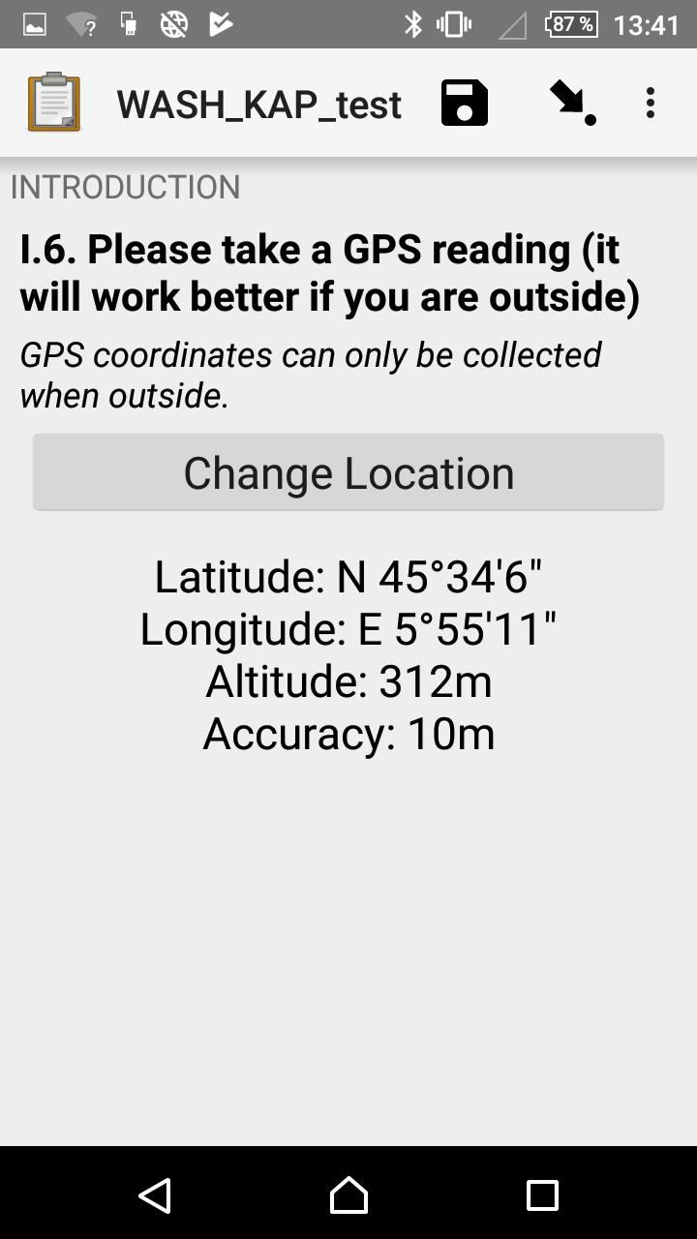
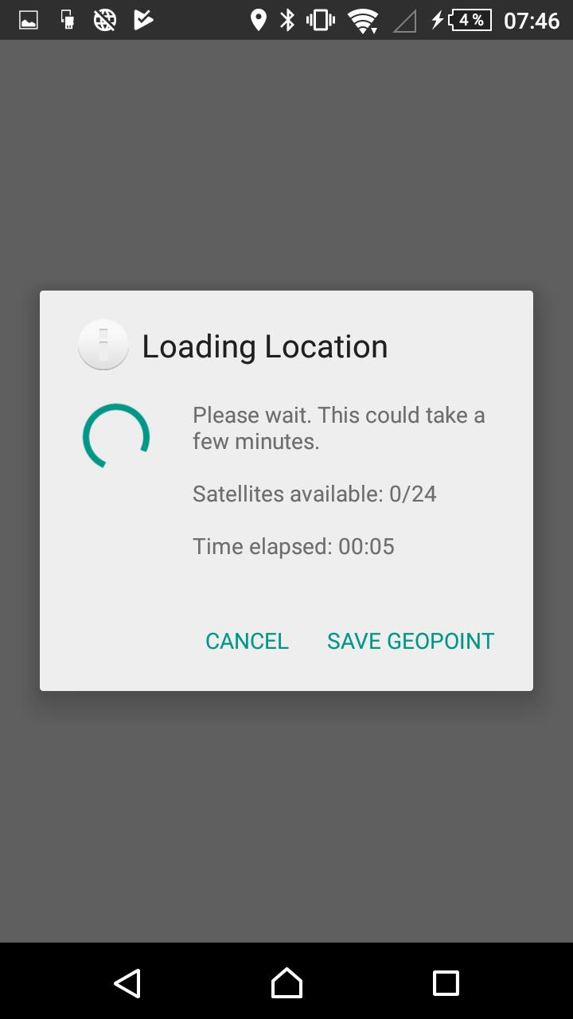
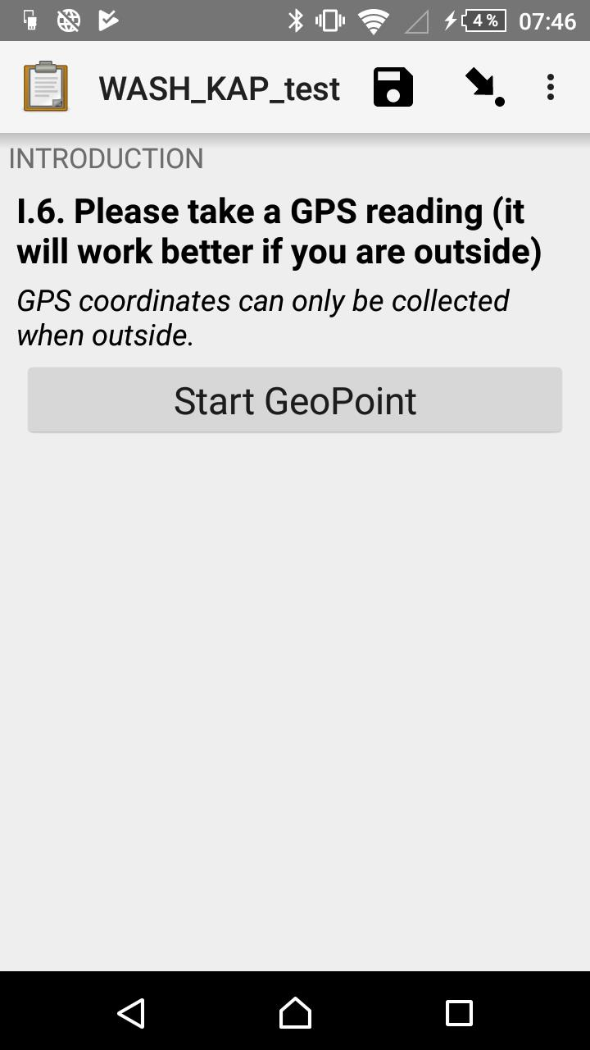
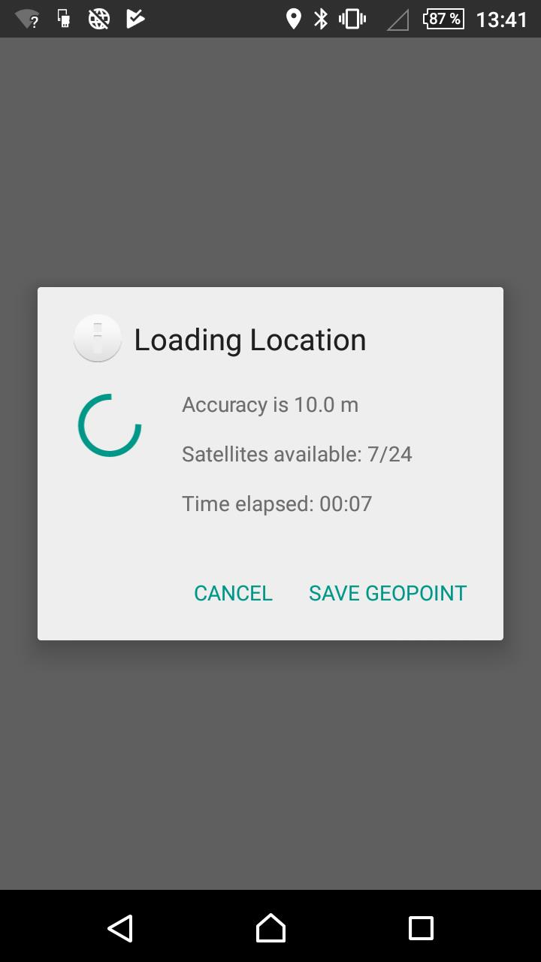
The coordinates are included by default in every SENS survey (except Demography/Mortality module) but not activated. If you want to use it, you need to remove the condition 1=2 in the relevant column associated with the GPS field of the global form: (search for “GPS” in column B)
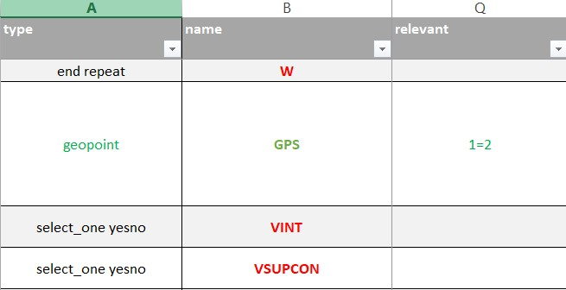
- If you are unable to do this, you can contact HQ for assistance.
- Do NOT make this question mandatory –there are legitimate reasons why it may not be possible to collect the GPS coordinate in a given location (such as technical issues with the phone). Forcing enumerators to do so may create issues as they might not be able to finish their records.

Implement GPS data collection by using other applications
Other applications are designed to allow quicker readings of location (and therefore by ODK Collect in our case) once they have been installed on the phones. Please note that the following app is available through Google Play services:
- GPS Test (formerly GPS Test Plus): which has been used for the SENS in the last years and can also be downloaded from the SENS Dropbox folder if you need an older version or cannot access Play Store.
In case GPS Test is not working well on your form, try others like GPS Status or GPS Fix.

How to use GPS data collection applications?
When smartphones are used for the first time, or have been shipped from another country, it is recommended to launch the GPS acquisition once outdoors so that it can obtain a fix on its new location. This process may take a few minutes – but it can be sped up if connected to a WIFI/SIM card. Once that first connection has been established, it will no longer be necessary to remain online or on a network.
Some basic requirements need to be followed when using GPS data collection applications in general:
- All the apps listed above must be launched in the morning to initialize the GPS;
- The accuracy of the reading should be below 15 meters;
- There is no need to use it again on the same day if you remain in the area when you change the location, you should re-use it.
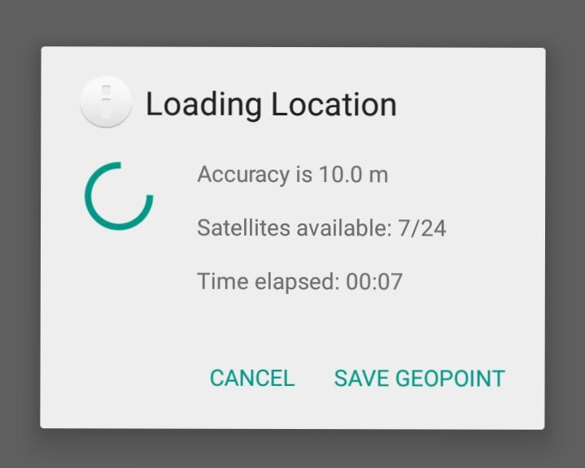
- In ODK Collect, the reading can be taken at any time manually (or it will be taken automatically when an accuracy of 5 meters has been reached). We suggest setting a threshold of 10 meters in the SOPs. More tips on how to collect GPS coordinates can be found in this blog post.

How to analyse GPS data?
A ready to use tool, the SENS mapper, has been developed to help create maps based on SENS data when GPS points have been included in the survey.
The SENS mapper can work as a standalone tool which means that you do not need to install any software to use it. Please note that you will need to have access to an internet connection and an internet browser. It has been optimized with Chrome but also works on Firefox. The mapper can either show OpenStreetMap data or Camp Mapping data (if available) as a background and is available online: http://maps.unhcr.org/apps/mdc_mapper/sens/index.html.
More information can be found in its documentation. Below is a map sample. Both SENS data on quantification and qualification of drinking water as well as the functional water points in the camp from the UNHCR camp map application appear on the map.
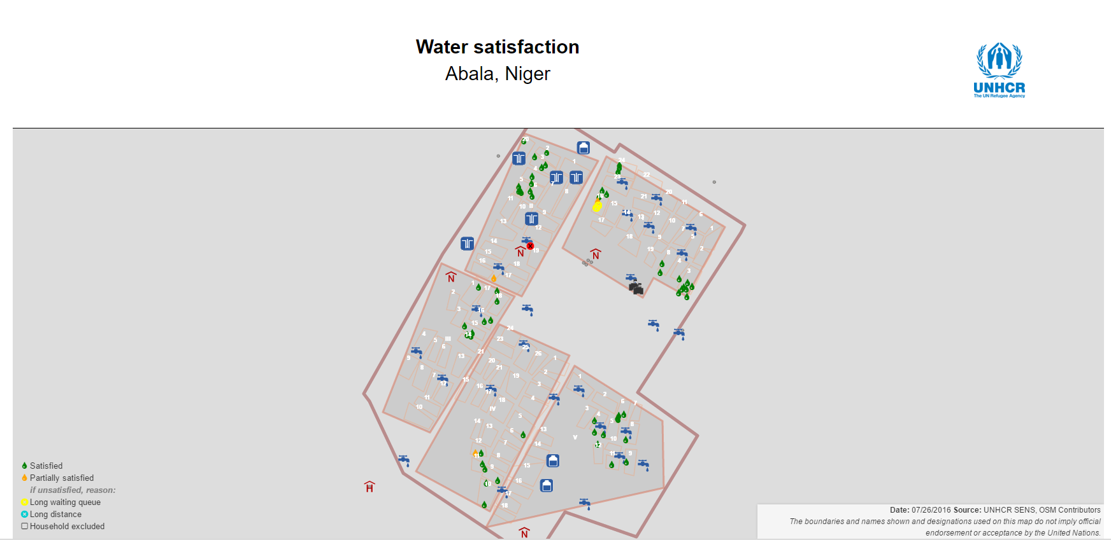
Figure 2: Mapping out Water satisfaction of the households selected for interviews in Abala, Niger. Background data: Historical data obtained from REACH incorporated into the UNHCR Camp Mapping Application.

- If you are interested to create any of these maps, don’t hesitate to contact HQ for support.

http://maps.unhcr.org/apps/mdc_mapper/sens/index.html
https://www.refworld.org/pdfid/55643c1d4.pdf

