UNHCR
STANDARDISED EXPANDED
NUTRITION SURVEY (sens) GUIDELINES
FOR REFuGEE POPULATIONs

MODULE 5:
water, Sanitation and hygiene
(WASH)

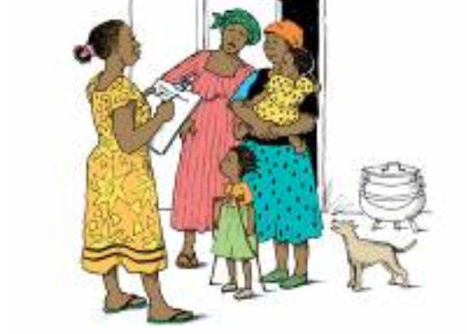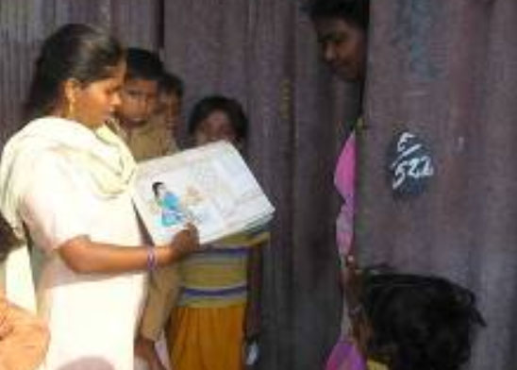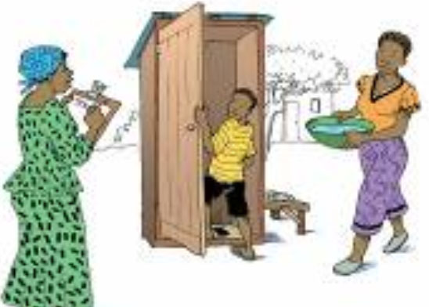


A PRACTICAL STEP-BY-STEP GUIDE VERSION 2 (2013)

Table of Contents

Key messages 4
Definitions of some key terms 5
Objectives 9
Data collection 10
Measurement methods 10
Material needed 10
Ethical considerations 10
Standard procedure and quality assurance 11
Training 12
Theoretical component 12
Practical component 14
Questionnaire and rationale of questions 15
Data cleaning 19
Daily questionnaire check and overseeing interviews 19
Database check 19
Presentation of results 20
Results tables and figures 21
Data analysis 24
Analysis procedures 24
Common errors and challenges in data analysis 29
Use of results 30
Classification of public health problem and targets 30
Recommendations 31
References 32

Annex 1 - Water source and sanitation facility definitions 34
Annex 2 - Water containers 43
Annex 3 - SENS WASH questionnaire 45
Annex 4 - Training ideas 47
Annex 5 - Epi info Data Entry 51
Annex 6 - Epi info Data Analysis 52
Annex 7 - Presentation of combined camp results 64

Key messages

- The inclusion of the basic WASH module in the nutrition survey will provide key information for planning interventions to address public health concerns and to ensure that basic rights are upheld.

- Poor water, sanitation and hygiene have serious consequences for the health and nutrition status of persons of concern to UNHCR.

- The WASH module provides only the core quantitative indicators for monitoring WASH programmes at the household level and should be used in conjunction with more detailed qualitative assessments undertaken by WASH specialists.

- The majority of questions for the household survey are taken from the UN Joint Monitoring Programme for Water and Sanitation that seeks to harmonise the surveys undertaken in the sector. The harmonisation of survey instruments and survey design can allow for comparison between e.g. national populations and refugee populations.

- On the standardised SENS WASH questionnaire, the questions on water source and sanitation facilities offer a detailed choice of technologies to choose from but it is only necessary to list the options applicable for the specific context that is being assessed (the wording of the actual questions should not be changed).

Definitions of some key terms

WASH: The main objective of water and sanitation interventions is to improve hygiene and health, and this entails ensuring that people are involved in decisions about the programme and that they make the best use of the facilities provided. The term WASH is preferred to water and sanitation or ‘watsan’ to emphasise the importance of a holistic approach to service delivery that focuses on health outcomes and encourages the involvement of communities.

Improved and unimproved drinking water sources

- The type of drinking water source used by the household serves to indicate whether their drinking water is of a suitable quality or not. The following “improved” water sources are assumed to be of a suitable quality: a piped water supply into the home or a yard/plot, a public tap/standpipe, a tube well/borehole (with pump), a protected dug well, a protected spring and rainwater collection.

- The following “unimproved” water sources are likely to be contaminated: an unprotected spring, an unprotected dug well, a small water vendor (e.g. cart with a small tank / drum), a water tanker-truck and surface water (e.g. river, pond).

- Tankering water may be used early on in an emergency response by UNHCR or partners; this is referred to as “UNHCR Tanker”. For the water to be considered “improved”, it must be chlorinated. Where water is sold from a tanker by a private contractor (like a water “tanker-truck”), it is considered “unimproved”.

- Bottled water is considered “improved” only when the household uses it by choice rather than because they are obliged to or when it can be guaranteed that this water is not contaminated. This will need to be assessed prior to the survey and categorised accordingly on a case-by-case basis.

Excreta disposal facilities

Sanitation facility definition

- An “improved” sanitation (toilet) facility is one that hygienically separates human excreta from human contact. The types of technology that are likely to meet this criterion are: flush to piped sewer system; flush to septic tank; pour flush to pit; composting toilet; VIP latrine; pit latrine with a floor / slab.

- Types of sanitation (toilet) facilities that are “unimproved” are: flush / pour flush to anywhere other than above mentioned e.g. an open drain; pit latrine without a closed slab or with an open pit; bucket; and a hanging toilet (often over an open water source or drain).

Sanitation facility classification based on above definition and on sharing

- Improved excreta disposal facility: To maintain consistency with other survey instruments (e.g. the multiple indicator cluster survey), UNHCR SENS WASH module classifies an “improved excreta disposal facility” as a toilet in the above “improved” category AND one that is not shared with other families. A single household toilet is not shared and is usually the easiest to keep clean.

- Shared family toilet: In refugee contexts, a “shared family toilet” is defined as a toilet in the above “improved” category AND one used by 2 families / households only (for a maximum of 12 people). It is believed that people are less likely to take responsibility for cleaning and maintenance of the toilet if there is more than one family using it. Nevertheless, it is important to note that this type of toilet is considered as an adequate level of provision for the medium term for UNHCR. In over-populated or urban areas especially, shared facilities are often the only viable alternative.

- Communal toilet: In refugee contexts, a “communal toilet” is defined as a toilet in the above “improved” category AND one used by 3 families / households or more. Often people will not have a sense of ownership or responsibility for the communal facilities unless they are mobilised to do so.

- Unimproved toilet: In refugee contexts, an “unimproved toilet” is defined as a toilet in the above “unimproved” category OR a public toilet which any member of the public can use e.g. in hospitals or markets – open use means that it is often difficult to ensure maintenance and cleanliness.

Table 1 provides an overview of the definitions of drinking water and sanitation (toilet) facilities

Table 1 Definitions

Drinking Water | Improved source | Unimproved source
Drinking Water | Piped water into dwelling, plot or yard | Unprotected spring
Drinking Water | Public tap/standpipe | Unprotected dug well or protected dug well with bucket
Drinking Water | Tube well / borehole (and pump) | Small water vendor (cart with small tank or drum)
Drinking Water | Protected dug well with hand pump | Tanker truck
Drinking Water | Protected spring | Bottled water*
Drinking Water | Rainwater collection from roof | Surface water (river, dam, lake, pond, stream, canal, irrigation channels). Rainwater collection from surface run off
Drinking Water | UNHCR tanker **
*Bottled water is considered improved only when the household uses it by choice rather than because they are obliged to or when it can be guaranteed that this water is not contaminated. This will need to be assessed prior to the survey and categorised accordingly.

**Tankering water may be used early on in an emergency response by UNHCR or partners. For the water to be considered ”improved” it must be chlorinated. Where water is sold from a tanker by a private contractor, it is considered “unimproved”.

Sanitation facility definition

 | Improved category | Unimproved category
 | Flush / pour flush to: | Flush / pour flush to:
 | - piped sewer system | - elsewhere e.g. to open drain
 | - septic tank | Pit latrine without slab (slab with holes) /open pit
 | - pit latrine | Bucket
 | - pit latrine | Hanging toilet / hanging latrine
 | VIP latrine | No facilities or bush or field
 | Pit latrine with slab
 | Composting toilet
Sanitation facility classification based on definition and sharing

Improved excreta disposal facility | A toilet in the above “improved” category AND one that is not shared with other families*,**
Shared family toilet | A toilet in the above “improved” category AND one used by 2 families / households only (for a maximum of 12 people)**
Communal toilet | A toilet in the above “improved” category AND one used by 3 families / households or more
Unimproved toilet | A toilet in the above “unimproved” category OR a public toilet which any member of the public can use e.g. in hospitals or markets
*To maintain consistency with other survey instruments (e.g. the multiple indicator cluster survey), UNHCR SENS WASH module classifies an “improved excreta disposal facility” as a toilet in the above “improved” category AND one that is not shared with other families / households.

**According to UNHCR WASH monitoring system, an “improved excreta disposal facility” is defined differently than in survey instruments and is defined as a toilet in the above “improved” category AND one that is shared by a maximum of 2 families / households or no more than 12 individuals. Therefore, the following two categories from the above SENS survey definitions are considered “improved excreta disposal facility” for UNHCR WASH monitoring system: “improved excreta disposal facility” and “shared family toilet”.

Safe excreta disposal for children aged 0-3 years: The safe disposal of children’s faeces is of particular importance because children’s faeces are the most likely cause of faecal contamination to the immediate household environment. It is also common for people to think that children’s faeces are less harmful than adult faeces. “Safe” is understood to mean disposal in a safe sanitation facility or by burying. This is the method that is most likely to prevent contamination from faeces in the household.

Things to note:

- More detailed explanations with pictures of specific water sources and sanitation facilities are provided in Annex 1. Help in deciding which types of water source and sanitation facilities that are available in a specific refugee context can be sought from WASH specialists working in the survey area.

Objectives

The SENS WASH survey questions aim to measure the following priority indicators at household level:

- Use of an adequate quantity of water
- Access to an improved drinking water source
- Safe excreta disposal practices

The objective should be worded as follows in the survey protocol and report:

- To determine the population’s access to, and use of, improved water and sanitation and hygiene facilities.

The specific objectives of the SENS WASH survey are to determine:

- The proportion of households that use an improved drinking water source
- The proportion of households that use a covered or narrow necked container for storing their drinking water
- The proportion of households that use an adequate quantity of water per person per day
- The proportion of households who say they are satisfied with the water supply
- The proportion of households using an improved excreta disposal facility
- The proportion of households with children under three years old whose (last) stools were disposed of safely

Data collection

Measurement methods

- WASH variables are assessed using interviews with mothers or the main caretaker of young children and specific observations.

- In order for the measurement methods to be reliable, it is vital that the questions are asked exactly as they are written and that any modification is agreed with all the surveyors so that the methodology is as standardised as possible.

- The capacity (in litres) of common water storage containers used in the specific context must be investigated prior to training the surveyors in order for the surveyors to make an accurate assessment of this variable. Annex 2 shows common water containers used. Pictures should be taken in each context to be shown during training of surveyors.

Material needed

- WASH survey questionnaires: 1 per household surveyed (always carry extra copies).

- The SENS WASH questionnaire is shown in Annex 3 or see SENS Pre-Module tool: [Tool 9-Full SENS Questionnaire].

- WASH pictorial guide for identifying different types of water sources, sanitation facilities and size of water containers.

Ethical considerations

- A standard WASH questionnaire will be administered with the consent of the householder. Refer to SENS Pre-Module Step 13 for guidance on approaching households and seeking informed consent.

Standard procedure and quality assurance

- A standard WASH questionnaire will be administered on a sample of households (refer to SENS Pre-Module Step 8 for guidance).
- A questionnaire is administered to the household even if there are no eligible children for the nutrition survey.
- The same definition of the household (appropriate to the context) should be used by all survey teams and in all subsequent surveys.
- The respondent should be the main carer of any children in the household or a responsible adult (preferably over the age of 18 years) who is able to answer the questions accurately.
- The children aged 0-3 years should be identified.
- The majority of questions rely on self-report from the key respondent. However, where there are doubts about the type of sanitation facility, observation may be necessary.

Training

- The training needs to contain a mix of theory, practical exercises (especially role plays), a standardisation exercise as well as a written or verbal test. Annex 4 provides some training ideas.

- It is crucial that the coordinator(s) refresh their skills before beginning the training and read all of the background material provided.

- The training on the SENS WASH questionnaire will require at least half a day.

- The questionnaire should be adapted prior to the training by selecting the categories that apply to the specific context for the water sources and type of sanitation facilities. Minor changes to wording / phrases or the use of explanations for questions can be agreed upon with the whole team during the training.

Theoretical component

The theoretical component on the WASH module should include:

- Overview of module, questionnaire and procedure to be followed
- The rationale for asking specific questions
- Information on specific WASH terms
- Information to help surveyors distinguish different water and sanitation technologies specific to their area
- A short written or verbal test

Things to watch out for:

- Table 2 describes the most common errors experienced by survey workers in WASH data collection. These should be emphasised during the training and the survey coordinator(s) and supervisor(s) should focus on these when assessing the teams’ performance during supervision visits throughout the survey.

Table 2 Common errors and challenges in data collection

Common errors | Examples | Solution
Respondents feel embarrassed to answer the questions | Women may not feel comfortable answering questions if the enumerator is male. | Investigate the likelihood of this being a problem prior to the survey and ensure that there are female interviewers.
Questionnaire categories do not capture the responses most commonly given | High percentage of ‘other’ category checked. | Adequate preparation prior to the survey is vital. Make sure that the questionnaire selects the context specific categories and that the surveyors understand these categories.
Respondents do not understand the questions or the information is too difficult to report | High percentage of ‘don’t know’ categories. | Review questions and translation.  Ensure that the respondent is ‘knowledgeable’ about the topic, i.e. that they know where young children defecate.
Inconsistencies in data collection | The skip patterns are not respected. | The supervisors must check the questionnaires; either in the field or at the end of the day and rectify any errors as quickly as possible.
Question is not read exactly as it is written | The surveyor asks about any water source rather than drinking water source specifically. | The training needs to highlight the common pitfalls.  During supervision visits, close attention must be paid to these pitfalls.
Surveyor does not understand the question well enough | The surveyor asks about the water that was collected the day of the survey. | The training needs to ensure that surveyors are well prepared so that they can explain the questions to the respondents in a standardised fashion.
The amount of water is not accurately assessed | Surveyors are not confident in determining capacity of containers and guess. | Ensure good preparation to identify likely containers used. Test surveyors during training. Ensure that they know when to contact the supervisor for help.

Practical component

- The practical component should form the main part of the training and should employ role-play to ensure that surveyors are following standard procedures and that they communicate effectively and respectfully with respondents.

Guidance for coordinators

- Table 3 provides instructions on the questionnaire for adaptation to the local context and instructions to be given to the surveyors.
- Discuss with WASH specialists on the types of technology used in the area. Delete any unnecessary options that do not apply to your area of investigation.
- Obtain photographs where possible and compile a quick pictorial guide of the different types of water sources, sanitation facilities and water container sizes that surveyors are likely to come across. Useful illustrations can be found at the following link:
http://www.childinfo.org/files/JMP_Pictorials_for_Water_and_Sanitation.pdf
- Invite a WASH partner involved to support facilitation where possible.
- Prepare / translate and back translate the questionnaire: do not change the wording of the questions.
- Sanitation may be a sensitive topic in some situations and this should be assessed prior to the survey so that acceptable ways of asking the household about their toilet facility can be determined. It may be necessary to have female surveyors interviewing female respondents.
- Some participants will learn more quickly than others and they should be paired with the less able surveyors both in the training and in the field.

Basic instructions for survey teams

- Survey teams need to be trained on interview techniques: introduction, consent, confidentiality etc.
- It is very important that surveyors ask each question exactly as it is written on the questionnaire.
- In addition to the questions, there are statements that appear in capital letters, indicating that they are surveyor instructions and should not be read aloud to the respondent.
- The question may need to be repeated again but the wording should not be changed too quickly as it may be that the respondent did not hear properly or was not concentrating.
- When a question is unclear, it should be asked again or with slightly different wording but care must be taken not to change the meaning or lead the respondent into giving a specific response.

Questionnaire and rationale of questions

- Table 3 below provides instructions on the questionnaire for adaptation to the local context, explain the rationale of each question, and highlight special instructions to be given to the surveyors.

- The recommended names and descriptions of the standard variables (as shown in the SENS WASH questionnaire shown in Annex 3), and the range of correct codes are shown in Table 3.

- A standard Epi Info View for data entry is shown in Annex 5. Free guidance on the use of Epi Info for Windows and training material on Epi Info can be found at the following site: http://www.cdc.gov/EpiInfo

Table 3 WASH Survey Module: Explanation of questions

Question number/  Section WS1 | Suggested variable name | Question | Rationale | Special Instructions
WS1 | HHSIZE | How many people live in this household and slept here last night? | This question is important for determining the total amount of water used by the household per day. | If one or more of the household members are away and did not sleep in the household last night, do not account for them.
WS2 | SOURCE | What is the main source of drinking water for members of your household?  01=Piped water; 02=Public tap/standpipe; 03=Tube well/borehole (& pump); 04=Protected dug well; 05=Protected spring; 06=Rain water collection; 07=UNHCR Tanker; 08=Unprotected spring; 09=Unprotected dug well; 10= Small water vendor; 11=Tanker truck; 12=Bottled water; 13=Surface water (e.g. river, pond); 96=Other; 98=Don’t know | The assumption is made that if households use an improved drinking water source, they are more likely to be drinking clean water. It is not yet possible to test all household water quickly and cheaply in a large-scale survey. | Ask about drinking water sources only, not other water sources.  Do not read the answers. Select one option only.  Adapt the answer options to the sources of water that are available to the surveyed population at the time of the survey. When adapting the options list, keep the original answer codes and do not change.
WS3 | SATISFY | Are you satisfied with the water supply?  1=Yes; 2=No; 3=Partially; 8=Don’t know | The question is subjective but the aim is to encourage greater accountability to affected populations and to at least have some quantitative data on user satisfaction. | This question relates to the drinking water supply.  If the response is ‘Yes’, ‘Partially’ or ‘Don’t know’ surveyor should skip to question WS5.
WS4 | REASON | What is the main reason you are not satisfied with the water supply?  01=Not enough; 02=Long waiting queue; 03=Long distance; 04=Irregular supply; 05=Bad taste; 06=Water too warm; 07=Bad quality; 08=Have to pay; 96=Other; 98=Don’t know | This question aims to identify the main reason why households are not satisfied with the water supply.  If many people are not satisfied then more in depth qualitative research may be required to identify and address the problems identified. | This question only applies to household answering ‘No’ to WS3.  Adapt the answer options to the context.
WS5 | TOILET | What kind of toilet facility does this household use?  01=Flush to piped sewer system; 02=Flush to septic system; 03=Pour-flush to pit; 04=VIP/simple pit latrine with floor/slab; 05=Composting/dry latrine; 06=Flush or pour-flush elsewhere; 07=Pit latrine without floor/slab; 08=Service or bucket latrine; 09=Hanging toilet/latrine; 10=No facility, field, bush, plastic bag | The aim of this question is to assess if the sanitation facility used by the household is defined as “improved” or “unimproved”, in order to complement the next question (WS6) and categorise the toilet facility. | Do not read the answers. Select one option only.  Adapt the answer options to the toilet facilities available to the surveyed population at the time of the survey. When adapting the options list, keep the original answer codes and do not change.  The question specifically asks what the household uses rather than what they have.
WS6 | TOILSHR  (optional to enter this data onto database) | How many households share this toilet?  Number of households (including the surveyed household) | The aim of these questions (WS5 and WS6) is to assess if the household uses: 1) an improved excreta disposal facility, 2) a shared family toilet, 3) a communal toilet, or 4) an unimproved toilet.  Public toilets that anyone can use (typically in a market or clinic) are very difficult to keep clean and may therefore discourage users. Communal toilets that are shared between a large number of families (3 or more households) may also be difficult to keep clean but it might be possible to organise a system of cleaning by dividing up the toilet block.  Shared family toilets, where no more than 2 families or no more than 12 people use the facilities will be easier to keep clean but a cleaning rota may still be necessary.  Single family toilets are not shared and should be the easiest to keep clean and maintain. | Record the number of households if known. This includes the surveyed household. Record 96 for public toilet. Record 98 if number of households is unknown.  Select one option for the toilet sharing category.
WS6 | TOILSHR_c  (toilet sharing category) | 1=Not shared (1 HH)  2=Shared family (2 HH)  3=Communal toilet (3 HH or more)  4=Public toilet (in market or clinic etc.)  8=Don’t know
WS7 | CHILD | Do you have children under three years old?  1=Yes  2=No | This question is to assess whether question number WS8 is applicable. | The child should be 35 months or younger and might be a young baby.
WS8 | STOOL | The last time [NAME OF YOUNGEST CHILD] passed stools, what was done to dispose of the stools?  01=Child used toilet/latrine; 02=Put/rinsed into toilet or latrine; 03=Buried; 04=Thrown into garbage; 05=Put/rinsed into drain or ditch; 06=Left in the open; 96=Other; 98=Don’t know | The safe disposal of children’s faeces is of particular importance because children’s faeces are the most likely cause of faecal contamination to the immediate household environment. It is also common for people to think that children’s faeces are less harmful than adults.  The preferred disposal method, which is likely to ensure protection of the household environment from faecal contamination, is putting or rinsing stools into a sanitation facility. | Do not read the answers. Select one option only.  Use the name of the youngest child when asking the question so that the respondent is as specific as possible.  Try to ensure that the person answering this question is the child’s main caretaker.  If the respondent suggests ‘don’t know’ too quickly, this may indicate that they are not the main caretaker and someone else should be asked this question.

OBSERVATION BASED QUESTIONS (observations are done after the initial questions to ensure the flow of the interview is not broken)
Section WS2
WS9 | LITRE | Please show me the containers you used yesterday for collecting water.  CALCULATE THE TOTAL AMOUNT OF WATER USED BY THE HOUSEHOLD PER DAY. THIS RELATES TO ALL SOURCES OF WATER (DRINKING WATER AND NON-DRINKING WATER SOURCES) | Hygiene and health are compromised by a lack of water.  The UNHCR standard is 20 litres per person per day (Sphere is 15 litres). | It is often difficult to assess accurately the amount of water used in the household. Prior to the survey, surveyors should know how to determine the capacity of the likely water containers used by a household. This question asks you to consider ALL of the water containers that are used to collect water (not just drinking water containers). Households may also have different containers for storage only – these will not be included.  If the surveyed household did not collect water yesterday or borrowed water containers to collect water yesterday and the containers are not in the households at the time of the survey, that household should be skipped and not replaced. Leave answer blank.
WS10 | STORE | Please show me where you store your drinking water.  ARE THE DRINKING WATER CONTAINERS COVERED OR NARROW NECKED?  1=All are  2=Some are  3=None are | Open containers with no lid are more likely to be contaminated. This question serves as a proxy or substitute for contaminated drinking water. Questions that ask how clean a container is are more subjective and are not used.  This question attempts to determine if households are drinking clean water but does not take into account the fact that water can become contaminated at the household level if e.g. unwashed hands come into contact with the drinking water or if the drinking water container is not covered. Contamination is less likely if the drinking water container is narrow necked. Where containers are covered, contamination can still occur when removing water from the container. | This question only relates to drinking water and not to water used for other purposes. Households will usually distinguish between the two.

Data cleaning

Daily questionnaire check and overseeing interviews

- Supervisors will not have the chance to observe every interview conducted but they are responsible for reviewing every questionnaire for errors.

- Reviewing questionnaires should be done in the field, if possible, so that any problems can be resolved immediately and, if not then, at the end of each day.

- Check that consent was given. If consent was not given, ask the surveyors if they know the reasons. If there are many refusals, understanding why will help clarify any misunderstandings, concerns or misconceptions with the community being surveyed.

- Check for missing data, ‘don’t know’ answers (these should always be minimal) or inconsistencies in data e.g. no child under 3 years in household but answer on disposal of youngest child’s stool filled out.

- Check for wrong codes in answers.

Database check

- Brief guidance on the data cleaning process is provided in Annex 6 using Epi Info (version 3.5.4 July 2012). Free guidance on the use of Epi Info for Windows and training material on Epi Info can be found at the following site: http://www.cdc.gov/EpiInfo

Presentation of results

- WASH results should be descriptive and presented as proportions (with 95% confidence interval) and means where applicable.
- When presenting the results from several camps with a representative sample drawn from each camp into one report, it is recommended to present results from each camp separately. See SENS Pre-Module tools: [Tool 4b-Dolo SENS Survey Report 2013] and [Tool 5-Dadaab Survey Report 2011].

- When several camps are surveyed with a representative sample drawn from each camp, it is not necessary to report combined results for each indicator; see Annex 7 for the recommended combined indicators to report. See the SENS Pre-Module tool that will automatically generate weighed prevalence results: [Tool 14-Weighting Data Tool].

- All survey reports should present results the tables and figures shown below.

- Where an exhaustive (census) survey is conducted, confidence intervals should not be presented.

Results tables and figures
- There are several figures that are recommended to be included in the final SENS report. For a tool that will automatically generate trend graphs, see SENS Pre-Module tool: [Tool 12-Trends and Graphs].

Table 4 WASH SAMPLING information

Household data | Planned | Actual | % of target
Total households surveyed for WASH |  | [only include households with data; exclude absent households and refusals]

Table 5 Water Quality

 | Number/total | % (95% CI)
Proportion of households using an improved drinking water source
Proportion of households that use a covered or narrow necked container for storing their drinking water

Table 6 Water Quantity: Amount of litres of water used per person per day

Proportion of households that use: | Number/total | % (95% CI)
≥ 20 lpppd
15 – <20 lpppd
<15 lpppd

Add the average water usage in lppd at the bottom of Table 6 in the final report.

Table 7 Satisfaction with water supply

 | Number/total | % (95% CI)
Proportion of households that say they are satisfied with the drinking water supply

Figure 1 Proportion of households that say they are satisfied
with the water supply (this FIGURE CAN BE automatically GENERATED BY USING sENS PRE-MODULE TOOL 12 – TRENDS AND GRAPHS)



Figure 2 Main reason for dissatisfaction among hoseholds not satisfied
with water supply (this FIGURE CAN BE automatically GENERATED BY USING sENS PRE-MODULE TOOL 12 – TRENDS AND GRAPHS)

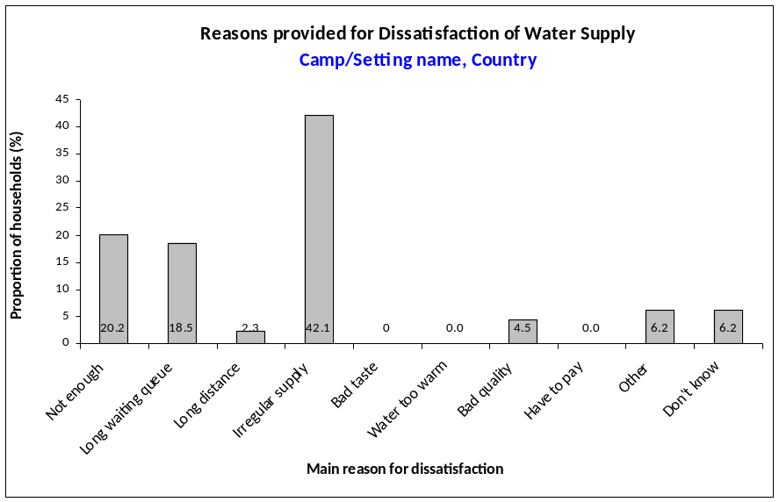

Table 8 Safe Excreta disposal

 | Number/total | % (95% CI)
Proportion of households that use:
An improved excreta
disposal facility (improved
toilet facility, 1 household)*,**
A shared family toilet
(improved toilet facility, 2
households)**
A communal toilet
(improved toilet facility, 3
households or more)
An unimproved toilet
(unimproved toilet facility
or public toilet)
Proportion of households with children under three years old that dispose of faeces safely

*To maintain consistency with other survey instruments (e.g. the multiple indicator cluster survey), UNHCR SENS WASH module classifies an “improved excreta disposal facility” as a toilet in the “improved” category AND one that is not shared with other families / households.

**According to UNHCR WASH monitoring system, an “improved excreta disposal facility” is defined differently than in survey instruments and is defined as a toilet in the “improved” category AND one that is shared by a maximum of 2 families / households or no more than 12 individuals. Therefore, the following two categories from the SENS survey definitions are considered “improved excreta disposal facility” for UNHCR WASH monitoring system: “improved excreta disposal facility (improved toilet facillity, 1 household)” and “shared family toilet (improved toilet facility, 2 households)”.

Figure 3 Proportion of households with children under the age of 3 years whose (last) stools were disposed of safely (this FIGURE CAN BE automatically GENERATED BY USING sENS PRE-MODULE TOOL 12 – TRENDS AND GRAPHS)

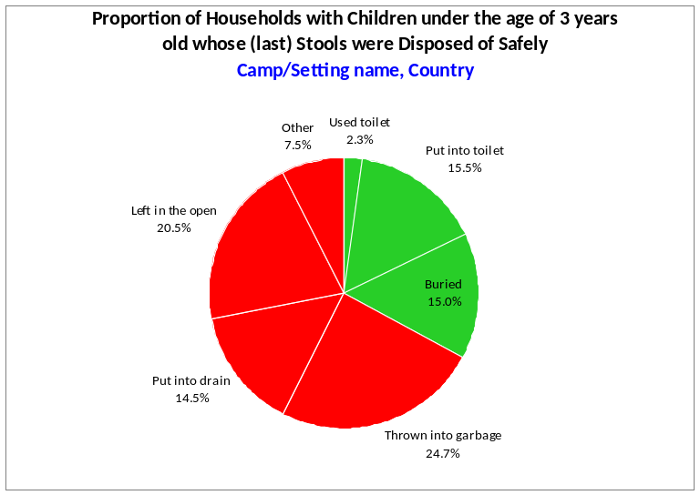
Data analysis

Analysis procedures

- The first step in the data analysis process is to classify the categories into more easily manageable variables that relate to the indicators you are trying to measure. This involves recoding some of the responses into ‘new’ variables. Table 9 provides some guidance on recoding the variables and on using Epi Info software.

- Make sure that the data has been cleaned before starting the analysis process.

- Brief guidance on using Epi Info software for analysis is provided below. Refer to Annex 6 for standard analysis commands using Epi Info (version 3.5.4 July 2012). Free guidance on the use of Epi Info for Windows and training material on Epi Info can be found at the following site: http://www.cdc.gov/EpiInfo

Table 9 Recoding instructions (where applicable)

QUESTION | REPORTED RESULTS  (ORGINIAL VARIABLE NAME) | ACTION
WS2. What is the main source of drinking water for members of your household?  01=Piped water; 02=Public tap/standpipe; 03=Tube well/borehole (& pump); 04=Protected dug well; 05=Protected spring; 06=Rain water collection; 07=UNHCR Tanker; 08=Unprotected spring; 09=Unprotected dug well; 10= Small water vendor; 11=Tanker truck; 12=Bottled water; 13=Surface water (e.g. river, pond); 96=Other; 98=Don’t know | Proportion of households using an improved drinking water source  (SOURCE) | Exclude from analysis households with answer 98 (this is automatically done with the analysis instructions suggested below).  Define a new variable for categorising the main drinking water source (SOURCE_c).  Recode SOURCE to SOURCE_c using the ‘Recode’ command: (1) improved or (2) unimproved.  (1) Improved [answers 01-07 of the standard SENS WASH questionnaire]  (2) Unimproved [answers 08-13 and 96 of the standard SENS WASH questionnaire]  Use the ‘Frequencies’ or ‘Complex Sample Frequencies’ command to analyse SOURCE_c to fill out Table 5. The frequency of answer 1 (‘Improved’) is reported.
WS3. Are you satisfied with the water supply?  1=Yes  2=No  3=Partially  8=Don’t know | Proportion of households that say they are satisfied with the drinking water supply  (SATISFY) | No recoding needed. Exclude from analysis households with answer 8.  Use the ‘Select’ command to exclude households with ‘don’t know’ answers and then the ‘Frequencies’/‘Complex Sample Frequencies’ command to analyse SATISFY. The frequency of answer 1 (‘Yes’) is reported in Table 7 and all options are reported in Figure 1.
WS4. What is the main reason you are not satisfied with the water supply?  01=Not enough; 02=Long waiting queue; 03=Long distance; 04=Irregular supply; 05=Bad taste; 06=Water too warm; 07=Bad quality; 08=Have to pay, 96=Other; 98=Don’t know | Main reason of dissatisfaction for households not satisfied with water supply  (REASON) | No recoding needed.  Use the ‘Frequencies’/‘Complex Sample Frequencies’ command to analyse REASON to draw Figure 2. The frequency of each answer is reported.
WS5. What kind of toilet facility does this household use?  01=Flush to piped sewer system; 02=Flush to septic system; 03=Pour-flush to pit; 04=VIP/simple pit latrine with floor/slab; 05=Composting/dry latrine; 06=Flush or pour-flush elsewhere; 07=Pit latrine without floor/slab; 08=Service or bucket latrine; 09=Hanging toilet/latrine; 10=No facility, field, bush, plastic bag | Proportion of households using an improved excreta disposal facility (improved toilet facility, 1 household)  Proportion of households using a shared family toilet (improved toilet facility, 2 households)  Proportion of households using a communal toilet (improved toilet facility, 3 households or more)  Proportion of households using an unimproved toilet (unimproved toilet facility or public toilet)  (TOILET, TOILSHR_c) | Define a new variable for sanitation facility definition (TOILET_c).  Recode TOILET to TOILET_c using the ‘Recode’ command: (1) improved or (2) unimproved.  (1) Improved category [answers 01-05]  (2) Unimproved category [answers 06-10]
WS6. How many households share this toilet?  1=Not shared (1 HH)  2=Shared family (2 HH)  3=Communal toilet (3 HH or more)  4=Public toilet (in market or clinic etc.)  8=Don’t know |  | Exclude from analysis households with answer 8 to WS6 (this is automatically done with the analysis instructions suggested below).  Define a new variable for classifying sanitation facilities based on the definition and sharing (SANITA).  Recode TOILET_c (question WS5 above) and TOILSHR_c to SANITA using the ‘If’ commands:  (1) Improved excreta disposal facility: if TOILET_c is ”improved” and TOILSHR_c is “not shared”.  (2) Shared family toilet: if TOILET_c is “improved” and TOILSHR_c is “shared family”.  (3) Communal toilet: if TOILET_c is ”improved” and TOILSHR_c is “communal toilet”.  (4) Unimproved toilet: if TOILET_c is “unimproved” or TOILSHR_c is “public toilet (in market or clinic etc.)”.  Use the ‘Frequencies’ or ‘Complex Sample Frequencies’ command to analyse SANITA to fill out Table 8. The frequency of each answer (1-4) is reported.
WS7. Do you have children under three years old?  1=Yes  2=No | (CHILD) | This data is not analysed.  Households with answer 1 (Yes) will be analysed in question WS8 (see below).
WS8. The last time [NAME OF YOUNGEST CHILD] passed stools, what was done to dispose of the stools?  01=Child used toilet/latrine; 02=Put/rinsed into toilet or latrine; 03=Buried; 04=Thrown into garbage; 05=Put/rinsed into drain or ditch; 06=Left in the open; 96=Other; 98=Don’t know | The proportion of households with children under three years old that dispose of faeces safely  (STOOL) | This question is only applicable to respondent having a child under three years old in their household.  Exclude from analysis households with answer 98 (this is automatically done with the analysis instructions suggested below).  Define a new variable for categorising stool disposal (STOOL_c).  Recode STOOL to STOOL_c using the ‘Recode’ command: (1) safe or (2) unsafe.  (1) Safe [answers 01-03]  (2) Unsafe [answers 04-06 and 96]  Use the ‘Frequencies’ or ‘Complex Sample Frequencies’ command to analyse STOOL_c to fill out Table 8. The frequency of answer 1 (‘Safe’) is reported.

OBSERVATION | REPORTED RESULTS (ORGINIAL VARIABLE NAME) | ACTION
WS9. CALCULATE THE TOTAL AMOUNT OF WATER BY THE HOUSEHOLD PER DAY | Proportion of households that use:  ≥20 litres per person per day  15-20 litres per person per day  <15 litres per person per day  (LITRE, HHSIZE) | Define a new variable for calculating the amount of water used per person per day per household (LPPPD).  Complete calculation of amount of water used per person per day per household by dividing the total water collected (LITRE) by the number of people in the household (HHSIZE), by using the ‘Assign’ command.  Define a new variable for categorising the amount of water used per person per day per household (LPPPD_c).  Recode LPPPD to LPPPD_c using the ‘Recode’ command:  (1) 20 or over 20 litres (≥20)  (2) 15- 19.99 litres (15-<20)  (3) 14.99 litres or less (<15)  Use the ‘Frequencies’/‘Complex Sample Frequencies’ command to analyse LPPPD_c to fill out Table 6. The frequency of each answer (1-3) is reported.
WS10. Please show me where you store your drinking water.  ARE THE DRINKING WATER CONTAINERS COVERED OR NARROW NECKED?  1=All are  2=Some are  3=None are | Proportion of households that use a covered or narrow necked container for storing their drinking water (STORE) | No recoding needed.  Use the ‘Frequencies’/‘Complex Sample Frequencies’ command to analyse STORE to fill out Table 5. The frequency of answer 1 (‘All are’) is reported.

Common errors and challenges in data analysis

Table 10 describes the most common errors experienced by survey coordinators/ supervisors when conducting the final data analysis.

Table 10 Common errors and challenges in data analysis

Common errors | Examples | Solution
Miscalculating the denominator for the proportion of households with children under the age of 3 years whose (last) stools were disposed of safely | The total number of households surveyed is used as the denominator when calculating the proportion. | Use only the total number of households with children under 3 years as the denominator.
Not taking into consideration a weighting factor when combining results from several camps | When surveying several camps with a representative sample drawn from each camp, combining the samples from all camps to calculate the overall results without taking into consideration a weighting factor. | For a tool that will automatically generate weighed results, see SENS Pre-Module tool: [Tool 14-Weighting Data Tool].
Reporting WASH results according to certain aggregates of clusters | Reporting the WASH results per groups of cluster. | Do not disaggregate cluster surveys according to clusters in the presentation of results. All clusters merged together from all section / blocks of the camp are representative of the camp as a whole and should not be disaggregated.
Reporting a change in the WASH situation without any evaluation of whether the observed change is statistically significant or real | Using the point estimate results of two surveys (e.g. 36% vs. 39%) and concluding that there has been a change in e.g. use of improved drinking water without looking at the confidence intervals or conducting a statistical test. | Assess whether the confidence intervals overlap and conduct a statistical test using the CDC IERHB calculator. See SENS Pre-Module tool: [Tool 13-CDC Calculator twosurveys].

Use of results

Classification of public health problem and targets

- Diarrhoea caused by poor water, sanitation and hygiene accounts for the annual deaths of over two million children under five years old. Diarrhoea also contributes to high infant and child morbidity and mortality by directly affecting children’s nutritional status. Refugee populations are often more vulnerable to public health risks and reduced funding can mean that long term refugee camps often struggle to ensure the provision of essential services, such as water, sanitation and hygiene. The problem of access to basic WASH facilities is also growing in urban areas as populations increase.

- Hygienic conditions and adequate access to safe water and sanitation services is a matter of ensuring human dignity and is recognised as a fundamental human right.

- Further investigation should be recommended even if only a small proportion of households are not disposing of children’s faeces safely.

International and Organizational Targets

- Water, sanitation and hygiene provision can contribute to many of the millennium development goals (MDGs) such as achieving universal primary education and reducing child mortality. The specific MDG that relates to improvements in water and sanitation is Goal 7.

- MDG Goal 7 Target 10 calls on countries to: "Halve, by 2015, the proportion of people without sustainable access to safe drinking-water and basic sanitation" and Target 11 calls for “a significant improvement in the lives of at least 100 million slum dwellers by 2020”.

UNHCR standard

The following standard applies to UNHCR WASH programmes:

Table 11 UNHCR WASH Programme Standard

UNHCR Standard | Indicator
Average quantity of water available per person/day | > or = 20 litres

Recommendations

- The WASH survey results should be used in conjunction with qualitative assessments and monitoring data to help UNHCR and its partners plan and prioritise public health and WASH interventions. For example, the results can:

  - Provide a quantitative baseline for subsequent monitoring and evaluation of programme progress and effectiveness;
  - Help to show if hygiene promotion has been successful or if the strategy used needs to be changed;
  - Help to develop or adapt WASH monitoring plans;
  - Identify areas of concern with regard to hygiene that require further in depth discussion with communities;
  - Highlight where additional physical or human resources need to be deployed;
  - Help to inform advocacy efforts to improve funding and /or the deployment of resources;
  - Recommendations can also be made to ensure that the survey results are followed up and that the information is shared with key stakeholders, including the affected community. Discussing the results with communities can help to mobilise future action on health issues;
  - Further in depth investigation of key variables may also be indicated from the results of the survey.

References

EHP (2004) Strategic Report 8 Assessing hygiene improvement; Guidelines for households and community levels, USAID; USA.
http://www.ehproject.org/PDF/Strategic_papers/SR-8-HISGPaperVersion.pdf

Espeut, D. (2001) KPC 2000+ Knowledge, Practices and Coverage Survey 2000+ Field Guide; The child survival technical support project, USAID USA.
http://www.ennonline.net/pool/files/ife/annex-4-kpc-survey-field-guide-(care)(1).pdf

Shaw, R. (2005) Preparation of pictorial illustrations on access to water supply and sanitation facilities for use in national household surveys, Prepared for the Joint monitoring programme on water supply and sanitation WHO and UNICEF, WEDC; UK.
http://www.childinfo.org/files/JMP_Pictorials_for_Water_and_Sanitation.pdf

annexes

Annex 1 - Water source and sanitation facility definitions

Improved drinking water source

Piped Water | This includes the two categories below and refers to water piped to the premises:
Piped water into dwelling | Also called a household connection, is defined as a water service pipe connected with in-house plumbing to one or more taps (e.g. in the kitchen and bathroom).  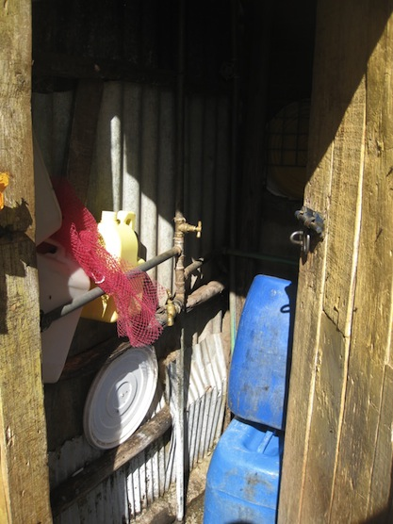
Piped water to the yard/plot | Also called a yard connection, is defined as a piped water connection to a tap placed in the yard or plot outside the house.  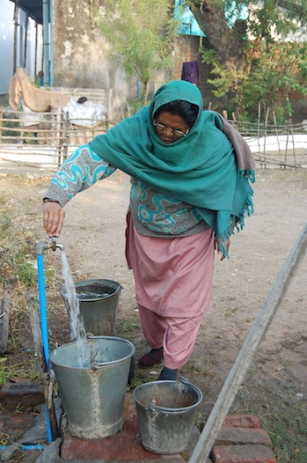
Public tap or standpipe | 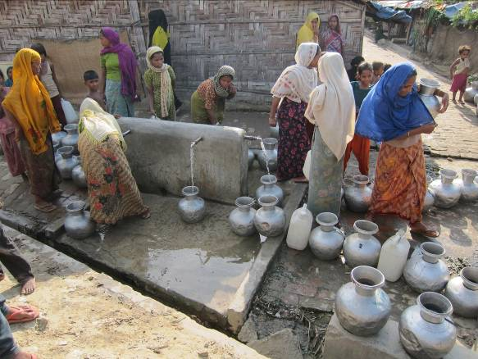  This is a public water point from which people can collect water. A standpipe is also known as a public fountain or public tap. Public standpipes can have one or more taps and are typically made of brickwork, masonry or concrete.
Tube well or borehole | This is a deep hole that has been driven, bored or drilled, with the purpose of reaching groundwater supplies. Boreholes / tube wells are constructed with casing, or pipes, which prevent the small diameter hole from caving in and protect the water source from infiltration by run-off water. Water is delivered from a tube well or borehole through a pump, which may be powered by human, animal, wind, electric, diesel or solar means. Boreholes / tube wells are usually protected by a platform around the well, which leads spilled water away from the borehole and prevents infiltration of run-off water at the well-head.  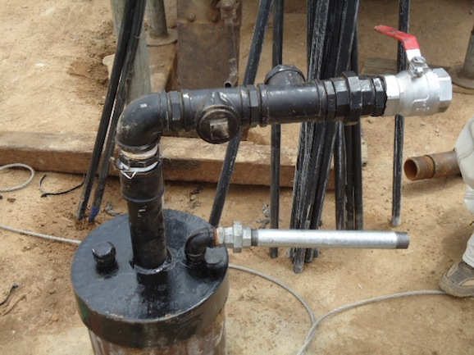  Submersible pump  Borehole head  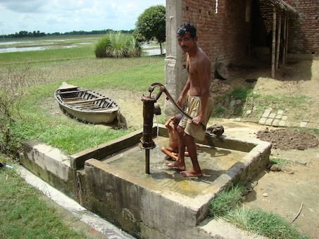  Double hand pump Hand pump  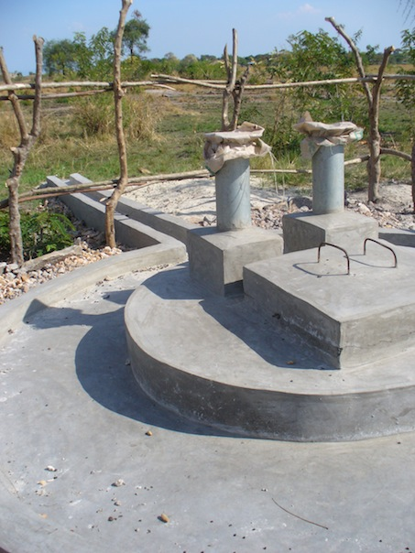  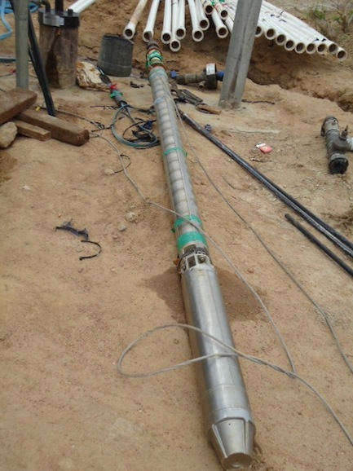
Protected dug well with hand pump | Is a dug well with a hand pump that is protected from runoff water by a well lining or casing that is raised above ground level and a platform that diverts spilled water away from the well. A protected dug well is also covered, so that bird droppings and animals cannot fall into the well.  Protected hand dug well with hand pump Protected hand dug well  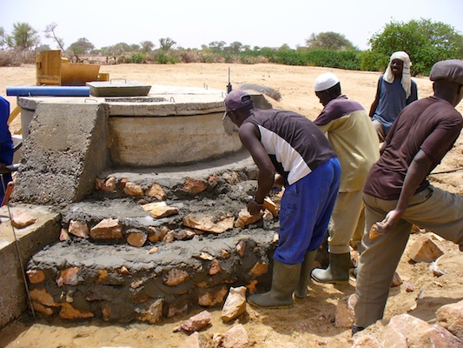  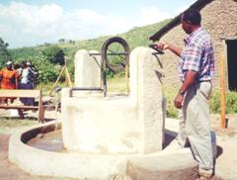
Protected spring | The spring is typically protected from runoff, bird droppings and animals by a “spring box”, which is constructed of brick, masonry, or concrete and is built around the spring so that water flows directly out of the box into a pipe or cistern, without being exposed to outside pollution.  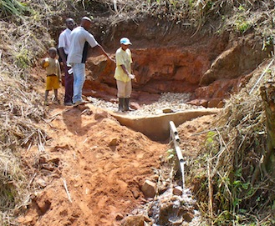  Protection of a spring Protected spring without reservoir  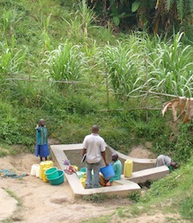  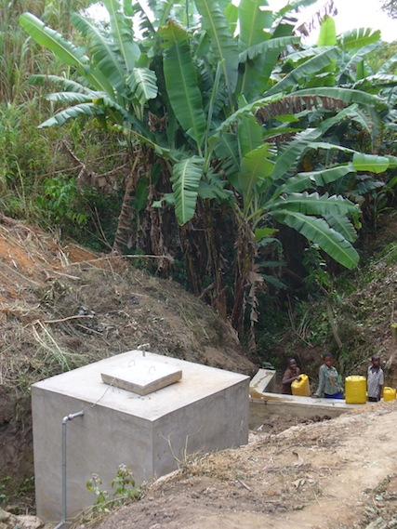  Protected spring with reservoir
Rainwater collection | 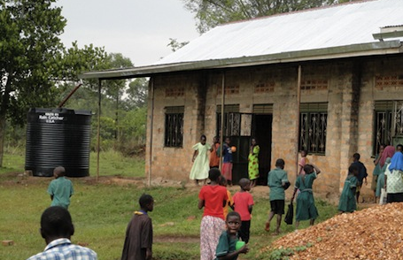  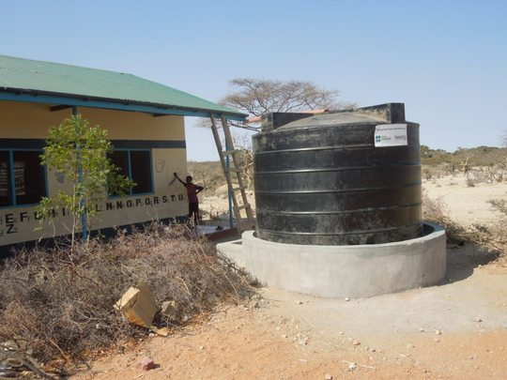  Refers to rain that is collected or harvested from surfaces (by roof or ground catchment) and stored in a container, tank or cistern until used.  Rainwater harvesting systems capture rain from building roofs and other catchment areas. They are often installed at the building level, collecting water from houses or public buildings such as schools or hospitals. The water is collected in tanks, drums, buckets, jerry cans until used.  Rainwater harvesting in schools
UNHCR Tanker | Refers to chlorinated or treated water provided by UNHCR or one of its partners and distributed using water tankers. The water must be subject to quality control measures.  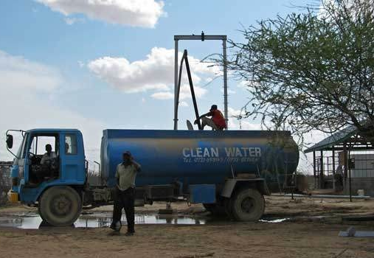

Unimproved sources of drinking water

Unprotected spring | This is a spring that is subject to runoff, bird droppings, or the entry of animals. Unprotected springs typically do not have a “spring box”.  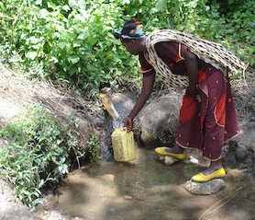
Unprotected dug well | This is a dug well for which one of the following conditions is true: 1) the well is not protected from runoff water; or 2) the well is not protected from bird droppings and animals. If at least one of these conditions is true, the well is unprotected.  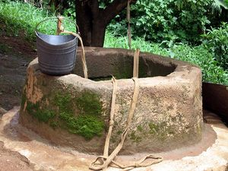  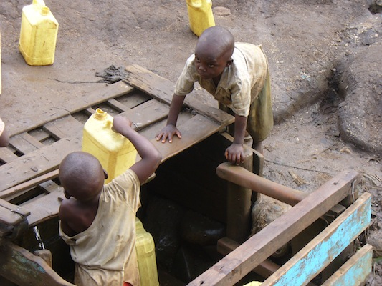
Small water vendor (cart with small tank or drum) | This refers to water sold by a provider who transports water into a community. The types of transportation used include donkey carts, motorized vehicles and other means.  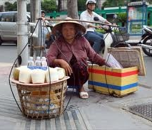  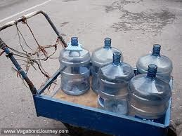
Tanker-truck | The water is trucked into a community and sold from the water truck by private contractors (but not approved by UNHCR).
Bottled water | Is considered an improved source of drinking water only when the household uses it by choice rather than because they are obliged to or when it can be guaranteed that this water is not contaminated. This will need to be assessed prior to the survey and categorized accordingly. A competent national surveillance body should oversee production of bottled water.
Surface water | Is water located above ground and includes rivers, dams, lakes, ponds, streams, canals, and irrigation channels.  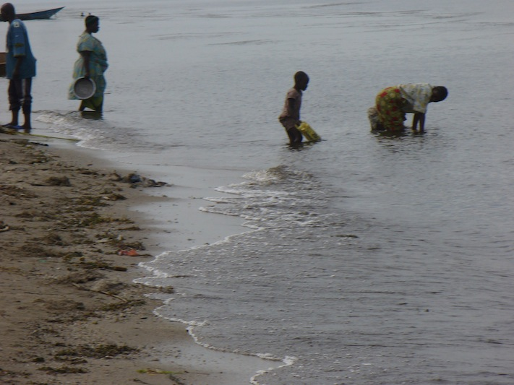
Rainwater collection from run off | Rainwater harvesting from run off is to collect the rain falling on the ground in a pond, dam, reservoir, berkade. The water is usually used by animals and for irrigation.  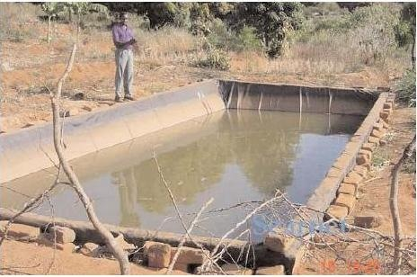
Protected dug well with bucket | Is a dug well protected from runoff water by a well lining or casing that is raised above ground level and a platform that diverts spilled water away from the well. The main difference is that the system to extract water is a bucket with a rope which will be the main source of contamination in the well as the bucket and rope are in contact with the ground.  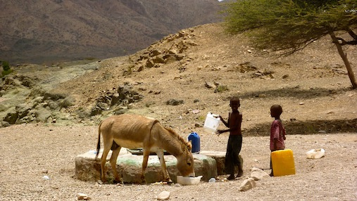

Sanitation facility definition: Improved category

A piped sewer system | This is a system of sewer pipes, also called sewerage, that is designed to collect human excreta (faeces and urine) and wastewater and remove them from the household environment. Sewerage systems consist of facilities for collection, pumping, treating and disposing of human excreta and wastewater.  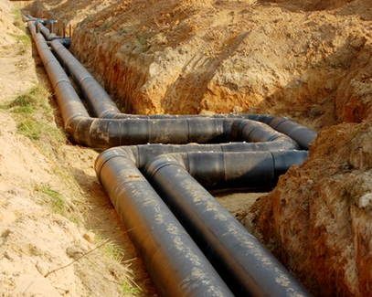
A septic system or tank | Is an excreta collection device consisting of a watertight settling tank, which is normally located underground, away from the house or toilet. The treated effluent of a septic tank usually seeps into the ground through a leaching pit. It can also be discharged into a sewerage system.  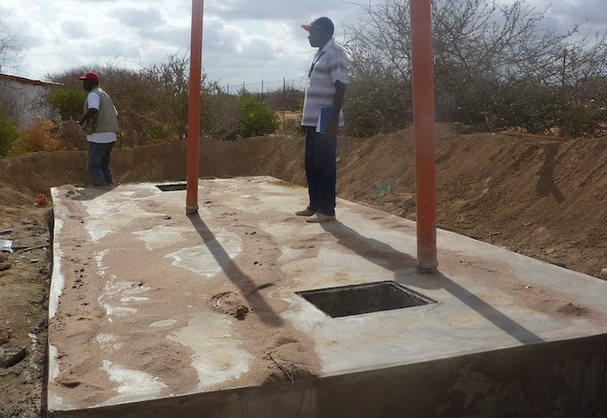
A pour flush toilet | Uses a water seal, but unlike a flush toilet, a pour flush toilet uses water poured by hand for flushing (no cistern is used).  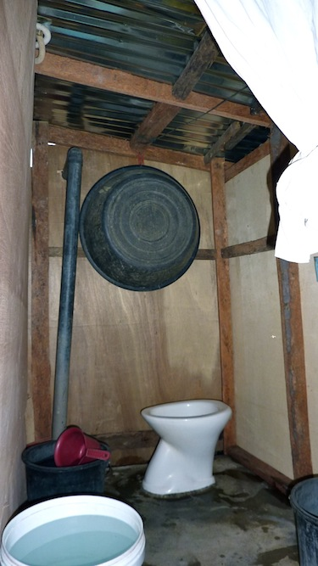
SENS WASH Questionnaire Toilet Categories

Flush to piped sewer system or septic system | Uses a cistern or holding tank for flushing water, and a water seal (which is a U-shaped pipe below the seat or squat- ting pan) that prevents the passage of flies and odours.  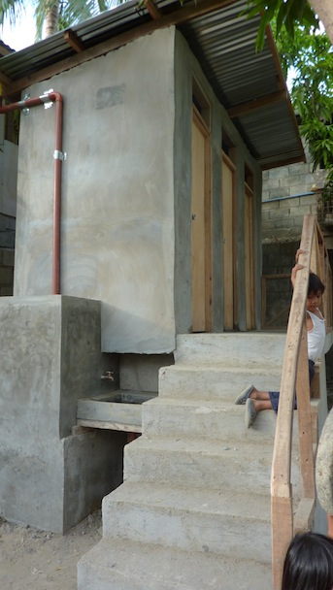
A pour flush to pit | Refers to a system that flushes excreta to a hole in the ground or leaching pit (protected, covered).  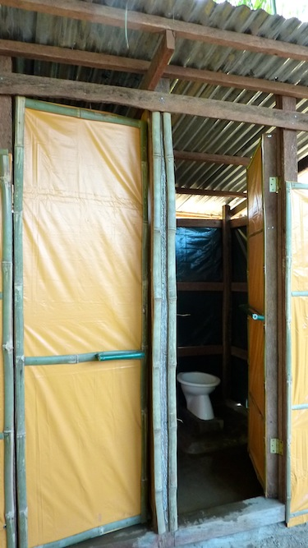
A ventilated improved pit latrine (VIP) | Is a dry pit latrine ventilated by a pipe that extends above the latrine roof. The open end of the vent pipe is covered with gauze mesh or fly-proof netting to prevent flies to enter the pipe, the inside of the superstructure is kept dark and the squatting hole is not kept covered to allow for air circulation.  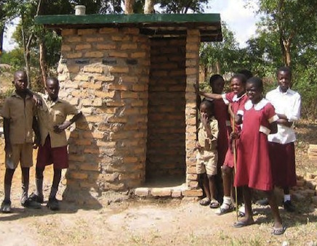
OR

A simple pit latrine with floor/slab | Is a dry pit latrine that uses a hole in the ground to collect the excreta and a squatting slab or platform that is firmly supported on all sides, easy to clean and raised above the surrounding ground level to prevent surface water from entering the pit. The platform has a squat- ting hole, or is fitted with a seat.  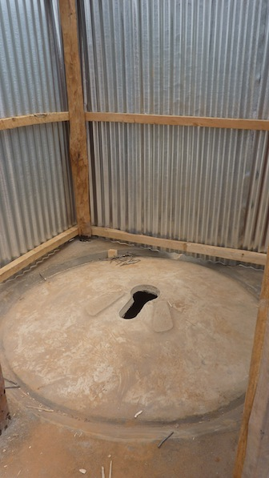
A composting/dry latrine | 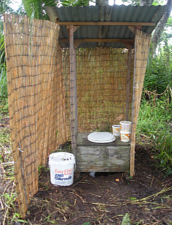  Is a dry toilet into which carbon-rich material (vegetable wastes, straw, grass, sawdust, ash) are added to the excreta and special conditions maintained to produce inoffensive compost. A composting latrine may or may not have a urine separation device.
NB: To be classified as an “improved excreta disposal facility” for the purpose of the SENS survey, the “improved” facilities shown above should not be shared with other households

Unimproved sanitation facilities

A flush/pour flush to elsewhere | Refers to excreta being deposited in or nearby the household environment (not into a pit, septic tank, or sewer). Excreta may be flushed to the street, yard/plot, open sewer, a ditch, a drainage way or other location.  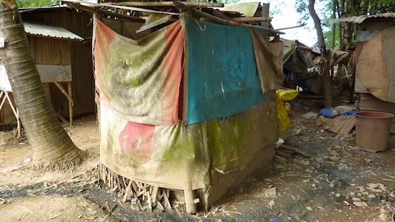
A pit latrine without floor/slab | 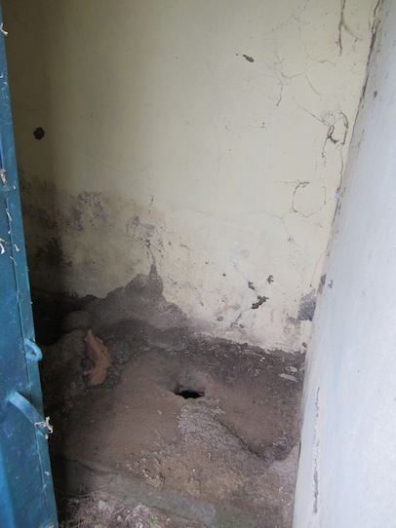  Uses a hole in the ground for excreta collection and does not have a squatting slab, platform or seat. An open pit is a rudimentary hole in the ground where excreta is collected.
Service or bucket latrine | Refers to the use of a bucket or other container for the retention of faeces (and sometimes urine and anal cleaning material), which are periodically removed for treatment, disposal, or use as fertiliser.  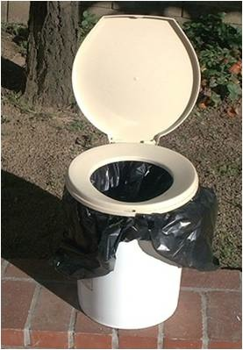
A hanging toilet or hanging latrine | Is a toilet built over the sea, a river, or other body of water, into which excreta drops directly.  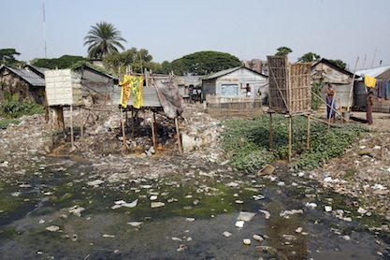

Annex 2 - Water containers

Adapt this work sheet with pictures from your own context and ask the surveyors to record the capacity of the containers in litres:
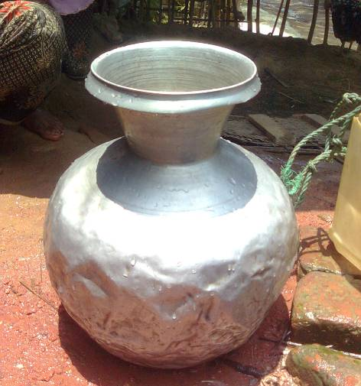
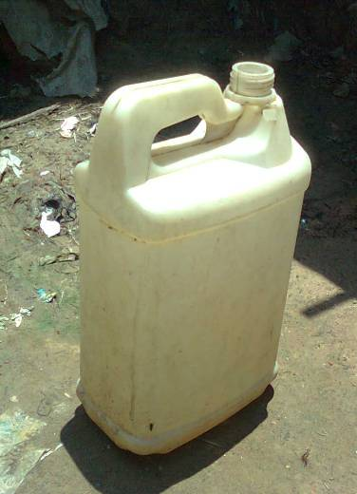
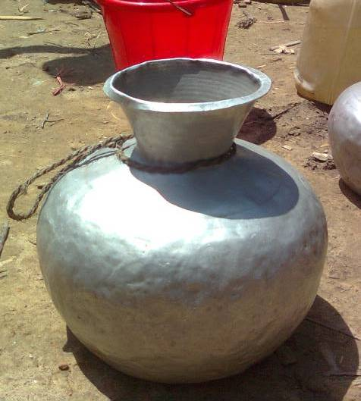
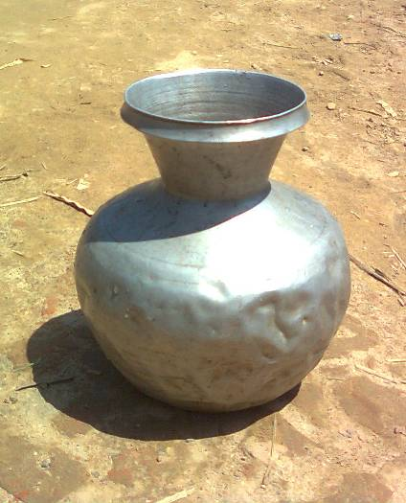
2. Aluminium pot (Medium),
14 L, Carrying Water

4. Plastic Jar,
5 L, Carrying water

3. Aluminium pot (Small), 8.5 L, Carrying Water

1. Aluminium pot (Large), 16 L, Carrying Water

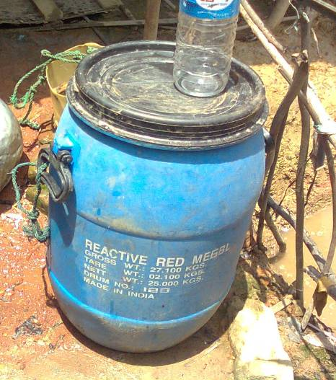
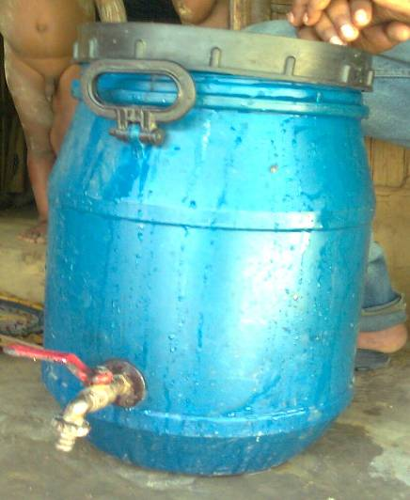
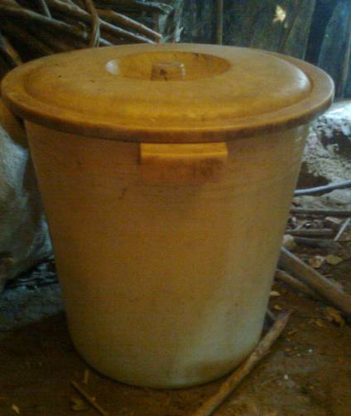
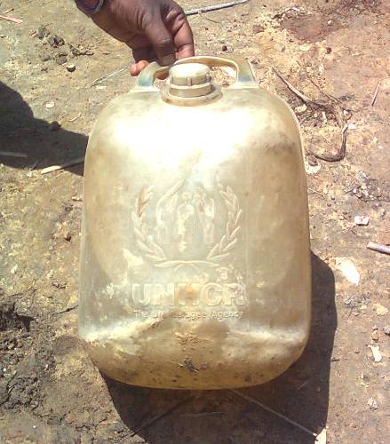
5. Plastic Drum,
50 L, Storing water

7. Plastic Pot,
42 L, Storing water

6. Plastic Drum with tap,
42 L, Storing Water

8. UNHCR Jar,
12 L, Carrying water

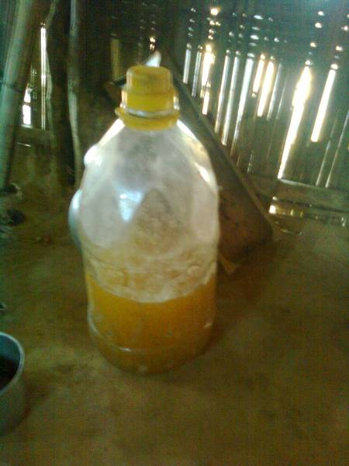
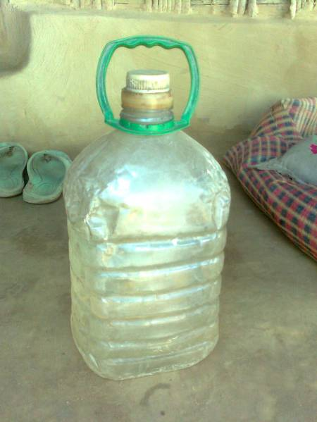
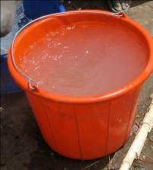
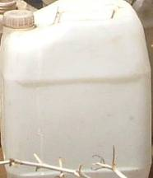
10. Plastic Can, 4.5 L, Domestic Use

12. 10 L, Carrying water

11. 15 L, Storing water

9. Plastic Can, 2.5 L, Domestic Use

14. 200 L, Storing water

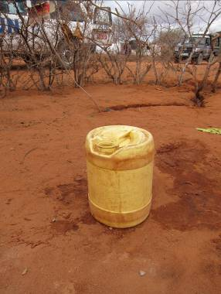
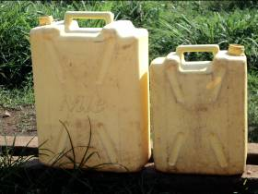
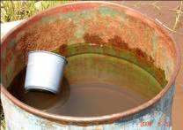

13. Large: 20 L, Carrying water
Small: 10 L, Carrying water

15. 20 L, Carrying water

Annex 3 - SENS WASH questionnaire

See SENS Pre-Module Tool 9 for the full SENS Questionnaire.

No | QUESTION |  | ANSWER CODES
SECTION WS1
WS1 | How many people live in this household and slept here last night?  HHSIZE |  | |___|___|
WS2 | What is the main source of drinking water for members of your household?  Adapt list to local setting before survey.  When adapting the list, keep the original answer codes and do not change.  DO NOT READ THE ANSWERS  SELECT ONE ONLY  SOURCE |  | Piped water 01  Public tap/standpipe 02  Tube well/borehole (& pump) 03  Protected dug well 04  Protected spring 05  Rain water collection 06  UNHCR Tanker 07  Unprotected spring 08  Unprotected dug well 09  Small water vendor 10  Tanker truck 11  Bottled water 12  Surface water (e.g. river, pond) 13  Other 96  Don’t know 98 |  |  | |___|___|
WS3 | Are you satisfied with the water supply?  THIS RELATES TO THE DRINKING WATER SUPPLY  SATISFY |  | Yes 1  No 2  Partially 3  Don’t know 8 |  |  | |___|  IF ANSWER IS 1, 3 OR 8 GO TO WS5
WS4 | What is the main reason you are not satisfied with the water supply?  Adapt list to local setting before survey.  DO NOT READ THE ANSWERS  SELECT ONE ONLY  REASON |  | Not enough 01  Long waiting queue 02  Long distance 03  Irregular supply 04  Bad taste 05  Water too warm 06  Bad quality 07  Have to pay 08  Other 96  Don’t know 98 |  |  | |___|___|
WS5 | What kind of toilet facility does this household use?  Adapt list to local setting before survey  When adapting the list, keep the original answer codes and do not change.  DO NOT READ THE ANSWERS  SELECT ONE ONLY  TOILET |  | Flush to piped sewer system 01  Flush to septic system 02  Pour-flush to pit 03  VIP/simple pit latrine with floor/slab 04  Composting/dry latrine 05  Flush or pour-flush elsewhere 06  Pit latrine without floor/slab 07  Service or bucket latrine 08  Hanging toilet/latrine 09  No facility, field, bush, plastic bag 10 |  |  | |___|___|  IF ANSWER IS 10 GO TO WS7
WS6 | How many households share this toilet?  THIS INCLUDES THE SURVEYED HOUSEHOLD |  | RECORD NUMBER OF HOUSEHOLDS IF KNOWN (RECORD 96 IF PUBLIC TOILET OR 98 IF UNKNOWN)  TOILSHR |  |  | |___|___|  Households
WS6 |  |  | SUPERVISOR SELECT ONE ONLY  Not shared (1 HH) 1  Shared family (2 HH) 2  Communal toilet (3 HH or more) 3  Public toilet (in market or clinic etc.) 4  Don’t know 8  TOILSHR_c |  |  | |___|
WS7 | Do you have children under three years old?  CHILD |  | Yes 1  No 2 |  |  | |___|  IF ANSWER IS 2 GO TO WS9
WS8 | The last time [NAME OF YOUNGEST CHILD] passed stools, what was done to dispose of the stools?  DO NOT READ THE ANSWERS  SELECT ONE ONLY  STOOL |  | Child used toilet/latrine 01  Put/rinsed into toilet or latrine 02  Buried 03  Thrown into garbage 04  Put/rinsed into drain or ditch 05  Left in the open 06  Other 96  Don’t know 98 |  |  | |___|___|
SECTION WS2
Observation Based Questions (done after the initial questions to ensure the flow of the interview is not broken )
No |  | OBSERVATION / QUESTION | ANSWER
WS9 |  | CALCULATE THE TOTAL AMOUNT OF WATER USED BY THE HOUSEHOLD PER DAY  THIS RELATES TO ALL SOURCES OF WATER (DRINKING WATER AND NON-DRINKING WATER SOURCES)  LITRE | Please show me the containers you used yesterday for collecting water  ASSIGN A NUMBER TO EACH CONTAINER | Capacity in litres | Number of journeys made with each container |  | Total litres  SUPERVISOR TO COMPLETE  HAND CALCULATION
 |  |  | 1 E.g. jerry can | 25 L | 1 x |  | 25
 |  |  | 2 E.g. jerry can | 10 L | 2 x |  | 20
 |  |  | 3 E.g. jerry can | 5 L | 2 x |  | 10
 |  |  | 4 E.g. jerry can | 5 L | 1 x |  | 5
 |  |  | 5 E.g. bucket | 50 L | 1 x |  | 50
 |  |  | 6
 |  |  | 7
 |  |  | 8
 |  |  | 9
 |  |  | 10
 |  |  | Total litres used by household |  |  |  | 110
WS10 |  | Please show me where you store your drinking water.  ARE THE DRINKING WATER CONTAINERS COVERED OR NARROW NECKED?  STORE | All are 1  Some are 2  None are 3 |  |  |  | |___|

Annex 4 - Training ideas

EXERCISES

Exercise 1: The questionnaire

- Divide participants into pairs and ask them to go through the questionnaire taking turns to be the respondent and the surveyor.
- Ask them to note any problem they have as they go along. Discuss in plenary.

Exercise 2: Determining the amount of water used

- Obtain samples of commonly used drinking water containers or compile photographs of the containers in a Word document.
- Show each container in turn and ask the participants to guess the capacity of each container, and correct or confirm their responses.
- Ask each person in turn the capacity of a specific container until you have been through them all several times and you think that everyone is confident in assessing the capacity of each container.
- In groups of 2 or 3 provide them with a set of pictures or containers for an imaginary household and ask them to practice filling in the questionnaire. They should invent the number of trips taken.
- The participants do not have to calculate the amount of litres per person per day for the survey but a competent group may want to try to work this out.

ROLE PLAYING

Role Play 1

- Divide the participants into pairs.
- The coordinator takes the role of the respondent and asks each team of two surveyors to use the questionnaire to ask him/her two to three questions.
- The coordinator uses this opportunity to identify the possible pitfalls highlighted in the box below (or identify issues that you think might be a problem in your context).
- After each question review the answer and discuss any problems identified such as poor communication or showing displeasure at a particular response.
- The exercise can be repeated with different participants asking different questions (see Table 12 for an example).

Table 12 Exercise

Question | Example responses from households | Expected response from surveyor
What is the main source of drinking water for members of your household?  (SELECT ONE) | We use the standpipe and the water from the river. | Make sure it is the drinking water source that is used the most.
Are you satisfied with the water supply? | Go on at length about how terrible it is and why can’t anything be done about it. | So you are not satisfied–thank you.
What kind of toilet facility does this household use? (SELECT ONE) | My neighbour has a very nice toilet – a VIP latrine.  Sometimes my children use it but I don’t… | Does your household usually use this toilet facility?  Where do you and the other members of your household usually go to the toilet?
How many households share this toilet? | Many.  I’m not sure. | Can you estimate how many?  Okay do you think that more than 2 households use this toilet? (Communal)  Can anyone use the toilet? (Public)
The last time [NAME OF YOUNGEST CHILD] passed stools, what was done to dispose of the stools? | He just goes in the compound.  She went on a cloth. | What did you do with the stools?  What did you do with the cloth?

Role Play 2

- In groups of 3 ask the participants to invent a short realistic role-play to highlight some of the problems that might be encountered when using the observation questions.
- For example:
  - showing displeasure when observing the dirty containers
  - not assessing all of the water containers used for collecting water for all purposes
- Ask the participants to identify the problems in each role-play once it has been performed and clarify the correct procedure.
- Ensure that surveyors know when to ask their supervisor for help e.g. if they don’t know about the capacity of a container.

Role Play 3

- In groups of 4 ask the participants to practice asking the questions taking it in turns to be the respondent and the surveyor.
- Each surveyor should go through all of the questions and observations.
- The other members of the group should take notes and provide constructive feedback to each surveyor.

FIELD PRACTICE

- Interview teams will go to the field in a location where the survey will not be taking place.
- Teams will practice the following.
  - Delivering the questionnaire to the household (3 questionnaires)
  - Calculating the total amount of water used by households
- Field practice will assist the coordinator and interview teams in identifying any additional difficulties that may present themselves when in the field.

TEST

- The questions in the training test show below can be used as a basis for the written or oral test but can be adapted according to circumstances.
- At least 5 questions should be given to the participants and participants should answer at least 3 out of 5 of the practical questions correctly to pass the test.
- The results of the test can help the coordinator to assess which of the surveyors will need more support in the field. The weaker surveyors can also be paired with stronger ones.
- The questions should be given out with a copy of the finalised questionnaire so that participants can refer to this.

Table 13 Training Test

WASH MODULE
PRACTICE

What does the writing in capital letters on the questionnaire mean?

Answer: These are instructions for the surveyor and should not be read aloud.
When asking about children’s excreta disposal:
- What do you do if the household only has children under five years old but over 3 years old?

Answer: Do not include these children on the questionnaire. Move on to the next question..
When asking about children’s excreta disposal:
- What do you do if the household only has a 2-month old baby?

Answer: The baby is under three years old and should be included in the response. Find out what the mother does when the child defecates.
How do you observe how much water a household is using per day?

Answer: Ask to see all of the containers that were used to collect water yesterday. Record the container capacity in the appropriate column. Record how many journeys were made with each container.
How do you ensure that you do not bias the answers given by the respondent?

Answer: Do not show disgust or pleasure with any answer given but remain respectful and neutral. Do not read out the list of answers but wait for the respondent to answer. Read out the questions exactly as they are written.
THEORY

Why is it important to ask about safe excreta disposal for young children?

Answer: This is an important way in which the household can be contaminated and people often think that children’s excreta are harmless.
Why are you interested in knowing if people store their drinking water in a covered or narrow necked container?

Answer: A narrow necked container or covering water can help to prevent water contamination.

Annex 5 - Epi info Data Entry
Below is the standard Epi Info view available in the Epi Info mdb file entitled HUN1207WSBUDA in the SENS WASH tool: [Tool 1-WS Data]. To access the view, go to the Make View module and open the corresponding View entitled WSSENS.

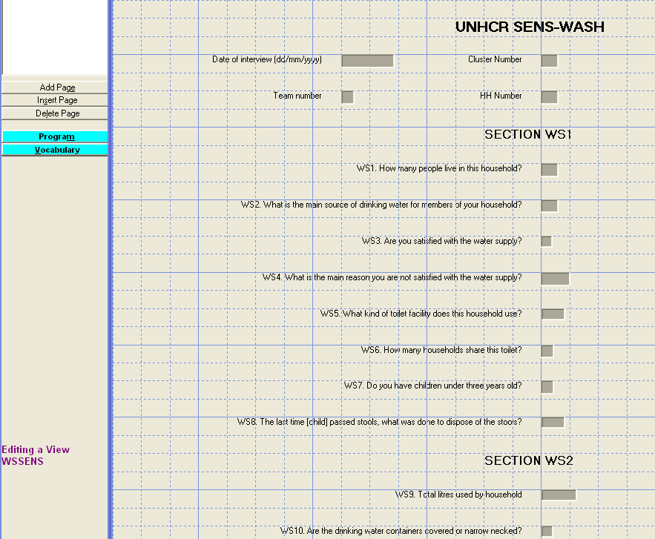

Annex 6 - Epi info Data Analysis

Below are the standard Epi Info codes to use for analysis. The standard PGM files containing these Epi Info codes can be found in the Epi Info mdb file entitled HUN1207WSBUDA in the SENS tool: [Tool 1-WS Data]. To access the PGM files, go to Program Editor window and open the corresponding PGM file needed for the analysis.

Refer to the fictitious dataset available for practical purposes; Go to SENS WASH Tool 1, and see the Excel database HUN_1207_WS_BUDA.

The practical Excel database HUN_1207_WS_BUDA is from a survey using cluster sampling.

Data cleaning

Run these commands (together or separately; regardless of the survey design) and make sure that the ranges of the variables entered in the database match the standard codes shown in Table 3 above.

MEANS HHSIZE (note that the range of household size should not exceed 20-25 in most refugee contexts; you should check that no obvious data entry errors occurred, e.g. entering 100 instead of 10)

FREQ SOURCE
FREQ SATISFY
FREQ REASON
FREQ TOILET
FREQ TOILSHR_c
FREQ CHILD
FREQ STOOL

MEANS LITRE (note that the this number can be quite high for some households in some refugee contexts like 300-500 litres, however it is rare; you should check that no obvious data entry errors occurred, e.g. entering 1000 instead of 100)

FREQ STORE

You should check the missing data in your database and double-check that this was not a data entry oversight. The commands below need to be run separately, one by one. After selecting the variable using the code shown below, use the LIST command to view the specific records with missing data and double-check with the original data collection questionnaire. Then cancel the selected variable by typing SELECT and proceed with checking another variable.

SELECT HHSIZE=(.)
SELECT (this will cancel the selected variable)

SELECT SOURCE=(.)

SELECT SATISFY=(.)

SELECT REASON=(.)

SELECT TOILET=(.)

SELECT TOILSHR_c=(.)

SELECT CHILD=1 AND STOOL=(.)

SELECT LITRE=(.) (note that data can be missing for households having borrowed containers to collect water or households not having collected water yesterday)

SELECT STORE=(.)

Data analysis

Results from the practical dataset are illustrated below.

Water quality analysis

 | Number/total | % (95% CI)
Proportion of households using an improved drinking water source | 158/321 | 49.2 (39.0-59.4)
Proportion of households that use a covered or narrow necked container for storing their drinking water | 334/343 | 97.4 (95.4-99.3)

Water source

DEFINE SOURCE_c

RECODE SOURCE TO SOURCE_c
1 - 7 = "improved"
8 - 13 = "unimproved"
96 = "unimproved"
END

FREQ SOURCE_c PSUVAR=CLUSTER

If you are analysing a simple random survey, the code is as follows:

FREQ SOURCE_c

SOURCE_c | TOTAL
improved | 158
Row % | 100.000
Col % | 49.221
SE % | 5.022
LCL % | 39.015
UCL % | 59.427
unimproved | 163
Row % | 100.000
Col % | 50.779
SE % | 5.022
LCL % | 40.573
UCL % | 60.985
TOTAL | 321
Design Effect | 3.229

Water storage

FREQ STORE PSUVAR=CLUSTER

If you are analysing a simple random survey, the code is as follows:

FREQ STORE

STORE | TOTAL
1 | 334
Row % | 100.000
Col % | 97.376
SE % | 0.963
LCL % | 95.419
UCL % | 99.333
2 | 5
Row % | 100.000
Col % | 1.458
SE % | 0.850
LCL % | -0.270
UCL % | 3.185
3 | 4
Row % | 100.000
Col % | 1.166
SE % | 0.555
LCL % | 0.037
UCL % | 2.295
TOTAL | 343
Design Effect | 1.241

Water quantity analysis

Water Quantity : Amount of litres of water used per person per day

Proportion of households that use: | Number/total | % (95% CI)
≥ 20 lpppd | 180/341 | 52.8 (44.7-60.9)
15 – <20 lpppd | 48/341 | 14.1 (9.5-18.6)
<15 lpppd | 113/341 | 33.1 (24.4-41.8)

Add the average water usage in lpppd:______24.3 lpppd_________

Water quantity (lpppd)

DEFINE LPPPD

ASSIGN LPPPD=LITRE/HHSIZE

DEFINE LPPPD_c
RECODE LPPPD TO LPPPD_c
LOVALUE - 14.99 = "<15"
15 - 19.99 = "15-<20"
20 - HIVALUE = ">=20"
END

FREQ LPPPD_c PSUVAR=CLUSTER

If you are analysing a simple random survey, the code is as follows:

FREQ LPPPD_c

LPPPD_c | TOTAL
15-<20 | 48
Row % | 100.000
Col % | 14.076
SE % | 2.244
LCL % | 9.516
UCL % | 18.637
<15 | 113
Row % | 100.000
Col % | 33.138
SE % | 4.286
LCL % | 24.427
UCL % | 41.848
>=20 | 180
Row % | 100.000
Col % | 52.786
SE % | 3.987
LCL % | 44.683
UCL % | 60.889
TOTAL | 341
Design Effect | 1.416

MEANS LPPPD PSUVAR=CLUSTER

If you are analysing a simple random survey, the code is as follows:

MEANS LPPPD

 | LPPPD
 | Count | Mean | Std Error | Confidence Limits |  | Minimum | Maximum
 |  |  |  | Lower | Upper | Minimum | Maximum
TOTAL | 341 | 24.295 | 1.380 | 21.490 | 27.100 | 4.000 | 240.000

Satisfaction with water supply ANALYSIS

Satisfaction with water supply

 | Number/total | % (95% CI)
Proportion of households that say they are satisfied with the drinking water supply | 302/346 | 87.3 (79.3-95.2)

Satisfaction with water supply

SELECT SATISFY<>8

FREQ SATISFY PSUVAR=CLUSTER

If you are analysing a simple random survey, the code is as follows:

FREQ SATISFY

SATISFY | TOTAL
1 | 302
Row % | 100.000
Col % | 87.283
SE % | 3.918
LCL % | 79.321
UCL % | 95.245
2 | 34
Row % | 100.000
Col % | 9.827
SE % | 3.670
LCL % | 2.368
UCL % | 17.285
3 | 10
Row % | 100.000
Col % | 2.890
SE % | 1.065
LCL % | 0.725
UCL % | 5.055
TOTAL | 346
Design Effect | 4.771

Main reason for dissatisfaction

Note that answer options are to be adapted to the local setting.

SELECT SATISFY=2

FREQ REASON PSUVAR=CLUSTER

If you are analysing a simple random survey, the code is as follows:

FREQ SATISFY

Draw recommended graph according to results.

REASON | TOTAL
1 | 6
Row % | 100.000
Col % | 17.647
SE % | 4.353
LCL % | 7.353
UCL % | 27.941
2 | 3
Row % | 100.000
Col % | 8.824
SE % | 4.256
LCL % | -1.240
UCL % | 18.887
3 | 4
Row % | 100.000
Col % | 11.765
SE % | 5.430
LCL % | -1.076
UCL % | 24.605
4 | 2
Row % | 100.000
Col % | 5.882
SE % | 3.339
LCL % | -2.014
UCL % | 13.779
5 | 13
Row % | 100.000
Col % | 38.235
SE % | 9.221
LCL % | 16.431
UCL % | 60.039
6 | 2
Row % | 100.000
Col % | 5.882
SE % | 3.339
LCL % | -2.014
UCL % | 13.779
7 | 2
Row % | 100.000
Col % | 5.882
SE % | 3.509
LCL % | -2.416
UCL % | 14.181
96 | 1
Row % | 100.000
Col % | 2.941
SE % | 2.619
LCL % | -3.252
UCL % | 9.134
98 | 1
Row % | 100.000
Col % | 2.941
SE % | 2.619
LCL % | -3.252
UCL % | 9.134
TOTAL | 34
Design Effect | 0.430

Safe excreta disposal ANALYSIS

Safe Excreta disposal

 | Number/total | % (95% CI)
Proportion of households that use:
An improved excreta  disposal facility (improved  toilet facility, 1 household) | 121/350 | 34.6 (27.2-42.0)
A shared family toilet  (improved toilet facility, 2  households) | 56/350 | 16.0 (11.6-20.4)
A communal toilet  (improved toilet facility, 3  households or more) | 63/350 | 18.0 (12.0-24.0)
An unimproved toilet  (unimproved toilet facility  or public toilet) | 110/350 | 31.4 (22.9-39.9)
Proportion of households with children under three years old that dispose of faeces safely | 201/223 | 90.1 (85.9-94.3)

Toilet facility type

DEFINE TOILET_c

RECODE TOILET TO TOILET_c
1 - 5 = "improved"
6 - 10 = "unimproved"
END

DEFINE SANITA

IF TOILET_c="improved" AND TOILSHR_c=1 THEN
SANITA="improved"
END

IF TOILET_c="improved" AND TOILSHR_c=2 THEN
SANITA="shared family"
END

IF TOILET_c="improved" AND TOILSHR_c=3 THEN
SANITA="communal"
END

IF TOILET_c="unimproved" OR TOILSHR_c=4 THEN
SANITA="unimproved"
END

FREQ SANITA PSUVAR=CLUSTER

If you are analysing a simple random survey, the code is as follows:

FREQ SANITA

SANITA | TOTAL
communal | 63
Row % | 100.000
Col % | 18.000
SE % | 2.951
LCL % | 12.004
UCL % | 23.996
improved | 121
Row % | 100.000
Col % | 34.571
SE % | 3.652
LCL % | 27.150
UCL % | 41.993
shared family | 56
Row % | 100.000
Col % | 16.000
SE % | 2.177
LCL % | 11.576
UCL % | 20.424
unimproved | 110
Row % | 100.000
Col % | 31.429
SE % | 4.184
LCL % | 22.926
UCL % | 39.931
TOTAL | 350
Design Effect | 2.059

U3 children stool disposal

DEFINE STOOL_c

RECODE STOOL TO STOOL_c
1 - 3 = "safe"
4 - 6 = "unsafe"
96 = "unsafe"
END

SELECT CHILD=1

FREQ STOOL_c PSUVAR=CLUSTER

If you are analysing a simple random survey, the code is as follows:

FREQ STOOL_c

SELECT (this will cancel the selected variable(s); only to be executed after the analysis is done and the results recorded)

STOOL_c | TOTAL
safe | 201
Row % | 100.000
Col % | 90.135
SE % | 2.072
LCL % | 85.924
UCL % | 94.345
unsafe | 22
Row % | 100.000
Col % | 9.865
SE % | 2.072
LCL % | 5.655
UCL % | 14.076
TOTAL | 223
Design Effect | 1.072

Annex 7 - Presentation of combined camp results

- Weighting the data will need to be done if you have conducted surveys in a number of different camps or areas, and need to combine the results for reporting or planning purposes.

- It is not required to report the combined results for all indicators or to report the confidence intervals for the combined estimates. The tables below outline the indicators that should be reported during a combined analysis and included in the SENS report.

- For a tool that will automatically generate weighed prevalence results, see SENS Pre-Module tool: [Tool 14-Weighting Data Tool].

Combined amount of litres of water used per person per day

Proportion of households that use:
≥20 litres | %
15 – <20 litres | %
< 15 litres | %

Combined excreta disposal

Proportion of households using an unimproved toilet | %

In refugee settings, a household is typically defined as a group of people who live together and routinely eat out of the same pot.
Only include children 0-35 months.
School attendance will be affected by WASH related disease as will children’s ability to concentrate once they get to school. Research has also shown that many girl children especially do not attend school because of the absence of sanitation facilities.
Adapted from: WHO and UNICEF (2006) Core Questions on Drinking Water and Sanitation for household surveys; WHO Geneva

