

Join a meeting without a

Teams account

1. Go to the meeting invite and select **Join Microsoft Teams Meeting**.
2. That'll open a webpage, where you'll see two choices: **Download the Windows app** and **Join on the web instead**. If you join on the web, you can use either Microsoft Edge or Google Chrome. Your browser may ask if it's OK for Teams to use your mic and camera. Be sure to allow it so you'll be seen and heard in your meeting.
3. 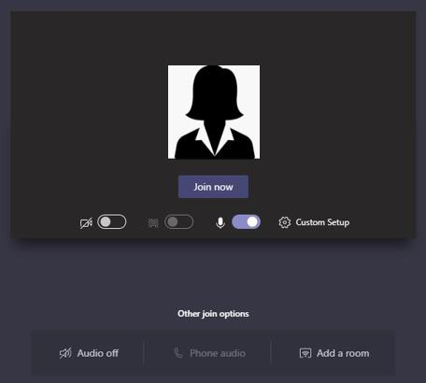Enter your name and choose your audio and video settings. If the meeting room (or another device that's connected to the meeting) is nearby, choose **Audio off** to avoid disrupting. Select **Phone audio** if you want to listen to the meeting on your mobile phone.
4. When you're ready, hit **Join now**.
5. This will bring you into the **lobby**. We'll notify the meeting organizer that you're there, and someone in the meeting can then admit you.

UNHCR Iraq encourages supplier to make their offer well in advance of the deadline to avoid last minute technical glitches in the submission. In case of technical query regarding the eTenderBox, please send an email to the following helpdesk email address: hqsmsbid@unhcr.org