Group work: Survivor-centred
Attitudes and Beliefs
Expected duration: 25 mins
Objective: enhance participants’ understanding of survivor-centred attitudes and beliefs

- Divide the participants in groups.
- Distribute a set of attitude cards to each of the groups – see below, as well as tape and two flipcharts.
- Ask the groups to stick on one flipchart the negative attitudes and beliefs, and on the other the supportive attitudes and beliefs.
- Check the flipcharts as the groups are discussing (no plenary debrief).
- At the end of the activity, ask the groups if they had any doubts and repeat key considerations below.

Key considerations
- We all bring our own attitudes and beliefs to this work, and some of these attitudes may be harmful to survivors without us knowing it. It is important to recognize and begin to challenge our own attitudes. Survivor-blaming is common in many communities and is something that we must actively strive to avoid and counter in our work with survivors.
- Survivors are never responsible for the violence they experience. The use of violence is always a choice made by perpetrators.
- This is an essential tenet for ensuring the safety and recovery of GBV survivors and avoiding causing further harm. Survivor-centred attitudes involve putting the best interests of the survivor first, ensuring that all work is based on what the survivor wants and needs rather than our own opinion of what they want and need
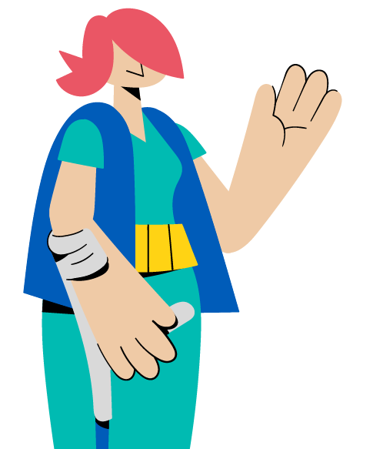
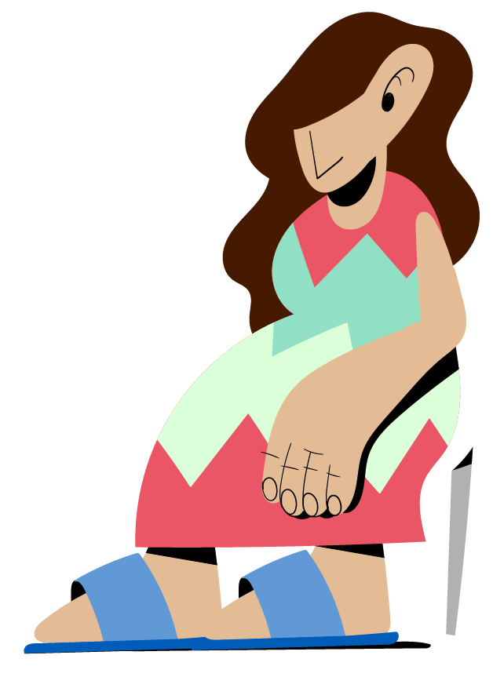
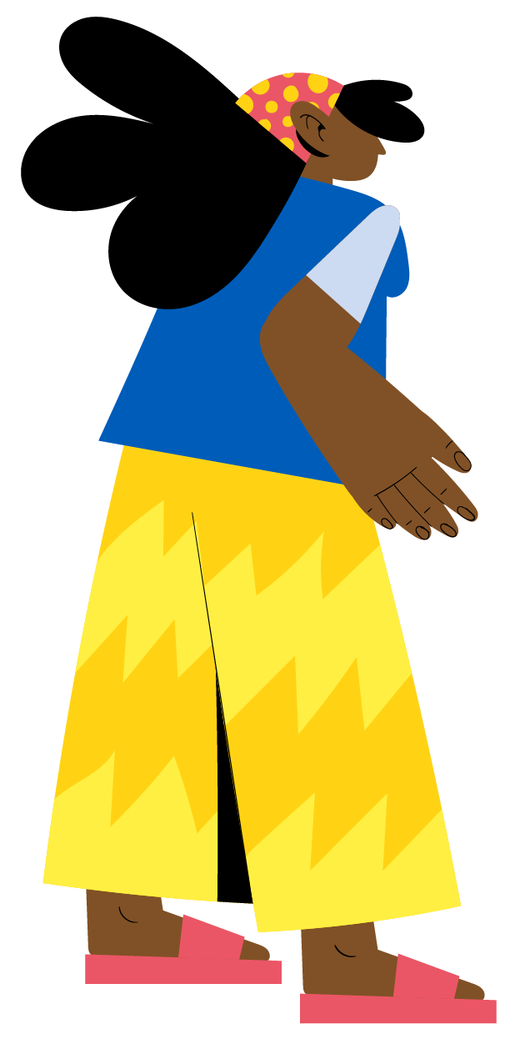
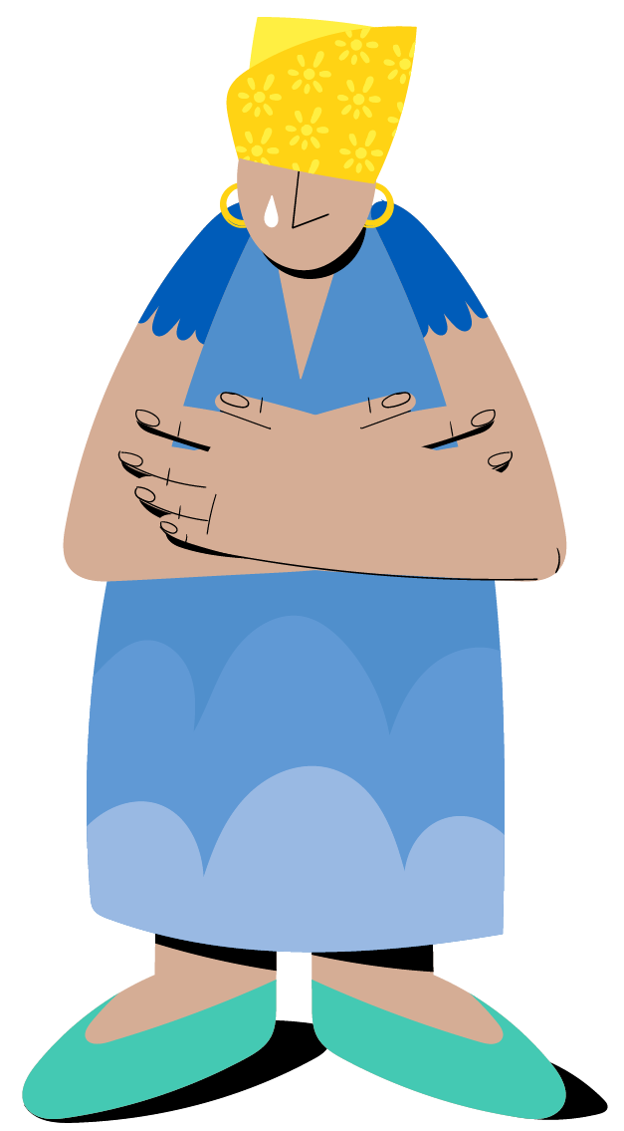
Content derived and adjusted from the IASC Pocket Guide User Guide.

Attitude cards: negative attitudes and beliefs
If women and girls who behave inappropriately are raped, it is their fault. | Women are raped if they wear the wrong clothes or go to the wrong places.
If a survivor can’t answer the questions asked during an interview, they are making up the incident. | Women often lie about being raped.
A woman causes her husband’s violence because of her own behavior. | Rape only occurs outside, at night when the victim is alone.
A person who forces another person to have sex is just someone who cannot control their sexual desire. | If a person doesn’t “fight back” she was not really raped.
Intimate partner violence is a family matter and should be handled within the family. | If a survivor does not show physical injuries from the rape, she was not raped.
Most men beat their wives only after they have been drinking or using drugs. | Incest (rape or sexual abuse by family members) is rare.
A GBV survivor should always report their case to the police or other justice authorities. | Sexual assault usually occurs between strangers.
A man cannot rape his wife. | People who sell or exchange sex cannot be raped.
It is the job of a humanitarian worker to determine whether a survivor is telling the truth. | A survivor should not think too much about the violence she has experienced. She should “forget it.”

Attitude cards: supportive attitudes and beliefs
Rape is choice made by the perpetrator to use his power over another person. It is never the fault of the survivor. Acts of GBV are always the fault of the perpetrator. | Global research shows that, similar to report of other serious crimes, a very low percentage of rape reports are given falsely. This is the same as for other serious violent crimes.
Most rapists are motivated by power, anger, and control not the desire to have sex. Men can control their sexual impulses. Most rapes are planned in advance – the man is in control when he rapes. | Rape can and does occur anytime and anyplace. Many rapes occur during the day and in the survivors’ homes, e.g. girls and women with disabilities can be raped when they are left at home alone. In addition, often women or girls know the perpetrator (their stepfather, uncle etc.) These rapes often occur in the home.
Violence is a choice of the perpetrator and it never is justified to use in relationships. | Incest is common and happens in every community.
The psychological and physical responses to trauma may lead a survivor to be confused and unable to answer questions about the event. | Rape is potentially life-threatening. Whatever a person does to survive the assault is the appropriate action. This may include not fighting because of fear.
Intimate partner violence should be a significant safety and health concern for a community and is a crime in many countries. Thousands of women are killed every year due to intimate partner violence. Intimate partner violence survivors require community support. | Survivors who are not allowed to talk about the violence they experienced have a much more difficult time recovering from it. All survivors should be offered the opportunity to talk about the assault with those personally close to them if they wish to do so.
Survivors should be able to choose who knows about their case. | It is the job of humanitarian workers to support survivors and believe them.

