Discussion: Myths about GBV
Expected duration: 20 mins
Objective: debunk common myths about GBV and reinforce correct understanding of basic GBV concepts
- Inform participants that they are going to do a GBV quiz.
- Read the statements below and after each statement participants should indicate whether they think the statement is true or false.
- If there is enough space and not too many people: put two signs on the wall in different corners of the room: “true” and “false”. Ask participants to move to the sign reflecting their opinion about the statement on the slide.
- If there is not adequate space or too many people: ask participants to stand up when they think the statement is true and remain seated if they think the statement is “false”.
- Facilitate a discussion between “true” and “false” groups for 3 minutes. After each statement, explain why the statement is “true” or “false”.

Statements
- GBV is about rape and sexual violence.
- FALSE: There are different types of GBV, including but not limited to rape and sexual violence, which will be discussed in more detail shortly.
- GBV can be perpetrated against boys and men.
- TRUE: GBV can be perpetrated against boys and men. However, the vast majority of survivors are women and girls due to gender inequality and power imbalance between males and females. GBV is understood as predominantly men’s violence against women and girls, however it also includes some forms of violence against men and boys. At the heart of this interpretation is the understanding that violence is used with the view of reinforcing dominant forms of masculinity and their position of power in society. GBV includes physical, psychological, sexual and socio-economic violence against women and girls, and/or various types of violence targeting persons with diverse sexual orientation, gender identity, gender expression and sex characteristics (SOGIESC) that do not conform to prevailing sociocultural norms, as well as sexual violence against men and boys. This Package will refer to the female pronoun (“she”/”her”) when referring to GBV survivors (excepts in parts that specifically refer to men/boys/non-binary gender identities), given that structural and systemic gender inequality and discrimination puts women and girls are higher risk of GBV, while having less access to services and humanitarian assistance.
- Culture needs to be always respected even if it is harmful for girls and women.
- FALSE: Harmful practices such as child marriage and female genital mutilation (FGM) cause negative impact to the survivor, family and community. These harmful practices need to be addressed even if it is a part of the culture of the society. Many aspects of culture are highly contested within the culture itself and cultural consensus should not be assumed; some segments of society may be keen to change a cultural practice while others, particularly those who benefit from it, may fight to maintain it. Moreover, inequality of women and girls in itself is deeply rooted in a society’s notions of how women and men “should be” and “should behave”. These “gender norms” are influenced by history, tradition, culture and religion, all of which change over time.
- GBV is always the fault of the perpetrator.
- TRUE: GBV is a choice made by the perpetrator to use his power over another person. It is never the fault of the survivor. Common excuses of perpetrators are that they were provoked by the survivors, e.g. by the way the survivor dressed or behaved – this is called survivor-blaming and it is a harmful attitude. It is important to remember that ats of GBV are always the fault of the perpetrator.
- Intimate partner violence is the result of poverty and lack of education.
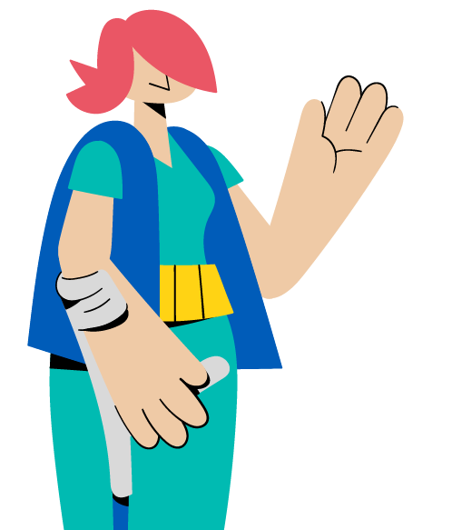
- FALSE: Intimate partner violence does not occur in all families of which its members are poor and have limited educational background. Intimate partner violence can also happen within a wealthy and educated family. Poverty and the lack of education are only contributing factors. Intimate partner violence happens because of the gender inequality and power imbalance between males and females.

