Group Work: Socio-Ecological Model
Expected duration: 15 mins
Objective: reinforce participants' understanding of the socio-ecological model

- Display the following video: https://www.whatworks.co.za/resources/film-and-audio/ item/400-equal-access-Nepal .
- Divide the participants in groups.
- Let the participants work in groups for 5 minutes, inviting them to reflect on the extent that the prevention strategy of Equal Access Nepal works across the different levels of the socio-ecological model.
- No plenary feedback session.

Key considerations:
- Individual level: life skills building, mainly focused on communication in marriage.
- Relationships level: direct work with couples, facilitated group discussions about
healthy relationships.
- Community level: social and behavioural change communication through community outreach, e.g. through role play, theatre.
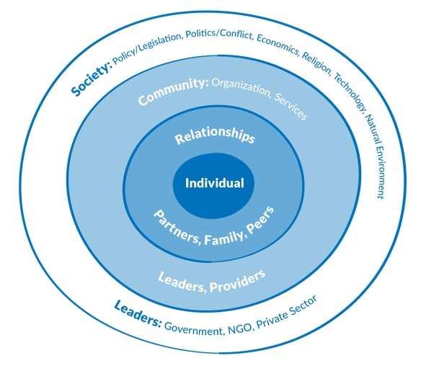
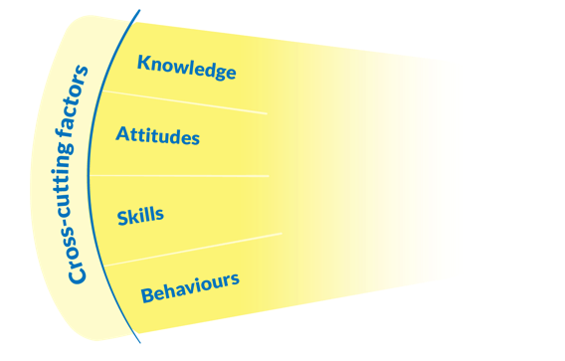
- Society level: using media (radio campaign) for social and behavioural change communication.

