Discussion: Gender Inequality

Expected duration: 10 mins
Objective: identify different forms of intersecting gender inequalities in own community
Brainstorm with participants to think of examples from their own community of gender
inequality, a root cause of GBV and how intersecting factors play a role in the power
differentials and discrimination.
- What examples do you see in your community of gender inequality?
- What intersecting factors play a role in this lack of equality?
Key considerations:
- Gender inequalities are deeply rooted in a society’s notions of how women and men “should be” and “should behave” in one’s culture. These preconceptions determine what society expects of men and women, their roles, privileges and limitations. Gender inequality between women and men exists in all societies. It is this gender inequality and these often rigid gender norms that are considered the root cause of GBV. Gender norms are influenced by history, tradition, culture and religion, all of which change over time.
- GBV programming that promotes transformational change is based on understanding GBV to be the result of gender inequality. Gender inequality is compounded by a number of contributing factors. Intersecting factors of oppression, such as age, ethnicity, class, gender identity and sexual orientation, and disability further harm and disempower women and girls. (Inter-Agency Minimum Standards)
- Possible examples:
- The belief that boys should receive preferential access to education over girls.
- The belief that men should have decision-making power over women.
- The belief that people with disability are not suited for work or study.
- Rigid gender roles that define masculinity in terms of honour, dominance and aggression and ask that men be family protectors and decision-makers.
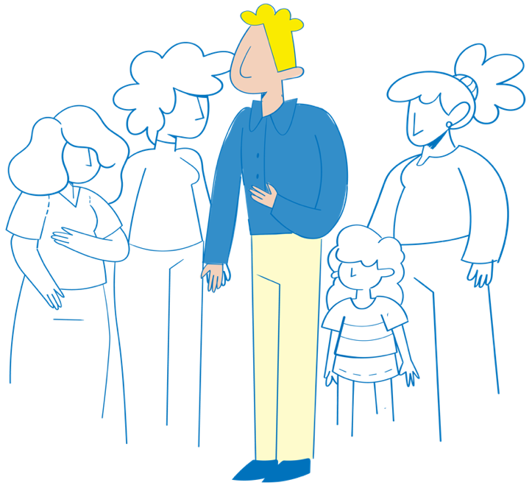
- Rigid ideas which impose that women stay at home, take care of the house and children and are main caregivers also of older persons or persons with disabilities
- National legislation that supports child and forced marriage and does not recognize intimate partner violence.
- Beliefs and practices, including laws, that blame the survivor.
- Beliefs and practices that limit adolescent girls' mobility.
- A perceived lack of value for women’s work and their contribution to society.
- Discriminatory land, inheritance and property rights.

