Discussion: GBV Prevention in Emergencies
Expected duration: 10 mins
Objective: reflect on the importance of GBV prevention in emergencies
Invite learners to share their ideas in plenary in relation to the following statement: “In an acute emergency situation, response to GBV survivors should be prioritized over prevention work.”
- What do you think?
- Do you agree?
- Why or why not?
- Can you give an example of a prevention activity that can be implemented at the onset of an emergency?
Key considerations:
- Relatively simple prevention actions can be life-saving and need to be implemented immediately at the onset of an emergency. GBV prevention often receives less attention during acute emergencies, as it is seen as less urgent than providing support to survivors. Prevention activities may be perceived as longer-term measures to be considered at a later phase of displacement. However, prevention actions can be life-saving, given that they can stop violence from occurring, or reduce the frequency and severity of violence if it has already happened.
- Although crises can exacerbate pre-existing gender inequalities and increase the risk of GBV, they also provide opportunities for social change. There may be shifts in conventional roles, attitudes, beliefs and practices, or new opportunities to discuss subjects that were previously proscribed. Space may open to build positive social and cultural norms that challenge GBV and a culture of impunity for perpetrators.
- Given the increasingly protracted nature of humanitarian crises, promoting positive gender and social norms from the start of the emergency response provides a basis for continued efforts throughout the crisis and sets a foundation for longer-term interventions, acknowledging that changes to attitudes, beliefs and practices may take time.
- Ensure essential services for health and psychosocial support, at minimum, are functional before beginning more transformative social norms and systems change activities. This is also one of the provisions of the UNHRC GBV Policy which states that response services must be in place when starting programming that aims to transform the systems and social norms that perpetuate gender inequality and discrimination.
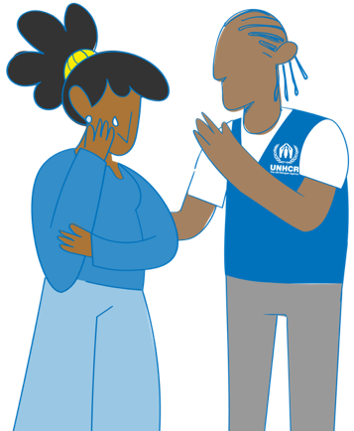
- Examples of prevention activities at the onset of an emergency: promote women’s and girls’ participation and create opportunities for increased decision-making from the onset of the emergency. Participation is a key aspect of empowerment. Empowerment is a process that means that women can take control over their lives, including by making decisions, setting their own agendas, gaining skills (and/or having their skills and knowledge recognized), solving problems and developing self-reliance. Let participants know that over the course of the session we will have the chance to explore more activities related to participation. (Inter-Agency Minimum Standard for Gender-based Violence 13).
- Emphasize that GBV is underreported for many reasons (including fear of stigma or retaliation, limited availability or accessibility of trusted service providers, impunity for perpetrators, and lack of awareness of the benefits of seeking care). Recorded cases represent only a small fraction of the overall incident total, and it should always be assumed that GBV is occurring. Obtaining prevalence data is not a priority at the onset of an emergency and prevention and response measures are to be put in place without any need for proof or evidence.

