Discussion: Analyzing Gender and Power
Expected duration: 15 mins
Objective: reflect on the importance of a Gender and Power analysis
- Invite participants to reflect on the following questions in plenary.
- Why it is important to analyze gender and power?
- How are these two elements connected?
- Make sure the below points are raised and highlighted during the discussion.

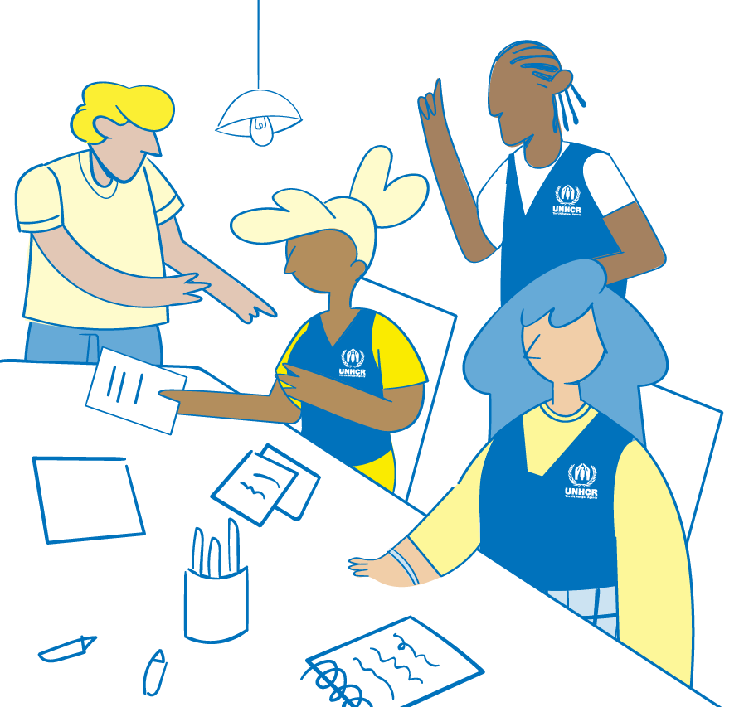
Key considerations:
- Gender norms and hierarchies exist in all aspects of social life. They shape everything from our family roles and decision-making power to our aspirations and job opportunities to our land and inheritance rights.
- Key feminist theories of power, like intersectionality, emphasize gender as a critical power differential that overlaps with others, such as age and ethnicity, to shape experiences of oppression.
- The Gender and Power analysis, therefore, draws attention to the numerous power hierarchies and interconnected systems of oppression that cause inequality. It enables an examination of how unequal power relations overlap with sexism to deepen or produce specific inequalities and forms of discrimination.
- The Gender and Power framework also highlights that power is exercised across a series of social domains and levels of the socio-ecological model (individual, relational, community, and society).
- Power shapes individual’s and group’s access to and control over resources and opportunities, their ability to exercise their agency and rights, and their experiences of inequality and discrimination.
- Using a gender and power framework enables UNHCR and partners to identify, understand, and address the root causes of inequality, rather than only the symptoms, supporting us to design and deliver transformative prevention programming. It helps move beyond social inclusion, which tends to focus on including people with marginalized identities and characteristics within existing systems, leaving the causes of inequality unexamined and unchanged.
- By focusing on power, the Gender and Power Analysis framework reveals the unequal power hierarchies and systems that cause gender inequality and social injustice and supports programming that tackle GBV these root causes.

Content derived and adjusted from the Save the Children Gender & Power Analysis Guidance and Tools, 2021 (https://resource centre.savethe children.net/document/gender
-power-gap-analysis/).

