Activity: Unequal Power Relations
Expected duration: 10 mins
Objective: deepen participants’ understanding that power relations and gender norms are social constructs subject to change
- Put three signs on the wall around the room: “Agree”, “Disagree” and “Not sure”.
- Ask participants to move to the sign reflecting their opinion about the below statement. They can stand in between the different signs as well, along an imaginary gliding scale.
- Unequal power relationships between men and women will never change.
- Ask participants to explain their opinion and allow discussion to take place.
- Make sure the below points are raised and highlighted during the discussion.

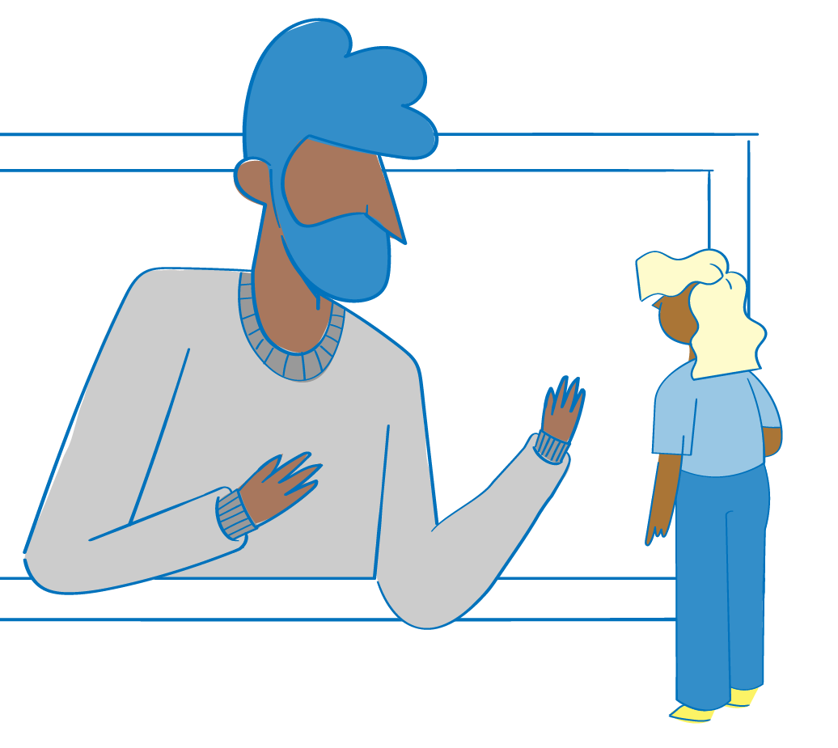
Key considerations:
- Power relations and gender norms are social constructs (influenced by history, tradition, culture and religion) that change over time. Although it is important to understand the social and cultural context in an emergency setting, culture should also be viewed as dynamic, subject to many influences over time, and therefore subject to change. As history shows, women and men around the world have gained (and lost) many privileges and opportunities over the course of time.
- Many aspects of culture are highly contested within the culture itself; some segments of society may be keen to change a cultural practice while others, particularly those who benefit from it, may fight to maintain it. Therefore, GBV programme actors should not assume cultural consensus, but rather identify allies and opinion leaders who can promote positive shifts to prevent GBV.
- Recall that, although crises can exacerbate pre-existing gender inequalities and increase the risk of GBV, they also provide opportunities for social change. There may be shifts in conventional roles, attitudes, beliefs and practices, or new opportunities to discuss subjects that were previously proscribed. Space may open to build positive social and cultural norms that challenge GBV and a culture of impunity for perpetrators.

