Activity: Power Walk Intersectionality
Expected duration: 25 mins
Objective: enhance participants’ understanding of unequal power relations and differences in access to opportunities, services and resources
- Two volunteers are each given a character, 'Alieva' and 'Amina’.
- Provide print-outs of the scenarios to the groups (see below).
- The rest of the group will read out different scenarios experienced by each character.
- The volunteers take steps forward or steps backwards according to how the scenario promotes opportunities for and strengthens assets of that individual.
- An individual may have both positive and negative things happening in each scenario, and so they may take multiple steps forward or backwards accordingly.
- There may also be events that affect the other women and girls in the family, and this may have additional impact on the individual.
- Refer to these key questions to facilitate discussion on whether each girl should move forward or backward:
- What are the good and bad things that are happening in this scenario for the girl?
- What personal/social/physical/financial assets are they developing?
- What personal/social/physical/financial assets are they missing?
- What kind of power exists in the relationships around them? (e.g. power over/power within/power to/power with)
- How does this affect their vulnerability or resilience to challenges?
- How does this affect their risk of or protection from GBV?

Key considerations:
- This exercise is about the unequal power relations and differences in access to opportunities, services and resources. These differences are not based on skill or experience, but socialized power inequality and intersecting factors, perpetuated by cultures and norms. Women experience this inequality throughout their lives, and it is the foundation upon which violence develops and is perpetuated. Of course, not all men are the same, and not all women are the same. Even within those groups, there are significant differences of power and privilege – associated with status, physical ability, wealth, etc.
- Videos to enhance understanding of intersectionality:
- https://www.youtube.com/watch?v=O1islM0ytkE
- https://www.youtube.com/watch?v=w6dnj2IyYjE&t=88s
- Why is intersectionality important in our work? Intersectionality is an analytical framework for understanding how aspects of a person's social and political identities combine to create different modes of discrimination and privilege. Intersectionality identifies multiple interconnected factors of advantage and disadvantage that influence power, privilege and oppression. The experiences of women differ vastly across the world. Intersectionality helps us understand what barriers individuals face over time, and how gender inequality, systemic discrimination and unequal power relations affect them.
- While UNHCR seeks greater gender equality for people of all sexes and/or gender identities, our work focuses primarily on those people that most experience gender discrimination: women and girls and marginalized groups (including particularly individuals with diverse SOGIESC). GBV programming across all the three pillars of risk mitigation, response and prevention must take into consideration the intersection between different interrelated risk factors.
- Research has found that women with disability are twice to four times more likely to experience intimate partner violence than other women. (What Works to Prevent Violence Against Women and Girls, Video: Disability and Violence against Women, 2018 (https://vimeo.com/281426654?embedded=true&source=video_title&owner=32168174) and LGBTIQ+ women and girls face a lack of inclusive services, and can be excluded from resources offered to their cisgender and heterosexual counterparts (Changing the picture – full suite of resources | Suite of resources | Our Watch - Our Watch).
- Inter-Agency Minimum Standards: in practical terms, applying an intersectional lens means engaging community members and, in particular, diverse women and girls, from the onset of a crisis, to identify, analyse and determine strategies to address intersecting forms of structural oppression.

Activity derived and adjusted from the WRC/IRC Toolkit for GBV Practitioners: Building Capacity for Disability Inclusion in GBV Programming in Humanitarian Settings, 2015 (http://www.womensrefugeecommission.org/wp-content/uploads/2020/04/GBV-Disability-Toolkit-English.pdf).

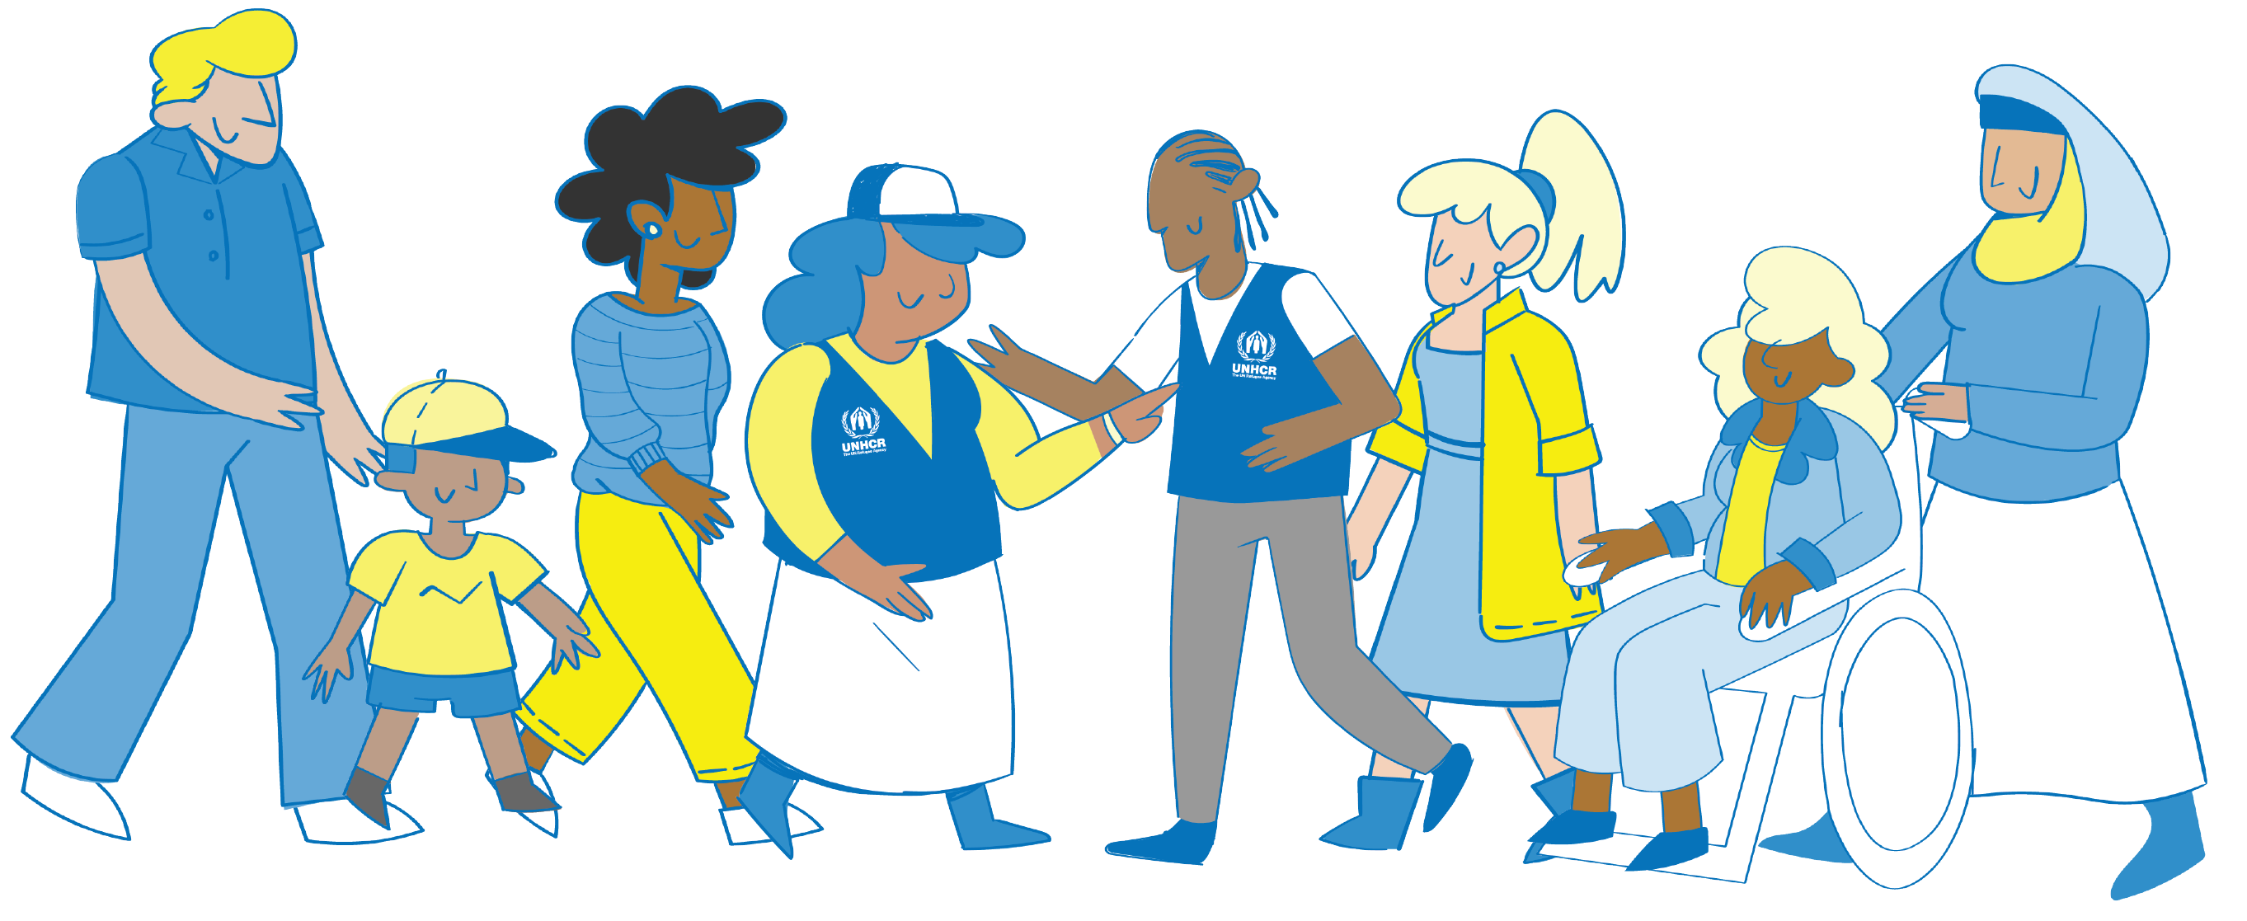

PRINT-OUT 1 - Scenarios Alieva

- Alieva is 15 years old. She was born with her disability – she has difficulty moving, and was slow to develop her speech. The doctors said that Alieva would never go to school, and so she spends most of her time inside the house.

- Alieva’s mother helps her with daily care, like washing and going to the toilet. Her father recently left the family, and now Alieva’s mother must find a way to get income for the family. Alieva’s younger sister must stay at home to help her with things when their mother goes out for meetings.

- Alieva’s sister and another neighbor have started attending a group a local women’s center with Alieva. The social workers spend time talking to Alieva – when she is ready, they organize transportation so the three girls can travel together to the center. Alieva looks forward to these days being around the other girls, and is hoping to learn more about computers.

- One day you meet with the girls to identify the activities they would like to do at the center. Alieva doesn’t speak at this meeting and all the other girls want hairdressing. They all say that Alieva will enjoy this, as they can all do her hair for her – she can be the client, and doesn’t need to stand up to do that.

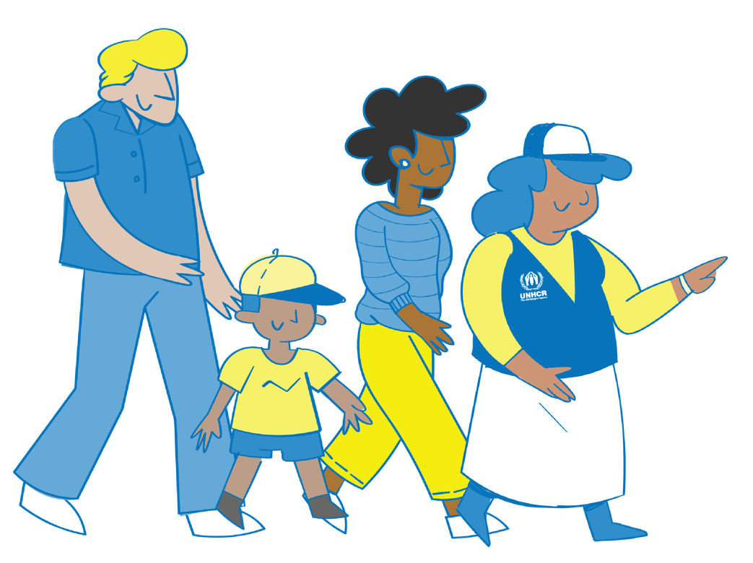

PRINT-OUT 2 - Scenarios Amina

- Amina is 16 years old. She finished her primary education, but has missed a lot of her secondary school because her family members are always asking her to undertake different chores. Her aunt has been encouraging her to do some classes, so she can get a job one day.

- Amina has a lot of friends from primary school. They meet sometimes in the shops and talk a lot on the phone. Some of her friends are going to the center to learn accounting, and Amina would like to join them. Her friends give her lots of information that she shares with her parents, and they say it is OK for her to go, as long as she is able to continue her other work.

- Amina has learned a lot at the center and now has many more friends. Her brothers sometimes take away her phone to prevent her from talking to these friends. The other girls at the center sometimes have the same thing happen, and they discuss different ways to talk to their families about this.

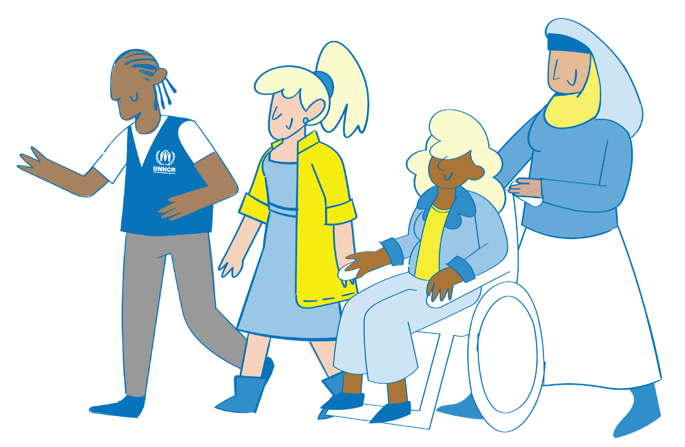
- Amina has passed her accounting course and wants to find work. The teachers at the center give her some different ideas of places to look for work and how the recruitment processes work. Amina talks to her aunty – she also works and has a lot of experience. Amina’s aunty supports her when she discusses this idea with her family.

