Annex A – Technical Offer Form
Ref: CAI/RFQ/014/ 2022
- Information
Bidders are encouraged to use the technical form for the submission to facility the evaluation of the technical offers and assess if the company has the minimum required, noting that compliance with the following technical criteria is mandatory to be technically complaint. Poor quality samples will be technically disqualified, recommended supplier(s) sample(s) will be considered as the minimum accepted quality for future deliveries.

Tender: CAI/RFQ/014/2022
Description: Printing Services for UNHCR
Company Name: ____________________________________
Focal point from the company: _______________________________

Part 1 Company technical requirement: (Pass/Fail criteria)
Company Structure and Experience | YES/NO | Please attach to this form all the relevant documentation that proves your expertise and compliance with the requirements.
Ability to provide registration documents that the company is legally constituted in Egypt, including company size and brochure of the company |  | To be submitted together with this form and submitted via email as per the tender information.
Minimum 3 years of experience in the market providing printing services |  | To be submitted together with this form and submitted via email as per the tender information.
Provision of clientele list with a minimum of 4 references with contact details, including a minimum of 2 (two) references of previous work with multinational companies, international institutions or similar international organizations. |  | To be submitted together with this form and submitted via email as per the tender information.
Ability to designate two (2) experienced staff members to handle all UNHCR requests for printing and provide their CVs |  | To be submitted together with this form and submitted via email as per the tender information.
Technical Competence | YES/NO | Please attach to this form all the relevant documentation that proves your expertise and compliance with the requirements.
Provision of samples as the following.  Samples to be submitted.  - Desk Calendar  - Wall Calendar  - Notebook  - Pens A type  - Mug  - Printed T-Shirt |  | To be submitted.
Provision of a minimum of two (2) samples of previous printing works of acceptable quality and, relevance for similar organizations or companies (for examples books, booklets, manuals …etc) |  | To be submitted together with this form and submitted via email as per the tender information.

Part 2 – Ability to provide the required printed items

UNHCR Colour reference | • PANTONE 300 C/U • RGB 0 114 188 / • CMYK 99  50 0 0/ • HEX #0072BC | Ability to print in this pantone? Y/N

Description of items | Specifications | QTY | Remarks | Description of items | Specifications | QTY | Remarks
Cards (Two-sided)
A6 | 100 - 200gm | 50 |  | A5 | 100 - 200gm | 50
 | 250 - 350gm | 50 |  |  | 250 - 350gm | 50
 | 100 - 200gm | 100 |  |  | 100 - 200gm | 100
 | 250 - 350gm | 100 |  |  | 250 - 350gm | 100
 | 100 - 200gm | 200 |  |  | 100 - 200gm | 200
 | 250 - 350gm | 200 |  |  | 250 - 350gm | 200
 | 100 - 200gm | 1000 |  |  | 100 - 200gm | 1000
 | 250 - 350gm | 1000 |  |  | 250 - 350gm | 1000
85mmx53mm | 100-200 gm | 200
A6 Envelope with UNHCR logo (printing 1 color) | 100 - 200gm | 50 |  | A5 Envelope with UNHCR logo (printing 1 color) | 100 - 200gm | 50
 | 250 - 350gm | 50 |  |  | 250 - 350gm | 50
 | 100 - 200gm | 100 |  |  | 100 - 200gm | 100
 | 250 - 350gm | 100 |  |  | 250 - 350gm | 100
 | 100 - 200gm | 200 |  |  | 100 - 200gm | 200
 | 250 - 350gm | 200 |  |  | 250 - 350gm | 200
 | 100 - 200gm | 1000 |  |  | 100 - 200gm | 1000
 | 250 - 350gm | 1000 |  |  | 250 - 350gm | 1000
Posters and Handouts
A4 one sided (Price to be provided with adhesive and without back adhesive with Celluphane) | 100 - 200gm | 10 |  | A4 double sided with celluphane (might include 1 or 2 folds - prices to be given with folds and without) | 100 - 200gm | 10
 | 250 - 350gm | 10 |  |  | 250 - 350gm | 10
 | 100 - 200gm | 50 |  |  | 100 - 200gm | 50
 | 250 - 350gm | 50 |  |  | 250 - 350gm | 50
 | 100 - 200gm | 100 |  |  | 100 - 200gm | 100
 | 250 - 350gm | 100 |  |  | 250 - 350gm | 100
 | 100 - 200gm | 200 |  |  | 100 - 200gm | 200
 | 250 - 350gm | 200 |  |  | 250 - 350gm | 200
 | 100 - 200gm | 1000 |  |  | 100 - 200gm | 1000
 | 250 - 350gm | 1000 |  |  | 250 - 350gm | 1000
A3 one sided (Price to be provided with adhesive and without back adhesive with Celluphane) | 100 - 200gm | 10 |  | A3 double sided with a fold with celluphane | 100 - 200gm | 10
 | 250 - 350gm | 10 |  |  | 250 - 350gm | 10
 | 100 - 200gm | 100 |  |  | 100 - 200gm | 100
 | 250 - 350gm | 100 |  |  | 250 - 350gm | 100
 | 100 - 200gm | 1000 |  |  | 100 - 200gm | 1000
 | 250 - 350gm | 1000 |  |  | 250 - 350gm | 1000
A1 one sided (Price to be provided with adhesive and without back adhesive with Celluphane) | paper roll printing 200gm matte | 10 |  | A2 one sided (Price to be provided with adhesive and without back adhesive with Celluphane) | 100 - 200gm | 10
 |  | 50 |  |  | 250 - 350gm | 10
 |  | 100 |  |  | 100 - 200gm | 100
 |  | 1000 |  |  | 250 - 350gm | 100
A0 one sided (Price to be provided with and without back adhesive) | paper roll printing 200gm matte | 10 |  |  | 100 - 200gm | 1000
 |  | 50 |  |  | 250 - 350gm | 1000
 |  | 100 |  | A4, 8-page booklet, 100 grams with two staples |  | 50
 |  | 1000 |  |  |  | 100
 |  |  |  |  |  | 250
Calendars
Desk Calendar | Coche paper 300gm - 20 x 15 cm - 25 paper - duplex stand | 100 |  | Wall Calendar | 300 gm paper (8 pages, double sided) + + celluphane | 100
 |  | 500 |  |  |  | 500
 |  | 1000 |  |  |  | 1000
 |  | 2000 |  |  |  | 2000
Stickers (price to be provided for 1 and 2 colors)
Round (12" diameter) |  | 50 |  | 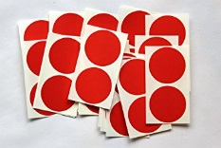  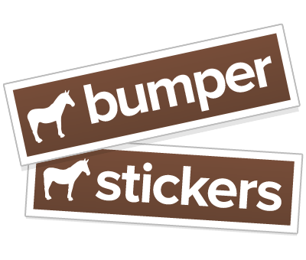  Round (9" diameter) |  | 50
 |  | 100 |  |  |  | 100
 |  | 500 |  |  |  | 500
 |  | 1000 |  |  |  | 1000
A6 |  | 50 |  | A5 |  | 50
 |  | 100 |  |  |  | 100
 |  | 500 |  |  |  | 500
 |  | 1000 |  |  |  | 1000
Books (4 colors, Cover 300 gm, inside 135 gm couche matt, perfect binding)
70 Pages + cover |  | 10 |  | 200 Pages + cover |  | 10
 |  | 50 |  |  |  | 50
 |  | 100 |  |  |  | 100
 |  | 1000 |  |  |  | 1000
100 Pages + cover |  | 10 |  | 300 Pages + cover |  | 10
 |  | 50 |  |  |  | 50
 |  | 100 |  |  |  | 100
 |  | 1000 |  |  |  | 1000
Pens
Pens Grade A | Metal material with UNHCR logo | 100 |  | Pens Grade B | Plastic material, blue color, with UNHCR logo | 100
 |  | 300 |  |  |  | 300
 |  | 500 |  |  |  | 500
 |  | 1000 |  |  |  | 1000
 |  | 2000 |  |  |  | 2000
 |  | 3000 |  |  |  | 3000
Services Guide
Up to 40 pages | Size A5, couch matte150gm cover (2-sided), 90gm inside, full color, 2 staples | 50 |  | Up to 40 pages | Size A5, couch matte150gm cover (2-sided), 90gm inside, full color, 2 staples | 1000
 |  | 100 |  |  |  | 2000
 |  | 500 |  |  |  | 3000
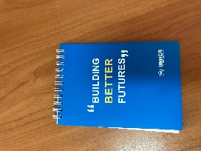
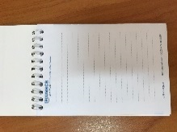
Notebooks (Cover 250 gm, inside 70 gm one color)

A6 | Wire binding, price to be provided for 60 and 80 pages, inside page single sided | 50 |  | A5 | Wire binding, price to be provided for 60 and 80 pages, inside page double sided | 50
 |  | 100 |  |  |  | 100
 |  | 500 |  |  |  | 500
 |  | 1000 |  |  |  | 1000
 |  | 2000 |  |  |  | 2000
A4 | Wire binding, price to be provided for 80 and 100 pages, inside page double sided | 100 |  | 25 cm * 17.5 cm | Hard Cover (2 colors)  Wire binding, price to be provided for 80 and 100 pages, inside page one color double sided | 500
 |  | 500 |  |  |  | 1000
 |  | 1000 |  |  |  | 2000
 |  | 2000 |  |  |  | 3000
Rollup |  |  |  | Others
60*160 cm | Price includes roll up machine (skeleton) + printing | 1 |  | Plaque metal | A4 with engraved text | 1
85*200 cm |  | 1 |  | Caps | Blue, 100% cotton, High quality, UNHCR embroidery logo, | 100
100*200 cm |  | 1 |  |  |  | 250
150*200 cm |  | 1 |  |  |  | 500
200*200 cm |  | 1 |  | USB with logo 8gb | Excellent durable chips with engraved UNHCR logo, one year warranty. | 100
60*160 cm | Price of printing only - UNHCR will provide the machine (Skeleton) | 1 |  |  |  | 250
85*200 cm |  | 1 |  |  |  | 500
100*200 cm |  | 1 |  | Bag | A3, non-woven bag with external handles, logo (1 color) printed on one side | 250
150*200 cm |  | 1 |  |  |  | 500
200*200 cm |  | 1 |  |  |  | 1000
Shirts |  |  |  |  |  | 2000
T-shirts | 100% cotton, short sleeves, printed UNHCR logo, machine washable, no color bleach. | 100 |  | 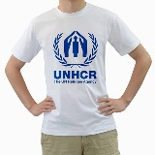  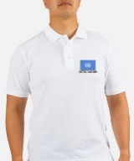  Mug | White, strengthened porcelain, UNHCR logo printed | 200
 |  | 250 |  |  |  | 500
 |  | 500 |  |  |  | 1000
Polo Shirts | 100% cotton, short sleeves, printed UNHCR logo, machine washable, no color bleach. | 100 |  | Thermal Mug | Silven thermal mug, with UNHCR logo printed in one color | 200
 |  | 250 |  |  |  | 500
 |  | 500 |  |  |  | 1000
Banner |  |  |  | Daily Planners (PU Cover + 365 pages at least) | PU leather cover in blue, 70g wood-free paper, inside pages 2 colors, perfect binding 20.7cm*14cm with UNHCR Logo printed on the cover, perfect binding | 100
70*90 cm |  | 1 |  |  |  | 200
90*100 cm |  | 1 |  |  |  | 300
1m2 with wooden frame |  | per m2 |  |  |  | 500
Vest | Vest light material (Blue, high quality with logo printed) as per UNHCR Brand_Guidelines | 50 |  | Hoodie | Sweatshirt Branded - With Hoodie with printing on one side (different print per hoodie) | 50
 |  | 100 |  |  |  | 100
 |  | 300 |  |  |  | 300
Acrylic Boards | 2 sided, 4 mm, installation in Cairo | 5 |  | 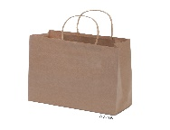  Water bottle | 650 ml branded water bottle | 100
 |  | 10 |  |  |  | 200
 |  | 15 |  |  |  | 500
Paper bags | Branded 32x36 cm paper bag with logo printed on two sides. | 500
 |  | 1000
 |  | 2000
 |  | 5000 |  | 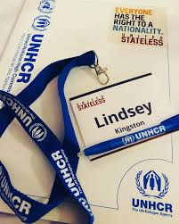
Lanyards | Branded UNHCR lanyards | 200
 |  | 500
 |  | 1000
Certificates | 250-350 grams  Sirio Pearl Oister Shell’ paper or whatever is available subject to prior agreement with UNHCR  printing on one side | 1 |  | 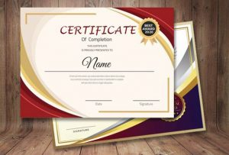
Name tents |  | 1
Business cards | Standard size | 100
 |  | 200
- Acknowledged Annex D (General Conditions of Contracts) – | Indicate  Yes or No

Date of submission:
Company Name: ____________________________________

Official Stamp of the Company and Focal Point ____________________________________________

